Pharmacy Enterprise Customization System (PECS)

User Guide



Version 6.0.01

May 2016

Department of Veterans Affairs

Office of Information and Technology (OIT)

Product Development

*(This page included for two-sided copying.)*

Document Control Section

Revision History

| Date | Revised Pages | Patch Number | Description of Change |
| --- | --- | --- | --- |
| May 2016 | All  i, xvi  165  5, 6, 14, 46, 144  23, 81  126  39  135-139  4  6  7  3, 4  13  14  24  26-28  38  43  53  62  76  84, 85  94  95, 96, 122, 128  132  153  158 | PREC*6.0*1 | Removed periods from description, edited for 508 conformance  Date, Footer updated, Corrected Page number  Removed extra text  Adjusted bullets on lists for consistency Removed blank page  Added blank page  Removed extra space  Adjusted bullets  Formatted cross-references as hyperlinks  Updated punctuation on bulleted lists  Capitalized drug names  Added SFTP to acronyms  Replaced FTP with SFTP  Updated WebLogic version  Adjusted hyphens, text edit  Removed periods  Added word, text edit  Removed extra space  Text edit  Removed extra space, text edit  Revised text to clarify  Text edit  Removed extra space  Revised text to clarify  Removed extra space  Added apostrophe  Revised text to clarify  Removed extra space  Brian Holihan, Susan Heiress |
| 11/17/2014 | x  70  96  99  123, 141, 169 | PREC*5.0*1 | Added blank page  Updated internal document links  Updated internal document links  Updated missing linked screen capture  Removed unnecessary link  Brian Holihan |
| 11/17/2014 | 8  16  63  66  68  112  117  163 | PREC*5.0*1 | Clarified sentence describing the Pre-Production and Production environments.  Clarified sentence on Customize Settings; corrected missing linked screen capture.  Added quotation marks to “Display in Query” for clarity.  Removed extra space between sentence and period.  Changed “an” to “a”  Removed extra space between sentence and period.  Clarified sentence .  Removed extra period.  Brian Holihan |
| 11/17/2014 | 2  6  8  12  14  19  30  34  51, 60, 62  16  All  89, 124  47-49  All  vii  ix – xiv  xv - xviii | PREC*5.0*1 | Updated link  Removed extra text  Removed extra text  Removed asterisk  Switched spell-out of DDI to first use  Removed extraneous parenthetical statement  Provided definition for DRC  Provided list of options  Updated reference links  Removed extraneous section  Page numbers updated  Changed section names so that the text would fit on the TOC  Removed strange section of linked text causing multiple instances of the same text and graphics  Updated referenced page numbers  All references to FDB MedKnowledge Framework were reverted to FDB-DIF to correct an inaccuracy; the product name does not change until the 4.x series, not the 3.3 version of the FDB product deployed with PECS v5.0.  Added blank page so that TOC starts on an odd page, separate from Revision History  Updated TOC page numbers  Updated List of Figures page numbers  Brian Holihan |
| 11/13/2014 | All  vi  vi  51  73  80 | PREC*5.0*1 | Updates for PECS v5.0  Updated Revision History  Removed blank page so TOC starts on odd page  Removed extra bullet item  Added blank page so Section 8 starts on odd page  Removed blank page and stray text; fixed hyperlink  Brian Holihan |
| 07/18/2014 | All | PREC*3.0*1 | Changed date to real release date (month)  Reviewed and fixed typos from search and replace  Changed format of Revision History pages; changed FDB-DIF to FDB MedKnowledge Framework  Made additional changes per CPS  Made changes per CPS: graphics caption formatting, added links, created new heading for cross-reference purposes (Drug Pair Customization; changed “Records You Can Modify” to Modifying Records.”)  Marella Colyvas |
| 04/18/2014 | 17-24 | PREC*5.0*1 | Updated Section 4 to include some changes for Section 508 Compliance  Marella Colyvas |
| 04/16/2014 | All | PREC*5.0*1 | Changed Template (software version in title page) and one line in section 9.4.4  Marella Colyvas |
| 04/02/2014 | 120 | PREC*5.0*1 | Completed edits/screen shots for Drug Pair Detail Screen for Multiple Customizations (RTC 35830)  Marella Colyvas |
| 03/13/2014 | All | PREC*3.0*1 | Added changes from CPS  Marella Colyvas |
| 03/03/2014 | 126-128 | PREC*5.0*1 | Added section 9.4.4 on Reverse DDIs  Marella Colyvas |
| 02/13/2014 | All | PREC*3.0*1 | Added Alt Text for Section 508 Compliance  Marella Colyvas |
| 01/17/2014 | All | PREC*5.0*1 | Fixed Section 508 Issues from Checker  Marella Colyvas |
| 01/06/2014 | All | PREC*5.0*1 | Completed PECS by Tab tasks, rearranged and rewrote major portions of guide. History in RTC.  Marella Colyvas |
| 02/12/2013 | 55-58 | PREC*3.0*1 | Added FDB Drug Pair Content  Marella Colyvas |
| 02/11/2013 | All | PREC*3.0*1 | Updated for PECS 3.0  B Holihan |
| 02/08/2013 | All | PREC*3.0*1 | Some formatting changes & edits; changed two screen shots in prep for PECS 3.0  Marella Colyvas |
| 02/07/2013 | 53, vii | PREC*2.2*1 | Updated graphic on Page 53 to ensure caption remained with image; Updated TOC  B Holihan |
| 02/07/2013 | All | PREC*2.2*1 | Updated Title Page to reflect Release month  Updated Revision History order  Updated Footer to include version number, release date.  B Holihan |
| 06/26/2012 | Title Page | PREC*2.2*1 | Updated title page to reflect the update month  Marella Colyvas |
| 06/13/2012 | All | PREC*2.2*1 | Updated to address Sonia T, Joanne C comments.  B Holihan |
| 06/12/2012 | All | PREC*2.2*1 | Updated to address Radu C comments of 06/11/12  B Holihan |
| 05/31/2012 | 101-108 | PREC*2.2*1 | Entered nearly all of Joanne’s comments re: FDB Comparison Reports.  Marella Colyvas |
| 05/23/2012 | All | PREC*2.2*1 | Updated TOC; changed some heading levels; replaced screen shots for Requestor & Approver home pages; adjusted pagination and section breaks  Marella Colyvas |
| 05/09/2012 | 61-62 | PREC*2.2*1 | Updated Quick Drug Pair selection.  B Holihan |
| 05/08/2012 | 84-85 | PREC*2.2*1 | Added screen capture to Null Drug Pair section; Reduced size of Custom Update samples  Marella Colyvas |
| 5/07/2012 | 84 | PREC*2.2*1 | Added sentence at the end of the Null Drug Pair write-up to contain info about the date from the FDB update.  Marella Colyvas |
| 05/04/2012 | 84-85 | PREC*2.2*1 | Added more information to Release Manager. Still needs better explanations of screen captures; added Null Drug Pairs write-up to Administrator Role (Julie’s); added write-up on Quick Drug Pair Selection; added information about CCR5122 in User Guide in the Notification of Drug Pairs Needing Action for an Approved Drug-Drug Interaction section.  Marella Colyvas |
| 5/04/2012 | 39 | PREC*2.2*1 | Clarified the "Also note: If you wish to put a Drug-Drug Interaction (DDI) . . ." statement at the end of the Notification of Drug Pairs Needing Action for the Approved Drug-Drug Interaction section.  Joanne Callahan |
| 05/03/2012 | 2, 62 | PREC*2.2*1 | Added explanation of Custom Update File in Release Manager section; updated definition of Administrator on pages 2 and 62 (added fact they can initiate null drug pair removal). Updated write-up on Quick Drug Pair Selection  Marella Colyvas |
| 4/27/2012 | 61-62; 75 | PREC*2.2*1 | Added PBM feedback to Release Manager write-up; added short write-up on Quick Drug Pair Selection  Marella Colyvas |
| 4/12/2012 | 39; 75 | PREC*2.2*1 | More changes to Drug Pair Notification; added Release Manager write-up  Marella Colyvas |
| 4/11/2012 | 39 | PREC*2.2*1 | More changes to Drug Pair Notification  Marella Colyvas |
| 4/9/2012 | 39 | PREC*2.2*1 | Renamed the Title of the Drug Pair Notification Section (was “Working with Drug Pairs”)  Marella Colyvas |
| 4/6/2012 | 50-51; 75-76 | PREC*2.2*1 | Edited and obtained new screen shots for Multiple DDI records to one FDB; attempted to write up Release Manager but need more information.  Marella Colyvas |
| 3/23/2012 | 39 | PREC*2.2*1 | Drafted Drug Pair Notification  Marella Colyvas |
| 3/15/2012 | 50-53 | PREC*2.2*1 | Cleaned up Record Locking; made edits from Sonia on Creating Multiple Custom DDIs to One FDB Record and Prevention of Duplicate DP on Single Record  Marella Colyvas |
| 3/13/2012 | 51 | PREC*2.2*1 | Added information on Creating Multiple Custom DDIs to One FDB Record and Prevention of Duplicate DP on Single Record  Marella Colyvas |
| 03/12/2012 | 63; All | PREC*2.2*1 | Added data on Forward/Reverse Monographs and Multiple DDIs to one FDB; included Lynn Teague’s changes  Marella Colyvas |
| 02/17/2012 | 44 | PREC*2.2*1 | Completed Record Locking  Marella Colyvas |
| 02/16/2012 | 44 | PREC*2.2*1 | Made a few additions to Record Locking  Marella Colyvas |
| 02/10/2012 | All | PREC*2.2*1 | Made a few changes to the text on Edit panels  Marella Colyvas |
| 1/26/2012 | All | PREC*2.2*1 | Created text for Not Editing Single Drug Pair window; added some screen shots; still have to add Sonia’s changes.  Marella Colyvas |
| 1/23/2012 | All | PREC*2.2*1 | Beginning of changes for PECS 2.2. Added new Read-Only screens for each concept; eliminated edit mode screen shots for now;  Marella Colyvas |
| 11/05/11 | All | PREC*2.2*1 | Edited information from customer on Action Statuses, and added information on Saved Queries  Marella Colyvas |
| 10/13/11 | All | PREC*2.2*1 | Added information on potential Easy Search/PECS Record discrepancy; changed a screen shot  Marella Colyvas, Wendy Cobb |
| 10/7/11 | All | PREC*2.2*1 | Reviewed and provided feedback / comments  Hussain Kedwaii |
| 10/6/2011 | All | PREC*2.2*1 | Added changes for 2.1  Marella Colyvas, Kristen Kriwox, Wendy Cobb |
| 04/12/2011 | All | PREC*2.2*1 | Added edits from CPS.  Marella Colyvas |
| 12/08/2010 CR 3520 | All | N/A (First Release) | Began changes for PECS v2.0, sprint 1, Professional Monograph and Historical Records  Marella Colyvas |
| 11/18/2010 CR 3391 | All | N/A (First Release) | Edited changes requested by customer analyst prior to second (final) review by EIE  Marella Colyvas |
| 10/12/2010 CR 3391 | All | N/A (First Release) | Updated elements found in Enterprise Infrastructure Engineering (EIE) review for Operational Readiness Testing (ORT)  Marella Colyvas |
| 4/14/2010 | All | N/A (First Release) | Baseline  Russell Chachula and Marella Colyvas |

ProPath Template used v1.2, April, 2014

*(This page included for two-sided copying.)*

Table of Contents

1 Introduction 1

1.1 Purpose 1

1.2 Overview 1

1.3 Project References 2

1.3.1 Information 2

1.3.2 Coordination 2

1.3.3 Help Desk 3

1.4 Organization of the Manual 3

1.5 Acronyms and Abbreviations 4

2 System Summary 7

2.1 System Configuration 8

2.1.1 Deployment Design – PECS 8

2.1.2 Hardware/Software Components 10

2.1.3 Production Environment 10

2.2 Data Flows 11

2.2.1 Process Flow 11

2.2.2 Transaction Flow 12

2.3 User Access Levels 14

2.3.1 Identity Management 14

2.3.2 Role Assignment 15

2.3.3 Role Descriptions for Identify Management 15

3 Customization Information 17

3.1 Drug-Drug Interaction and Professional Monograph 17

3.2 Duplicate Therapy 18

3.3 Dose Range 18

4 Getting Started 19

4.1 Login 19

4.1.1 Logging into PECS 19

4.1.2 Authentication Explanation 20

4.1.3 Changing User ID and Password 20

4.2 Application Organization 20

4.2.1 Welcome and Update Information 21

4.2.2 Help and “Contact Us” Information 21

4.2.3 General Page Structure and Navigation 22

4.2.4 Home Page 22

5 PECS by Tab 23

5.1 Home 23

5.2 Advanced Query/Customization 23

5.3 Easy Search 24

5.4 Drug Pair Lookup 25

5.5 Reports 25

5.6 Contact Us 26

5.7 Custom Updates 27

5.8 Administration 27

5.9 Help 28

6 Using Advanced Query/Customization 29

6.1 Accessing the Advanced Query/Customization Page 29

6.2 Build a Query Panel 30

6.3 Create a Query 31

6.3.1 Query Filters 33

6.3.2 And/Or Usage Examples 33

6.3.3 Query Specifics 34

6.3.4 Add Default DRC Query 34

6.4 Save a Query 36

6.5 Run a Saved Query 36

6.6 Rename a Saved Query 36

6.7 Delete a Saved Query 37

6.8 Query Results 37

6.8.1 Sort Query Results 38

6.8.2 Re-Order Results Columns 38

6.9 Export Query Results 39

6.10 Query Errors 41

7 Working with Customization Requests 43

7.1 Create a Customization Request 43

7.1.1 Customize a Drug-Drug Interaction Record 43

7.1.2 Customize Other Record Types 43

7.1.3 Create Customization from a Blank Form 44

7.2 Modify Customization Requests 44

7.3 Review Customization Requests 46

7.4 Approve Customization Requests 48

7.5 Reject Customization Requests 49

7.6 Delete Customization Requests 51

7.7 Record Locking Feature 53

8 User Roles and Tasks 55

8.1 Requestor 55

8.1.1 Requestor Home Page 55

8.1.2 My Request History: Requestor 55

8.1.3 Additional Tools Available to Requestors 56

8.2 Approver 57

8.2.1 Approver Home Page 57

8.2.2 My Request History: Approver 58

8.2.3 My Assigned Requests for Review 59

8.2.4 My Assigned Requests for Approval 60

8.2.5 My Assigned Requests for Deletion 61

8.2.6 Unassigned Requests 61

8.2.7 All Requests 61

8.2.8 Additional Tools Available to Approvers 62

8.3 Release Manager 62

8.3.1 Release Manager Home Page 62

8.3.2 Custom Update Tab 62

8.3.3 Custom Update Overview 63

8.3.4 Update Files Explained 63

8.3.5 Create a Custom Update 65

8.3.6 Review Custom Update History 65

8.3.7 Additional Tools Available to Release Managers 65

8.4 Administrator 66

8.4.1 Administrator Home Page 66

8.4.2 Administration Tab 66

8.4.3 Customize Settings 67

8.4.4 Change Field Display Order 70

8.4.5 Update User Roles 70

8.4.6 Null Drug Pair Removal Process 74

8.4.7 Editing Contact Us 75

8.4.8 Add a Contact Link 76

8.4.9 Edit a Contact Link 77

8.4.10 Additional Tools Available to Administrators 77

9 Easy Search 79

9.1 Easy Search Drug-Drug Interaction with Professional Monograph and/or Duplicate Therapy Query 79

9.2 Easy Search Interactions for a Single Drug Query 83

9.3 Easy Search Dose Range Query 85

9.4 Potential Easy Search Result and PECS Record Discrepancy 88

10 Drug Pair Lookup 91

10.1 Performing a Drug Pair Lookup Query 91

10.2 Export Query Results 92

11 Detail Pages 95

11.1 Detail Page Overview 95

11.1.1 Informational and Warning Messages 96

11.2 Using Detail Pages 97

11.2.1 Viewing Record Details 97

11.2.2 Edit a Record 97

11.2.3 Print a Record 98

11.2.4 Add Pre-Customization Comments 98

11.2.5 View Associated Record Links 99

11.2.6 History Report 99

11.2.7 Field-Level History Table 100

11.2.8 Export Date 100

11.3 Drug-Drug Interaction Detail 101

11.3.1 Multiple VA Customizations for One FDB Record 102

11.3.2 Create Multiple Customizations from One FDB Record 102

11.3.3 Cannot Add Identical Drug Pairs to Same DDI 103

11.3.4 Reverse Drug-Drug Interactions 104

11.3.5 Working with Drug Pairs within the DDI 105

11.3.6 Fields 105

11.4 Drug Pair Detail 107

11.4.1 Fields and Other Information 108

11.4.2 Finding Drug Pairs 110

11.4.3 FDB Drug Pair Detail Page 111

11.4.4 VA Customized Drug Pair Detail Page 115

11.5 Drug Pair Customization (Non 508-Compliant) Detail 115

11.5.1 Drug Pairs Panel 117

11.5.2 Notification of Drug Pairs Needing Action for an Approved Drug-Drug Interaction 117

11.5.3 Customizing Drug Pairs from the Selection List 120

11.5.4 Review a Drug Pair 122

11.6 Section 508 Compliant Drug Pair Customization Detail 124

11.6.1 Select Drug Pairs to Add to the Above VA Custom Interaction Panel 124

11.7 Professional Monograph Detail 127

11.7.1 Fields 129

11.7.2 Buttons 130

11.7.3 Forward and Reverse Professional Monograph 130

11.8 Duplicate Therapy Detail 131

11.8.1 Fields 132

11.8.2 Buttons 133

11.9 Dose Range Detail 133

11.9.1 Dose Range Concept Types 134

11.9.2 Fields 135

11.9.3 Buttons 137

12 Sample Modification Scenarios 139

12.1 Duplicate Therapy Modification 139

12.1.1 Process Steps 139

12.2 Duplicate Therapy Approval 140

12.2.1 Process Steps 140

12.3 Drug Interaction Research 140

12.3.1 Process Steps for Severity Check, Case 1 140

12.4 Drug Interaction Severity Change 140

12.4.1 Process Steps for Editing Case 1 141

12.5 Drug Interaction Severity Change 142

12.5.1 Process Steps for Editing Case 2 142

12.6 Remove Drug Pair from Interaction 143

12.6.1 Process Steps 143

12.7 Create Professional Monograph 143

12.7.1 Process Steps 144

13 Contact Us 145

14 Reports 147

14.1 Active Customization Reports 147

14.1.1 FDB Custom Dose Range Report 148

14.1.2 FDB Custom Drug-Drug Interaction Report 149

14.1.3 FDB Custom Duplicate Therapy Report 150

14.1.4 FDB Custom Professional Monograph Report 151

14.1.5 Deleted Monograph Customization Report 151

14.1.6 Null Drug Pairs Customization Report 152

14.2 FDB Comparison Reports 152

14.2.1 Structure of the FDB Comparison Report 155

14.2.2 FDB Comparison Drug-Drug Interaction/Drug Pair Report 157

14.2.3 FDB Comparison Duplicate Therapy Report 160

14.2.4 FDB Comparison Dose Range Report 162

15 Online Help 167

15.1 Accessing Online Help 167

*(This page included for two-sided copying.)*

# Introduction

The Pharmacy Enterprise Customization System (PECS) is a Graphical User Interface (GUI) application that currently allows the VA’s Pharmacy Benefits Management (PBM) pharmacists and Automated Data Processing Application Coordinators (ADPACs) to customize the contents of the following five business concepts:

* Drug-Drug Interaction
* Drug Pair
* Duplicate Therapy
* Dose Range
* Professional Monograph

## Purpose

The purpose of this user guide is to provide a general overview of the PECS application, as well as more detailed working information. It also provides reference material and task-based instructions for entering and approving Drug-Drug Interaction, Drug Pair, Duplicate Therapy, Dose Range, or Professional Monograph Customization Requests.

## Overview

When a VA provider orders a drug for a patient (either through CPRS [Computerized Patient Record System] or VistA), the Medication Order Check Healthcare Application (MOCHA) performs order checks on that drug, and alerts the provider if the drug they are ordering has any of the following anomalies:

* Causes an interaction with other drugs the patient is taking
* Is in the same Therapeutic Class as other drugs the patient is taking
* Is prescribed in a dose that is incompatible with patient factors such as age, weight and Body Surface Area (BSA)

The drug information used as a basis for these order checks comes from a Commercial Off the Shelf (COTS) product provided by First Databank (FDB) called the Drug Information Framework (FDB-DIF).

Sometimes, the information provided by FDB is not optimal for the VA Providers or the Veteran community they serve. The primary purpose of the Pharmacy Enterprise Customization System (PECS) is to give Pharmacy Benefits Management (PBM) the ability to customize the drug information provided by FDB so the order checks and resulting alerts are based on drug information tailored specifically for the VA.

The major users of PECS are Pharmacy Benefits Management (PBM) personnel and the Automated Data Processing Application Coordinators (ADPACs) who will research and request the customization of FDB data. Once approved by the National Drug File (NDF) committee members, the changes made will affect all of the VA sites throughout the country to where the data is sent and used in the enhanced order check. The order check is used by VA physicians and pharmacists to see if any serious drug conflicts occur with the patients’ existing medication. It will also check for duplication of therapy of other prescribed drugs also taken by the VA patient.

The advantages to the VA for using PECS are as follows:

* All customizations will be performed at the National level to provide consistent order checks between facilities.
* Use of First Databank for drug interaction, duplicate therapy, and dosing data.
* More specificity in drug interaction order checks with the ability to include or exclude dose routes.
* More specificity in duplicate therapy order checks with FDB data.
* Weekly FDB updates with monthly customization updates.
* More frequent customization updates when needed.

## Project References

This User Guide relies on the following documents, which can be found here:

http://vaww.oed.portal.va.gov/projects/pre/PRE_IPT_Rev/PRE_IPT_Rev_PECS/Lists/PECS%20v50%20Review/AllItems.aspx

**Note:** Due to policy constraints, active links cannot be included in this document. Please copy and paste the URLs into your browser.

* PECS Requirements Specification Document (RSD)
* Pharmacy Reengineering (PRE) Configuration Management Plan (CMP)
* PECS Database Design Document
* PEPS Style Guide
* PECS Project Architecture Document
* PECS Interface Control Document
* PECS Production Operations Manual (POM)

### Information

**Note: Due to policy constraints, this document cannot support live links. Please copy and paste the links into your browser.**

Project contacts for PD PRE PECS project are as follows:

* Office of Information & Technology (OIT) Product Development (PD) Program Manager
* OIT PD Project Manager PECS
* Business Sponsor/Stakeholder
* Business Subject Matter Expert (SME)/Lead Clinical Analyst

The current names of those serving these roles can be found in the organization chart for PD PRE: Be sure to look at the tab for PECS:  
http://vaww.oed.portal.va.gov/projects/pre/OverArching%20Documents/PRE_Organization_Chart_all%20tabs.pdf

These people can be contacted through the Global Address List (GAL).

### Coordination

Any coordination activities that must occur will take place between the PBM group and their ADPACs. If something has to be escalated, the ADPACs will have specific procedures for each site.

### Help Desk

Each site needs to use the help desk escalation that they normally use. Since each site is different, the only instructions for users are to go their ADPACs and to report issues.

See the Contact Us tab in the PECS Application for guidance.

## Organization of the Manual

Introduction

An overview of the PECS system and this User Guide

System Summary

A more detailed description of the PECS system including a non-technical overview of the product design, data flow, and application access

Customization Information

Provides a brief overview of customizations and how they’re created in PECS

Getting Started

Discusses logging into PECS and the organization of the application

PECS by Tab

PECS functions are organized into Tabs. PECS by Tab describes the tabs found in PECS

Using Advanced Query/Customization

Instruction on using Advanced Query/Customization feature

Working with Customization Requests

Instruction on how to create and process customization requests

User Roles and Tasks

Information on PECS User Roles and the functions they perform

Easy Search

Instruction on using the Easy Search feature

Drug Pair Lookup

Instruction on using the Drug Pair Lookup feature

Detail Pages

Description of the Detail Pages

Sample Modification Scenarios

Sample scenarios on why a record would be customized and the steps to make the customization

Contact Us

Information about the Contact Us page

Reports

Information about PECS Reports

## Acronyms and Abbreviations

Acronyms and Abbreviations used in this document.

Table : Acronyms and Abbreviations

| Term | Definition |
| --- | --- |
| ADPAC | Automated Data Processing Application Coordinator |
| AITC | Austin Information Technology Center |
| API | Application Program Interface |
| BSA | Body Surface Area |
| COTS | Commercial Off-the-Shelf |
| CPRS | Computerized Patient Record System |
| DATUP | Application that implements the FDB-DIF update business logic using the FDB Updater APIs to process the update file |
| FDB | First Databank |
| FDB-DIF | First Databank Drug Information Framework database |
| FTP | File Transfer Protocol |
| GCN | Generic Code Number |
| GUI | Graphical User Interface |
| J2EE | Java 2 Enterprise Edition |
| KAAJEE | Kernel Authentication and Authorization for J2EE |
| NDF | National Drug File |
| OIT/OI&T | Office of Information and Technology (verify which to use). |
| PBM | Pharmacy Benefits Management |
| PD | Product Development |
| PECS | Pharmacy Enterprise Customization System |
| PEPS | Pharmacy Enterprise Product System |
| PRE | Pharmacy Reengineering |
| RSD | Requirements Specification Document |
| SFTP | Secure File Transfer Protocol |
| URL | Uniform Resource Locator |
| VA | Department of Veterans Affairs |
| VAMC | VA Medical Center |
| VistA | Veterans Health Information Systems and Technology Architecture |
| VPN | Virtual Private Network |

*(This page included for two-sided copying.)*

# System Summary

The Pharmacy Enterprise Customization System (PECS) was born out of the need to support enhanced order checks. A decision was made to replace the home-grown order checking process, implemented in M, with a COTS product (FDB-DIF). However, the VA desired to be able to customize the drug information (such as drug interaction severity, monographs etc.) existing in FDB. PECS will satisfy this need, while adhering to stringent requirements intended to ensure patient safety.

The PECS application is designed with the following functionality:

* Allows customization of FDB data used in the enhanced order checking by National Drug File (NDF) Managers
* Provides access to GUI customization application by facility users to request custom changes
* Provides role based system accessibility
* Provides a report to list all customizations created to date compared against corresponding FDB standard reference data
* Provides a process to allow drug interaction information in VistA to be transferred to the custom tables
* Provides a process via Secure File Transfer Protocol (SFTP) to update from a national database to all local/regional instances of FDB standard and custom tables

PECS is developed to allow easy customization of FDB standard reference tables such as Duplicate Therapy, Dose Range, Drug-Drug Interaction, and Drug-Drug Interaction Professional Monograph, which are used in the enhanced order checking by the MOCHA system.

In more detail, PECS does the following:

* Allows users to customize the FDB standard reference tables used in the enhanced order checking that will be used by the Pharmacy Benefits Management (PBM) group, the Automated Data Processing Application Coordinators (ADPACs), and National Drug File (NDF) managers or designees to enter and update the custom table values.
* Allows users to do the following customizations:
* A custom drug-drug interaction, and any important attributes for that interaction
* Drug pairs associated with a custom drug-drug interaction
* A custom Professional Monograph for a drug-drug interaction, including any important attributes
* A custom duplication allowance value for a duplicate therapy class
* Custom values for attributes associated with a custom dose range check table
* Provides a Searching capability for a user to see Drug-Drug Interaction, Duplicate Therapy, or Professional Monograph information separately or together, for chosen drugs.
* Provides the following reports:
* History of custom changes for each of the five concepts
* Exportable FDB or Custom Data - Individual query data can be exported from the five FDB-DIF or Custom tables. The available format is Excel
* FDB Comparison Reports to compare incoming updated FDB data against VA customized data to help determine if the VA customized data needs to be modified
* Provides a process via SFTP to transfer Custom data from a National server to all local/regional instances servers.
* Leverages the existing FDB data loader utility at each site that is used to update the FDB-DIF databases.

Custom table content distribution involves using an automated utility, Data Update (DATUP). The distribution method supports the following data content scenarios:

* Only FDB standard reference table data.
* FDB standard reference table data and Custom table data.
* Only Custom table data.

Custom table content distribution supports both periodic and as-needed releases.

## System Configuration

PECS is installed in two environments at the Austin Information Technology Center (AITC) in Austin, TX: Pre-Production and Production. The new PECS build, database changes (updates), security patches, etc., are first applied to PECS Pre-Production and then on successful deployment promoted to PECS Production.

### Deployment Design – PECS

Figure 1 shows the overview of the logical deployment design for the PRE PECS Application.

Application Server

The WebLogic Application Server 12.1.1 will host PRE PECS and its business services.

Data Base Server

The Database Server software is Oracle 11g running on Red Hat Linux Enterprise version RHEL5. It will host the Custom Table Staging database and FDB-DIF database.

Failover Server

The Failover Server will host both the BEA WebLogic Application Server and Oracle Database Server to provide redundancy.

Legacy Interface

An existing VistA server will host legacy KAAJEE and VistALink interfaces.

Figure : Logical Deployment Design for the PRE PECS Application

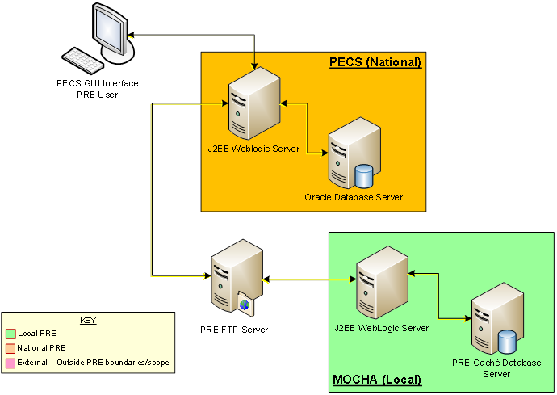

### Hardware/Software Components

The Hardware/Software components and deployment architecture of the Pre-Production and Production environments are the same. The PECS Application and database are kept in synchronization for both.

Figure : PECS High Level Deployment Design



### Production Environment

Figure 3 shows the Production environment that will be supported, and the local networks to which they will be attached for Local VA Medical Centers (VAMC), where PECS users are located.

Figure : Production Environment for PECS



## Data Flows

### Process Flow

Figure 4 shows the life cycle of a customization change from the Requestor entry to the point the record is ready to be sent to the production FDB Drug Information Framework (DIF) custom table. The updates and changes are made and maintained in a Staging Table. Records are not extracted until the Release Manager submits approved changes. Records are then formatted and placed in a directory where they will be updated to production. The process that updates these records uses software named DATUP.

Figure : PECS Customization Life Cycle



### Transaction Flow

Figure 5 depicts the Action Statuses of a record’s transition from creation to approval.

Figure : Action Statuses

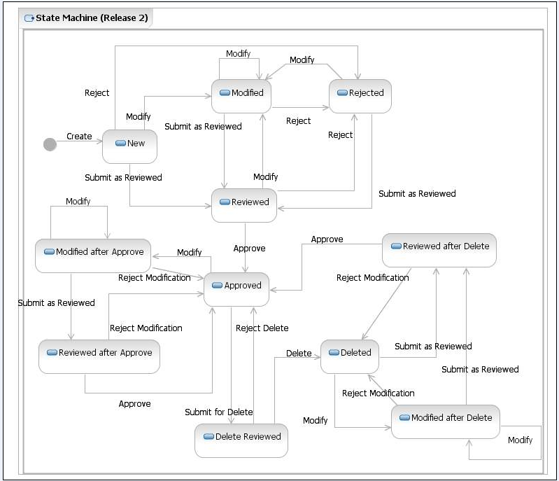

Action Statuses

This list displays the different Action Statuses a VA customized record may go through as it steps through the approval workflow within PECS. Note that only seven of the following eleven states are displayed in the user interface - in other words, some of this information is “behind-the-scenes.” It is included here as information only.

***New*** - A new customization request has been created. If a user has the appropriate authority, they may modify the request (Modified) to be completed at a later point. Then, if they have the proper authority, they may submit the request as reviewed (Reviewed).

***Modified***- A user can make changes to their own New requests. The record will remain Modified until a user with the proper authority (Approver role) reviews the request and submits the request as Reviewed.

***Modified After Approve*** ***- (displays as Modified)*** A user with the proper authority has requested a change in the Approved customization that requires another approval process.

***Modified After Delete*** - ***(displays as Modified)*** A user with the proper authority has requested the deleted record be considered again for Approval with or without modifications. This requires another approval process.

***Reviewed*** - This is the first stage of approval. A user with the proper authority (Approver role) reviews the new or modified customization request and submits it as Reviewed. The approver may also reject or modify the request. Note that an approver can review their own requests but not approve them.

***Reviewed After Approve*** - ***(displays as Reviewed)*** Modifications were made to an approved record. A user with the proper authority (Approver role) reviews the request and submits it as Reviewed. The Approver may also reject the request, in which case the record returns to the Approved state, or they may modify it.

***Reviewed After Delete*** - ***(displays as Reviewed)*** Modifications were made to a deleted record. A user with the proper authority (Approver role) reviews the request and submits it as Reviewed. The Approver may also reject the request, in which case the record returns to Deleted state, or they may modify it.

***Rejected*** - The customization request is in a Rejected state. At this point the user may make changes, resubmit, or allow the customization to remain in Rejected state. All records that are rejected or not approved will remain in that state and will be available to the user for any future changes.

***Approved*** - This is the second stage of approval. A user with the proper authority (Approver role) who did *not* submit the request as Reviewed will review the record and may approve, reject, or modify the request.

***Delete*** ***Reviewed*** - The record remains active but a user with the proper authority (Approver role) has requested deletion of an existing approved customization.

***Deleted*** - A user in the Approver role who did *not* submit the request for Deletion may delete the customization. If an Approver confirms the deletion, the record will remain active for potential future modifications.

## User Access Levels

The PECS application is accessible only by users signed directly into the VA network, or by users signed into the VA network via approved virtual private network (VPN) software. User authentication into the VA network is a precondition of PECS application access. Application authentication and authorization will be controlled by the VA Kernel Authentication and Authorization for J2EE (KAAJEE) security Application Programming Interface (API). Privileges are granted by PECS Administrators.

In order to log in to the application, each user must have a valid VistA account at a local or national facility, since KAAJEE delegates user authentication to VistA. At the application’s login screen, users are prompted for their access and verify codes and will be allowed to select the VistA institution which issued their credentials.

### Identity Management

Access to PECS is a two-step process. Authorization is handled through the use of specific VistA security keys which represent the user roles within PECS. These roles (Requestor, Approver, Release Manager and Administrator) have a set of permissions within PECS that allow them to perform specific tasks. A PECS user can hold multiple roles and would have access to all the functions associated with each role. These roles are mapped to security keys as follows.

Table : PECS VistA Security Keys

| PECS Role | VistA Security Key |
| --- | --- |
| Requestor | PSS_CUSTOM_TABLES_REQUESTOR |
| Approver | PSS_CUSTOM_TABLES_APPROVER |
| Release Manager | PSS_CUSTOM_TABLES_REL_MAN |
| Administrator | PSS_CUSTOM_TABLES_ADMIN |

The user provisioning process is part of the VistA system and is thus not documented here. Password changes, account activation/inactivation, etc., must be performed through VistA. Refer to the appropriate documentation for details on user account management.

### Role Assignment

In addition to the VistA Security Keys, users must be assigned to roles by a PECS Administrator in User Roles. The exception is the Requestor role (the least-privileged access to PECS), which does not require specific assignment by an Administrator. See Update User Roles for additional information.

### Role Descriptions for Identify Management

Following is a list of roles available within the application, and a description of what each role can do:

Requestor:

Creates Customization Requests.

Approver:

Creates Customization requests and Reviews and Approves Customization Requests created by other users.

Release Manager:

Generates Custom Update Files; Reviews existing Custom Updates.

Administrator:

Grants/Removes User Role privileges; Updates Concepts Settings; Edits content on the Contact us page.

*(This page included for two-sided copying.)*

# Customization Information

The Customization Information section describes the customizations that can be done through PECS.

## Drug-Drug Interaction and Professional Monograph

Figure 6 displays how a Drug-Drug Interaction is tied to Drug Pairs and Professional Monographs: More information on Drug-Drug Interactions, Drug Pairs, and Professional Monographs is provided later in the manual.

Figure : Drug-Drug Interaction Relationship

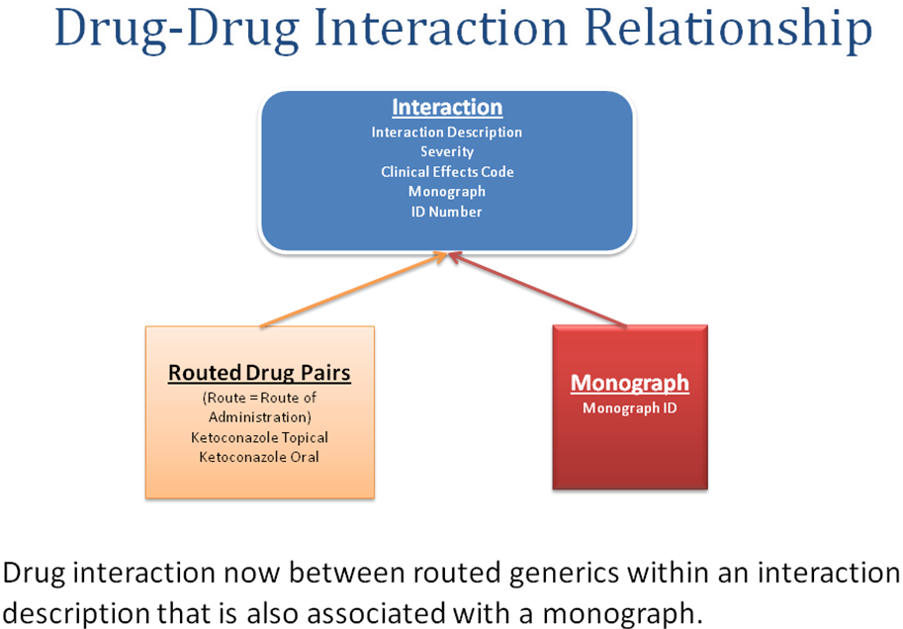

FDB Drug-Drug interaction severity levels:

1 = Contraindicated

2 = Severe

3 = Moderate

9 = Undetermined severity – Alternate therapy

Within the VA system, an FDB or VA Custom drug-drug interaction of severity level 1 will return a Critical order check and severity level 2 will return a Significant order check. Severity levels 3 and 9 will not return an order check.

Types of drug-drug interaction customizations include:

* Change in severity level
* Add or remove drug pairs
* Create drug interactions not found in FDB

**Note:** Due to the millions of possible drug pair combinations, you must be very specific on which two products are involved when reporting problems with the system.

## Duplicate Therapy

The Duplicate Therapy concept allows you to specify the maximum number (0, 1, 2, 3, or 4) of duplicate therapy matches that can occur within a therapeutic class without creating an order check. A ‘0’ duplicate allowance means only 1 medication from that therapeutic class can be on the patient profile without getting an order check (zero duplication). If a second drug from that class is added the provider gets the order check. If the allowance is ‘1’, two drugs can be on the patient profile at once, the 3rd drug added would get the check (one duplication), etc.

The only type of Duplicate Therapy customization allowed is to increase or lower the duplicate therapy allowance for a therapeutic category.

## Dose Range

A Dose Range is the allowable dosage of a drug based on a number of factors such as patient age, weight, and Dose Route. PECS allows you to modify the Dose Ranges included in the FDB-DIF product.

* Dosing is based on the GCN (Generic Code Number) Sequence Number (GCNSEQNO), a number specific to all drug products with the same generic ingredient(s), route of administration, drug strength(s) and dosage form.
* Dosing is age-specific for most products. FDB has dosing for neonatal, infant, adolescent, adult, and geriatric. All ages are by days, for example, 18 years x 365= 6570 days.
* FDB also has indication-specific dosing, and dosing type. Examples of dosing type are loading, maintenance, single, initial.
* A typical product may have 30 or more dosing records when all variables are taken into consideration.
* The initial implementation of dosing order checks within VistA looks at the maximum single dose and daily dose range order checks using a common indicator.

# Getting Started

The Getting Started section provides information that is essential for a user to get started with PECS.

## Login

PECS requires the user to login to prevent unauthorized users from accessing the system and to establish identity for their actions within the application. Note that authorization is handled through the use of specific VistA security keys. PECS doesn’t assign individual permissions to users. Instead, it defines a number of roles for its users (Requestor, Approver, Release Manager and Administrator) and associates a set of permissions with each of them. To see the list, refer to the Identity Management section.

Figure : KAAJEE Login Screen

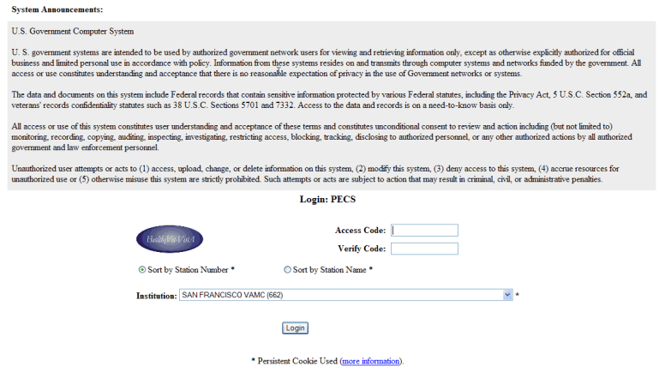

### Logging into PECS

To login to PECS:

1. When started, PECS displays the Confidentiality Statement. You must agree to this statement to continue. Click Agree.

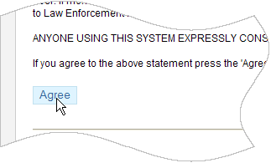

1. On the Login Screen, enter your Access Code and Verify Codes.

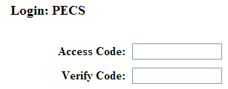

1. Select your Institution. This selection will be remembered the next time you login. Typing the first few letters of the name of the institution will jump to the first entry in the list with those letters.

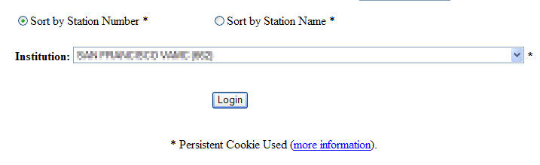

1. Click Login.

### Authentication Explanation

Application authentication and authorization is controlled by KAAJEE. Refer to VistA documentation for details on the user account maintenance.

If the response from the authentication request is successful via the KAAJEE API, KAAJEE returns a user profile object, which is used by the application to determine the user's role and permissions. On successful login, the system displays the PECS Home page.

### Changing User ID and Password

All users are assigned VistA Access and Verify Codes which are their assigned/designated "User IDs" and passwords for authentication in PECS.

All account maintenance activity must be performed through VistA. Contact your ADPAC for instructions.

## Application Organization

PECS is organized into a set of tabs. Only tabs that are relevant to the users role are displayed; for example, a Requestor user will see different tabs than an Approver user.

Figure : PECS Tab Groups Displayed

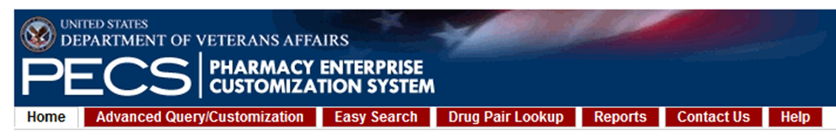

All available tabs in PECS are listed below. They will be discussed in more detail later in the User Guide.

* Home
* Advanced Query / Customization
* Easy Search
* Drug Pair Lookup
* Reports
* Help
* Contact Us
* Custom Updates
* Administration

See PECS by Tab for additional information.

### Welcome and Update Information

The Welcome and Update Information section at the top of the Home page displays the current user's account name and the dates of the last FDB-DIF Update and the last Custom Update.

Figure : Welcome Text and Update Information

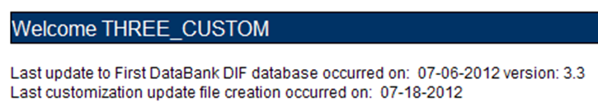

To Those Using Screen-Reading Assistive Technology

The window that displays the PECS tab groups also contains a link at the top, “Go to Main Content.” This link is for screen readers to jump directly to the main content of the selected tab and not read each and every tab every time a tab is selected.

Figure : PECS Tab Groups with “Go to Main Content” Link

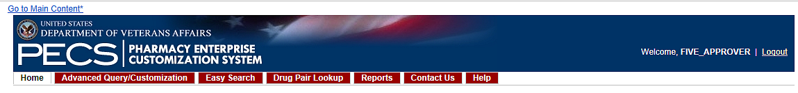

### Help and “Contact Us” Information

The Home page for all users tabs for accessing online help file and a Contact Us page.

The Help tab launches the PECS Online Help System and displays the "front page" of the Help System. To get context-sensitive help, click the Page Help link on the page you need help with. See the Help section for additional information.

The Contact Us page contains a list of PECS Project Contacts should you need additional information about the PECS product. The content of the Contact Us page is decided by users with the Administrator role. Click the link associated with the name to send that person (or group) an email. See Contact Us for additional information.

**Note:** Clicking the link opens your mail application and a new email message to the person specified in the properties of the link. This may produce a warning message. This is normal.

### General Page Structure and Navigation

All PECS application pages have certain features that provide information and help navigate the system.

Header

The PECS Header shows the Name of the current user and contains a Logout link for exiting the PECS application.

Tabs

The Tab row is used to access PECS functions.

Content

The tools (such as build a query) or content (such as a customization request) are displayed here.

Footer

The footer contains navigation links; this is a duplicate of the tabs. The application version is also displayed here.

### Home Page

The Home Page is the first page that the user sees after logging into PECS and can be returned to at any time by clicking the Home Tab. The Home page provides summary counts of the number of active customization records accessible to the current user. Additionally, it displays the last update to the First Databank DIF database tables occurred and also when the last customization update file was created.

The Home page is organized into panels containing specific information; only panels that are appropriate to the role of the current user are displayed. Home, Help, and Contact Us are displayed for all users.

# PECS by Tab

Tabs provide the organization for the functions provided by PECS. This section provides an overview of the tabs and their functions. The tabs themselves are explained in more detail later in the user guide.

## Home

The Home tab is available to the following type of PECS users:

* Requestor
* Approver
* Release Manager
* Administrator

The PECS Home tab is the first page you see after you have successfully completed Login. The appearance of the home tab is Role-specific; what appears on the page is different depending on the Role associated with your login credentials.

See the Home Page section in Getting Started for additional information, as well as the role-specific home page sections in User Roles and Tasks.

Figure : Requestor Home Page

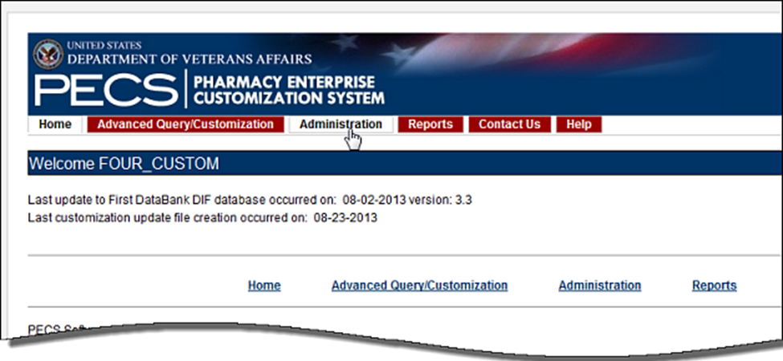

## Advanced Query/Customization

The Advanced Query/Customization tab is available to the following type of PECS users:

* Requestor
* Approver
* Release Manager
* Administrator

Searching for records is the one common task for all roles in PECS. It is done from the Advanced Query/Customization tab which is available to all users.

The Query Builder Panel on the Advanced Query/Customization page allows you to retrieve a specified set of records from the VA Custom Tables, the FDB standard tables, or both in order to perform research, make customizations, make customization changes, or export data. You can use it to create a new query, load a query you have previously saved, or load a query saved by another user.

Figure : Advanced Query/Customization Window with Sample Data

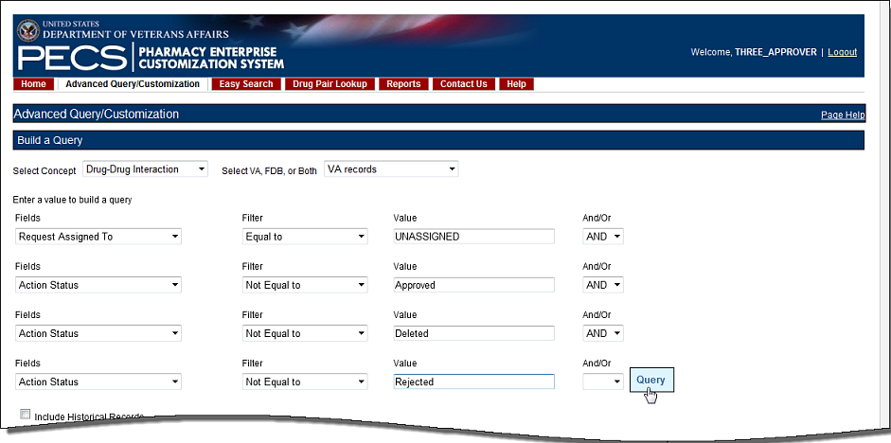

For detailed information on Advanced Query/Customization, see Using Advanced Query/Customization.

## Easy Search

The Easy Search tab is available to the following type of PECS users:

* Requestor
* Approver

Easy Search provides a simple way to display commonly-requested PECS information. Easy Search differs from other methods for finding information in that the results are display-only; the records displayed as a result of an Easy Search query cannot be modified. However, in some cases, a link is provided to an editable version of the resulting records.

The Easy Search tab is displayed on the Home pages of the Approver and Requestor roles only.

Figure : Initial Easy Search Window

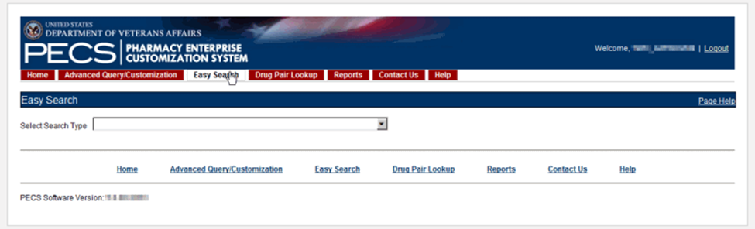

For additional information, see Easy Search for additional information.

## Drug Pair Lookup

The Drug Pair Lookup tab is available to the following type of PECS users:

* Requestor
* Approver

The Drug Pair Lookup tab provides the ability to perform a quick search on the most common elements of a drug pair: Generic Drug Name A, Generic Drug Name B, Interaction, and the Severity Code.

Figure : Drug-Drug Pair Lookup Window

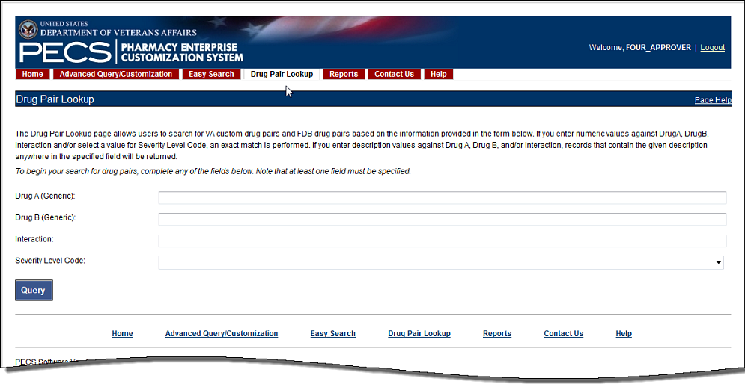

For additional information, see Drug Pair Lookup.

## Reports

The Reports tab is available to the following type of PECS users:

* Approver
* Administrator

**Note to Assistive Technology Users:**  
Please refer to the documentation included with your screen reader for commands related to reading column and row headers.

The Reports tab displays a list of available reports in PECS.

Figure : List of Reports

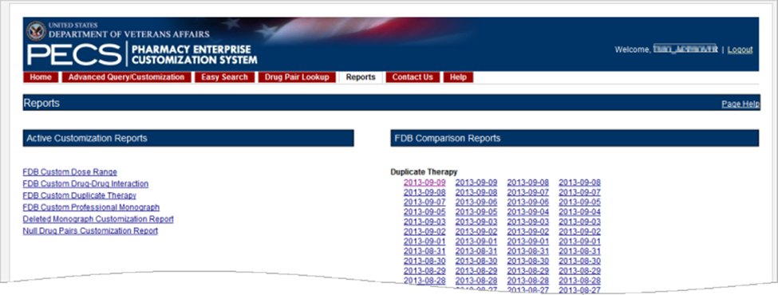

There are two types of Reports:

* Active Customization Reports
* FDB Comparison Reports

Reports are generated in the form of Excel spreadsheets. To run a Report, click the associated link. For additional information, see Reports.

## Contact Us

The Contact Us tab is available to the following type of PECS users:

* Requestor
* Approver
* Release Manager
* Administrator

The Contact Us page contains a list of PECS Project Contacts should you need additional information about the PECS product. The content of the Contact Us page is decided by users with the Administrator role. Contact Us may include links that allow you to send that person (or group) an email.

**Note:** Clicking the link opens your mail application and a new email message to the person specified in the properties of the link. This may produce a warning message. This is normal.

Figure : Example of Contact Us Data

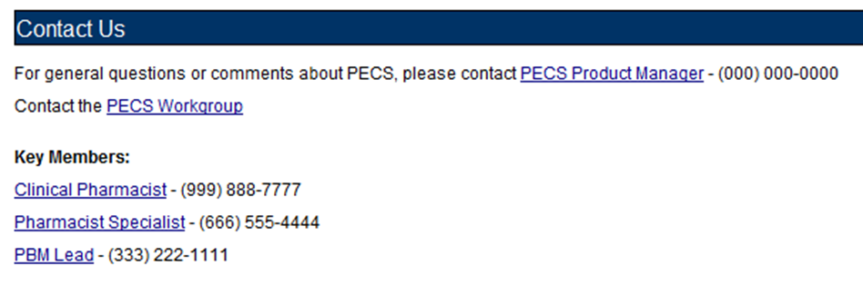

Note that the above example is only an example – it can be changed to display just about anything.

See Contact Us for additional information.

## Custom Updates

The Custom Updates tab is available to the following type of PECS users:

* Release Manager

The Custom Updates tab is seen and used by a Release Manager to generate a zip file containing files for each Order Check in the FDB update file format. Both updates files are created by clicking the "Create New Update" button.

Figure : Custom Updates Tab for Release Manager

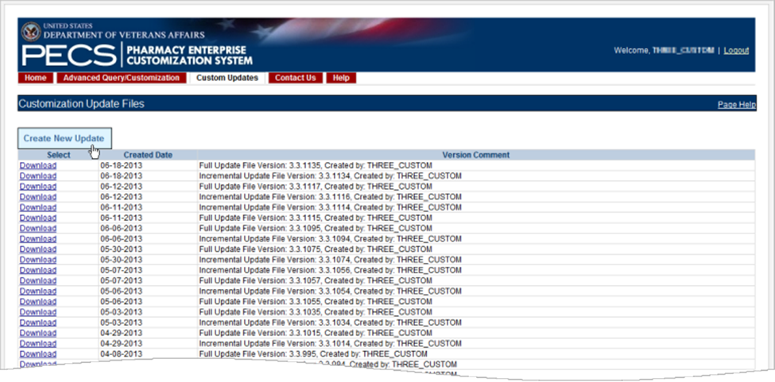

## Administration

The Administration tab is available to the following type of PECS users:

* Administrator

The Administration tab is used by PECS users with Administrator privileges to perform specialized tasks such as modifying certain aspects of the PECS environment, adding or deleting Approver users, and removing Null Drug Pairs. The Administration tab is visible only to users with Administrator role privileges.

Figure : Administrator's Home Page

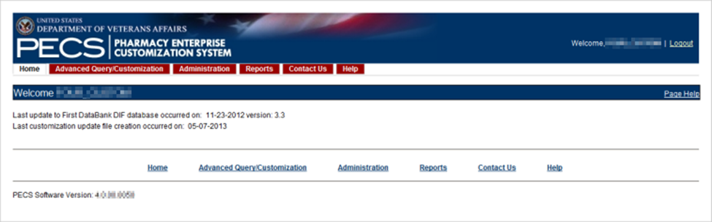

See Administrator for additional information.

## Help

The Help tab is available to the following type of PECS users:

* Requestor
* Approver
* Release Manager
* Administrator

The Help tab launches the PECS Online Help System and displays the "front page" of the Help System.

Figure : PECS Help Window

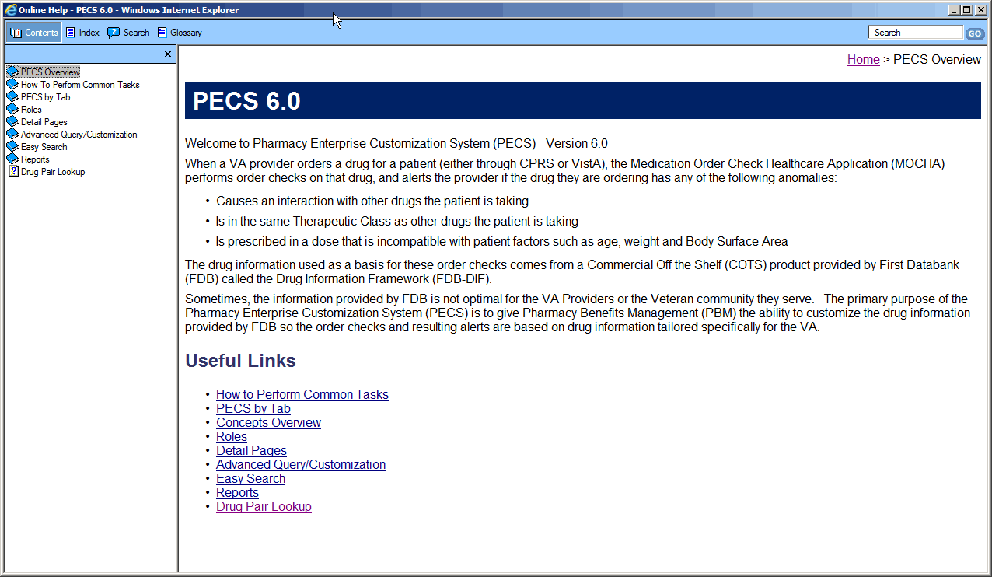

See Online Help for additional information.

# Using Advanced Query/Customization

Searching for records is a task common to all PECS roles. Advanced Query/Customization is the most comprehensive way to find PECS records. Advanced Query/Customization can be used to find both VA customizations and FDB records so that they can then be customized.

## Accessing the Advanced Query/Customization Page

Use the Query Builder (Build a Query) Panel on the Advanced Query/Customization page to retrieve a specified set of records from either the VA Custom Tables, the FDB standard tables, or both. This allows you to perform research, make customizations, change existing customization, or export data. In the Query Builder Pane, you can create new queries or load previously-saved queries (either yours or a query saved by another user).

There are three ways to display the Advanced Query/Customization page:

1. Click the Advanced Query/Customization tab on the navigation bar near the top of the page. This will open a blank query:

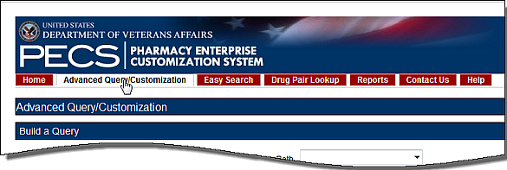

1. Click the Advanced Query/Customization link on the footer near the bottom of the page. This will open a blank query:

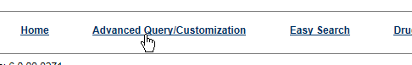

1. Click a link from one of the summary tables displayed on the Home tab. This will generate a query appropriate to the context of the link that was clicked. In the example below, a query displaying criteria to display the unassigned Drug-Drug Interaction records will be produced.

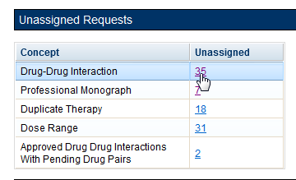

## Build a Query Panel

To build a new query, you first select a Concept (type of record) and the source for the record you want to find. The concepts are Drug-Drug Interaction, Drug Pair, Professional Monograph, Duplicate Therapy, and Dose Range.

Figure : Advanced Query/Customization Build a Query Panel – New Query

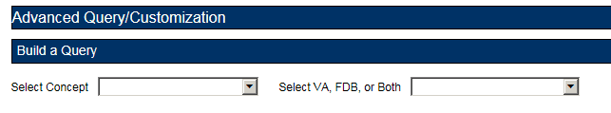

After selecting values for the Select Concept and Select VA, FDB, or Both fields, additional fields display, through which you can create your Query.

Table : Build a Query Panel Fields

| Field Name | Definition |
| --- | --- |
| Fields | Select the field you want to query on from the Fields list. The available fields are specific to the selected Concept. |
| Filter | Select a filter for the field from the Filter list (Contains, Equal To, etc.) See Query Filters for additional information. |
| Value | Enter search criteria in the Value field. Appropriate values are dictated by what was selected from the Fields list. |
| And/Or | Use the And/Or field to create complex queries by adding additional search criteria. If the query must meet multiple criteria, use AND; if a value from a list of criteria is acceptable, use OR. AND and OR can be combined when building the query. See And/Or Usage Example for additional information. |
| Query button | Click Query to run the query you have built or loaded |
| Add Default DRC Query button | Dose Range Queries Only: Adds two standard criteria (Concept Type = '6' and AGEHIGHINDAYS >= '6570) to the query. You should enter your specific criteria before clicking Add Default DRC Query. |
| 'Include Historical Records' checkbox | Select Include Historical Records to include inactive historical records in the Query results. Historical records cannot be modified, only viewed. A Historical Record is any previous version of a record. |
| 'Clear Query' button | Click Clear Query to delete the current query; only the Concept Type and record source will remain. |
| 'Query Name' | Enter a name for the current query if you want to save it. The name should be as descriptive as possible so that you (and other users) will understand what results the query will produce. |
| 'Save Query' button | Click Save Query to save the current query for later use. If the Query Name field is blank, this button is inactive. |

## Create a Query

To create a query:

1. On the Advanced Query/Customization tab, select a Concept.

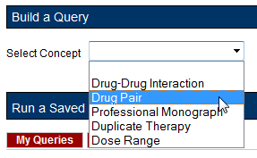

1. Select the data you want to view – VA, FDB, or Both.

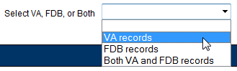

1. In the "Enter a value to build a query" area, select the Field you want to use as a query criteria. The available field options will be determined by the Concept you selected earlier.

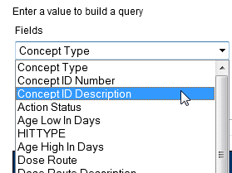

1. Select the Filter you want to impose on the Field. See Query Filters for additional information.

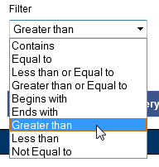

1. Enter a Value to use as your query criteria. The Value must be appropriate for the selected Field and Filter or an error message is displayed in the Results panel. See Query Specifics for additional information.

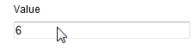

1. To add additional criteria to the query, make a selection from the And/Or list.

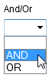

* + AND indicates the results must match the new criteria and all the AND-connected criteria above it
  + OR indicates that the results must match either the new criteria or the AND-connected criteria above it. SeeAnd/Or Usage Examplefor additional information.

1. To include Historical Records in the query, select the Include Historical Records check box.
2. When all criteria have been added, click the Query button. The results will display in the Results panel appropriate to the query being performed (VA or FDB).
3. To see details of the record, click the link in the Select column. The links are either Active (current VA record), Historical (old version of an active VA record), or Open (FDB record).

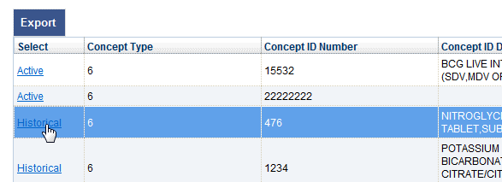

### Query Filters

The Advanced Query/Customization query function provides Filters that allow you to control what data is returned by the query. The filters are.

Table : Query Filters

| Filter Name | Filter Function |
| --- | --- |
| Contains | The contents of the Value field appears somewhere in the database row of the Field being queried. Used primarily for fields containing text data. Contains is the default Filter option. Contains = “25” would match 25, 125, and 250, but not 205. |
| Equal To | The contents of the Value field exactly matches the contents of the database row of the Field being queried. “Equal To” = “25” would match 25, but not 125, 250, or 205. |
| Less than or Equal to | The contents of the Value field is less than or equal to the contents of the database row of the Field being queried. |
| Greater than or Equal to | The contents of the Value field is greater than or equal to the contents of the database row of the Field being queried. |
| Begins with | The contents of the database row of the Field being queried starts with the contents of the Value field. |
| Ends with | The contents of the database row of the Field being queried ends with the contents of the Value field. |
| Greater than | The contents of the Value field is greater than the contents database row of the Field being queried. |
| Less than | The contents of the Value field is less than the contents database row of the Field being queried. |
| Not equal to | The contents of the Value field does not exactly match the contents of the database row of the Field being queried. |

### And/Or Usage Examples

To see approved records with an interaction description equal to "anti" or "Lido", build the query as follows:

Table : And/Or Example 1

| Field | Filter | Value | And/Or |
| --- | --- | --- | --- |
| Interaction description | Equals | anti | And |
| Status | Equals | approved | Or |
| Interaction description | Equals | Lido | And |
| Status | Equals | approved |  |

If you build the query below, you will get approved records with an interaction description = "anti", but you will get all records with an interaction description of "Lido", regardless of status.

Table : And/Or Example 2

| Field | Filter | Value | And/Or |
| --- | --- | --- | --- |
| Interaction description | Equals | anti | And |
| Status | Equals | approved | Or |
| Interaction description | Equals | Lido |  |

### Query Specifics

* Use the YYYY-MM-DD date format for searching date fields within a query
* Date values can only use the following filters
  + Equal to
  + Less than or Equal to
  + Greater than or Equal to
  + Greater than
  + Less than

If a value that is not appropriate for the selected Field and Filter, an error message is displayed in the Results panel.

Figure : Bad Query Value Error Message



### Add Default DRC Query

Queries on the Dose Range Concept (DRC) provide a special button that automatically adds predefined query criteria relevant to Dose Range records. These criteria can be used alone or in conjunction with other criteria you provide.

The predefined fields added when using the Add Default DRC Query button are:

* Concept type = 6

AND

* AGEHIGHINDAYS >= (greater than or equal to) 6570 (18 years old)

To add these criteria to your query, click the Add Default DRC Query button.

Figure : Default Dose Range Query Window, with Default Dose Range Query

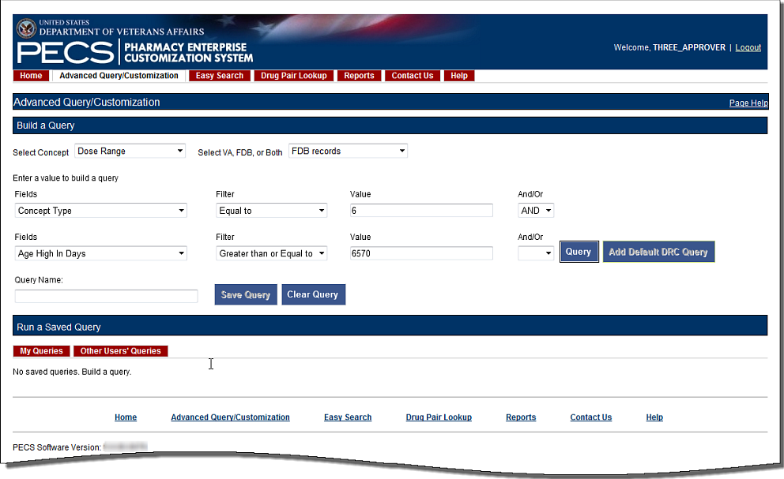

Figure : Results from Building a Dose Range Query with Default DRC Query

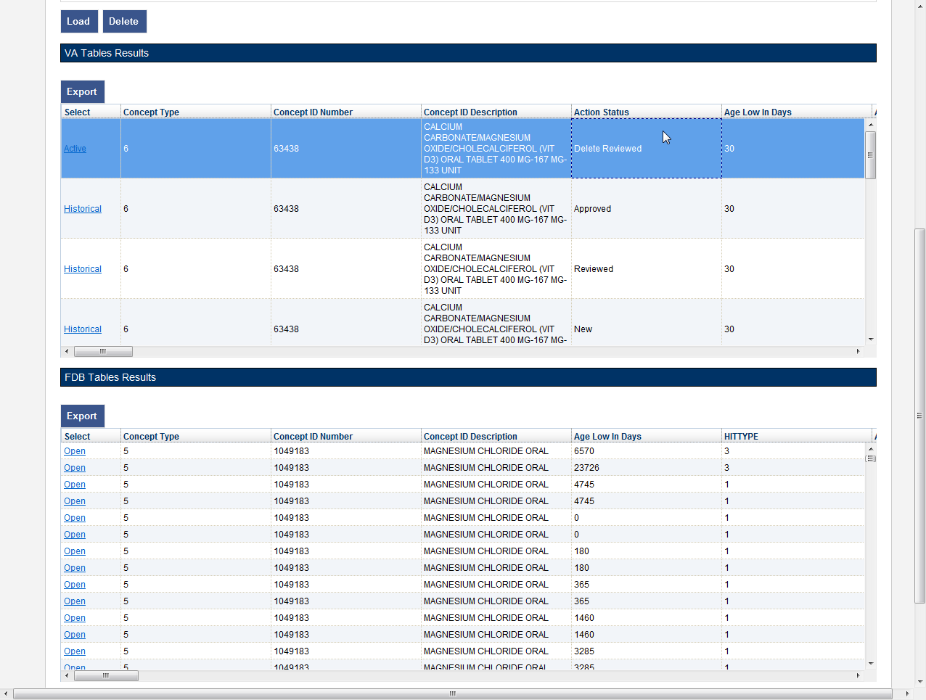

## Save a Query

PECS allows you to save a complete query so that you and other PECS users can run a specific query without having to re-build it every time.

**Note:** The state of the Historical Records check box will not be saved with the query; if desired, it must be re-selected after the query is loaded at run-time.

To save a query:

1. Create and run a query in the Build a Query panel. See Build a Query Panel for additional information.

Enter a name for the query in the Query Name field. The name must contain at least five characters and cannot be longer than 64 characters.

Click Save Query.

## Run a Saved Query

PECS allows you to run a previously saved query with the same Concept and content (VA, FDB, or Both). There are two types of saved queries: My Queries (those that you have saved) or Other Users’ Queries (queries saved by other PECS users).

To run a saved query:

1. On the Advanced Query/Customization tab, select a Concept.
2. Select what data you want to view-- VA, FDB, or Both.
3. In the Run a Saved Query sub-panel, select either My Queries or Other Users’ Queries, then select the query you want to run.
4. Click the Load button. This will add the components of the saved query to the Build a Query panel.

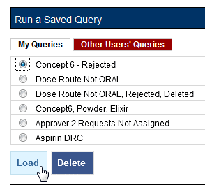

1. Click the Query button to run the query. You may also select additional criteria to alter or enhance the saved query.

## Rename a Saved Query

A saved query can be renamed by loading it then adding a different name in the Query Name field.

To rename a saved query:

1. On the Advanced Query/Customization tab, select a Concept.
2. Select what data you want to view-- VA, FDB, or Both.
3. In the Run a Saved Query sub-panel, select My Queries; you cannot rename a saved query created by another user.
4. Enter a new the Query Name field.
5. Click Save Query. The new query name will appear in the My Queries list in place of the original query.

## Delete a Saved Query

You can delete queries you have created and saved. Note that the delete operation is immediate; you will not be warned that the query is about to be deleted and there is no undo option.

To delete a Saved Query:

1. On the Advanced Query/Customization tab, select a Concept.
2. Select what data you want to view-- VA, FDB, or Both.
3. In the Run a Saved Query sub-panel, select My Queries; you cannot delete a query that was created by another user, then select the query you want to delete.
4. Click the Delete button. The query is deleted.

## Query Results

The results of the query will appear in either one or two panels: VA Table Results or FDB Table Results, depending on the type of records being queried. The results can be re-ordered, sorted by specific criteria, and exported.

Figure : Example Query Results

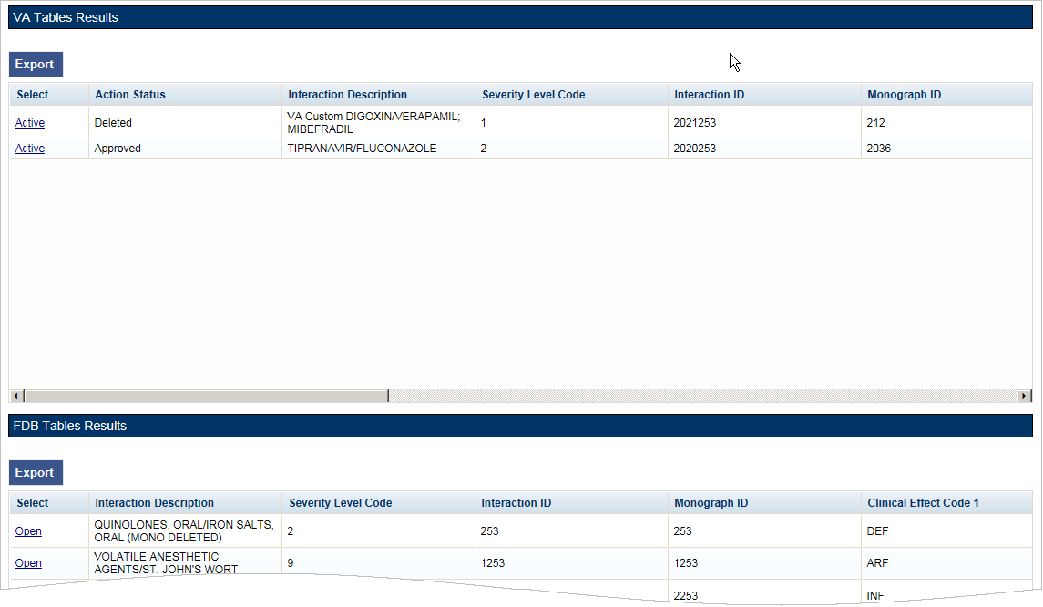

### Sort Query Results

You can change the sort order of results of your query by clicking on the column headings in the display grid. Clicking once will display the records in ascending order (A to Z, 1-2-3 etc.) based on the contents of the column of the header you clicked; clicking a second time display the records in descending order (Z to A, 3-2-1, etc.). A small arrow indicates the direction of the current sort and the primary sort field.

Figure : Sort Direction Indicator

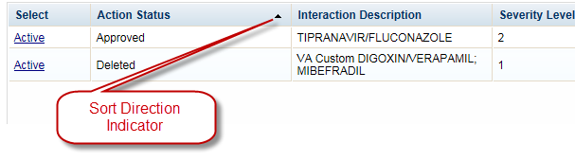

For VA records, the default sort order is by ‘Action Date’, from newest to oldest. This puts the VA Customizations that have been updated most recently at the top of the returned list. By default, FDB records are displayed in the order they appeared in the update file sent by FDB. However, they can be re-sorted by clicking a column header.

**Note:** Due to technical database restrictions, not all fields can be used to determine the sort order. For example, Concept ID Description on a Dose Range query cannot be used to sort the query results. Clicking these columns will have no result and the current sort order will be retained

### Re-Order Results Columns

You can also move the columns in these tables and compare different fields side-by-side. Click the heading and drag and drop it:

Figure : Dragging a Column to a New Position

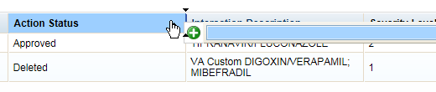

Figure : Re-positioned "Severity Level Code" Column

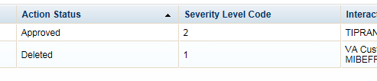

## Export Query Results

You can export query results for both VA and FDB records to an Excel spreadsheet.

To export the query results:

1. On the appropriate query results panel, click the Export button.

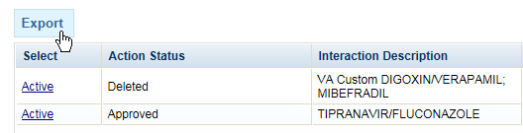

1. Select one of the following options from the dialog box:
   1. Open
   2. Save
   3. Cancel
2. Click Open to display the exported data in the spreadsheet; click Save to save a copy of the report to your system, or Cancel to abandon the export operation.



1. The spreadsheet contains two tabs:
2. The [Name of Concept] tab (either VA or FDB) displays the results of the query.

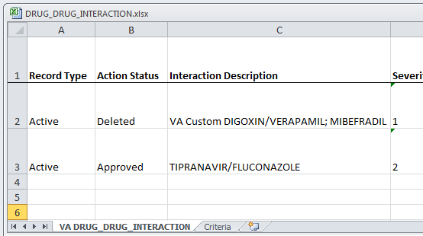

1. The Criteria tab displays the criteria used in the query.

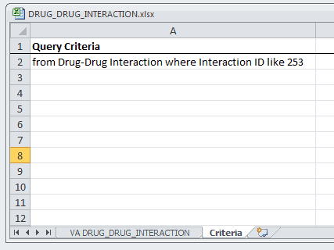

For Drug-Drug Interaction, Drug Pair, Professional Monograph, and Duplicate Therapy records, there is a 1,000,000 line limit for exporting to the spreadsheet; for Dose Range records, the limit is 100,000. If your query returned more than the allowable number of records and you submitted the records for export anyway, the Criteria tab on the report gives you the following message: “The number of rows returned in the search (XXXXXX) is greater than the maximum number of rows that can be exported (YYYYYY).”

Figure : Export Query Line Limit Message

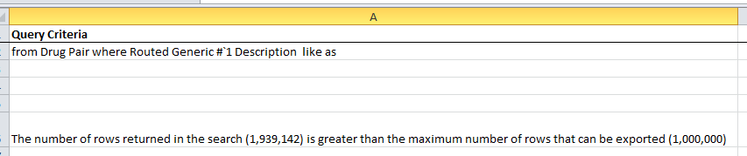

## Query Errors

After running your query, and error message may appear in the Results panel. This is usually caused by one of the following:

Figure : Generic Query Error



Database Timeout (Too Many Results)

The database may timeout if the query produces too many results. If you’re getting this error frequently, try re-writing your queries to be more specific or add additional criteria that will limit the results when possible.

Inappropriate Value

Entering a value that is not appropriate for the selected Field and Filter will also produce an error message in the Results panel. For example Export Date > “Z” produces an error because “Z” is not a date value.

*(This page included for two-sided copying.)*

# Working with Customization Requests

As suggested by the name of the application (Pharmacy Enterprise *Customization* System), customizations are the primary focus of PECS. The process of creating a customization may involve many steps, but the process is relatively simple. In its simplest, “happy path” form, the workflow consists of three steps:

1. Customization is Requested
2. Request is Reviewed
3. Request is Approved

## Create a Customization Request

The process for creating a customization request varies with the concept type you are customizing. Customization requests can be made by either Requestor or Approver users.

### Customize a Drug-Drug Interaction Record

Customizing a Drug-Drug Interaction record is more complicated than other record types in that you must also select and customize Drug Pairs associated with the record.

To customize a Drug-Drug Interaction record:

1. Find the Drug-Drug Interaction record you want to customize in the FDB database using Advanced Query/Customization. See Using Advanced Query/Customization for additional information.
2. Click the Open link next to the record you want to customize.
3. Click the Edit button.
4. Make changes to the record. At minimum, you must add text in the Current Action Reason field.
5. Click Customize. The system will inform you that the customization request has been entered and will be reviewed and that the Drug Pairs have not been approved or that no Drug Pairs have been associated.
6. Click the Drug Pairs button.
7. Associate one or more drug pairs with the customized Drug-Drug Interaction. See Drug Pair Customization (Non 508-Compliant) Detail for additional information.
8. All the components are now in place for the Drug-Drug Interaction record for review and approval.

### Customize Other Record Types

Customizing Professional Monograph, Duplicate Therapy, and Dose Range records is relatively straight-forward; there are no associated records (as in Drug-Drug Interactions) that must be modified or selected.

To customize a Professional Monograph, Duplicate Therapy, or Dose Range record:

1. Find the record you want to customize in the FDB database using Advanced Query/Customization. See Using Advanced Query/Customization for additional information.
2. Click the Open link next to the record you want to customize.
3. Click the Edit button.
4. Make changes to the record. At minimum, you must add text in the Current Action Reason field.
5. Click Customize. The system will inform you that the customization request has been entered and will be reviewed.

### Create Customization from a Blank Form

You can create a new record using the Open Blank Form button. This method can be used to create new Drug-Drug Interaction, Professional Monograph, and Dose Range records. It cannot be used to create a Duplicate Therapy record.



To Create a New Record:

1. Perform an Advanced Query/Customization Query for the record type (Concept) on both VA and FDB Records you want to create.
2. Click the Open Blank Form button at the bottom of the page.
3. Complete the form with as much information as possible. Fields marked as Required must be completed before the record can be saved. Some record types (concepts) have other requirements that must be met before the record can be created. See New Record Requirements by Concept Type for additional information.

New Record Requirements by Concept Type

Some records have specific requirements for new records that are not indicated by the Required label.

Drug-Drug Interaction

* For a completely new record, the interacting drugs must be separated by a forward slash (/) character.

Professional Monograph

* Custom Professional Monographs can be associated with Drug-Drug Interactions once they are Approved.

Dose Range

* Concept Type can only be 6.
* The Concept ID Number must correspond to an existing FDB record for Concept Type 6.

Duplicate Therapy

* New Duplicate Therapy records *cannot* be created using this method. A new Duplicate Therapy customization must be made on the Advanced Query/Customization page.

Drug Pairs

* New Drug Pair records *cannot* be created using this method. A new Drug Pair can be added by selecting routed generic drugs associated with a drug-drug interaction.

## Modify Customization Requests

Customization requests can be modified at any time. If a required field is changed (other than Current Action Reason), the customization Action Status will change to Modified; non-required fields do not affect Action Status. Requestors can modify customizations they have requested, but cannot modify customizations requested by other users. Approvers can modify any record at any time. Release Managers and Administrator cannot modify customization requests.

Note Although the Edit button will appear on customization requests for Release Managers and Administrators (and for Requestors viewing requests other than their own), there is no way to save any changes made.

To modify a customization request:

Find the record you want to modify in the VA database using Advanced Query/Customization. See Using Advanced Query/Customization for additional information. You can also use the links on your Home page to locate records for processing. See Record Locking Feature

Records from all five concept types (Drug-Drug Interaction, Drug Pairs, Professional Monograph, Dose Range, and Duplicate Therapy) can be edited only by a single user at a time. If more than one user attempts to edit the same record at the same time, the user who entered the record first will have precedence and the subsequent users will receive a message that the record is in-use and cannot be edited at the current time.

Figure 30: Record in Use

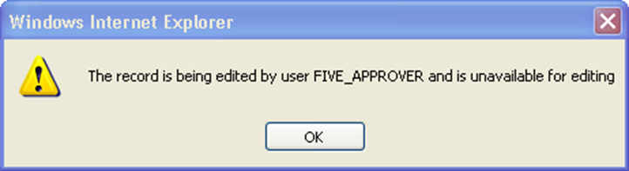

If you have opened a record that has been modified by another user while you are looking at it, PECS will warn you that the data is stale. Click OK to load the modified record.

Figure 31: Record Recently Modified

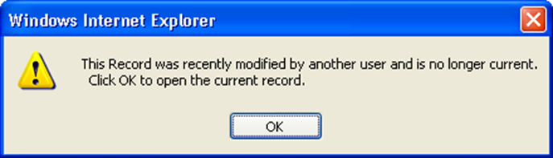

To prevent the record from being locked for too long a time, the lock will be automatically removed if no edits are done in two consecutive minutes. Click OK to continue editing the record.

Figure 32: Editing Time-Out Warning

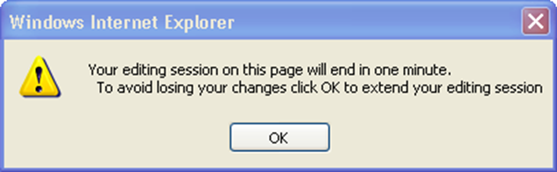

If you navigate away from an un-saved record, a warning dialog box will appear. Click Cancel to continue editing the page; click OK to return to the read-only display.

Figure 33: Re-navigation Causing Loss of Changes Warning

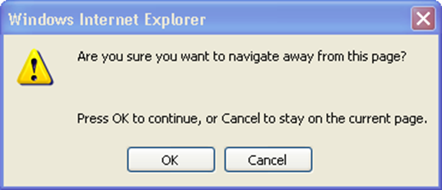

1. User Roles and Tasks and the Home page section related to your PECS role for additional information.
2. Click the Active link next to the record you want to modify.
3. Click the Edit button.
4. Make changes to the record. At minimum, you must add text in the Current Action Reason field.
5. Click Modify to save your changes. Click Cancel Edit to abandon your changes and return to the detail page.

## Review Customization Requests

Review is the second step to getting a customization Approved. A Review must be performed by an Approver. Approvers cannot Review customization requests they have created and cannot Approve customization requests they have Reviewed.

To Review a customization request:

Find the record you want to Review in the VA database using Advanced Query/Customization. See Using Advanced Query/Customization for additional information. You can also use the links on your Home page to locate records for processing. See Record Locking Feature

Records from all five concept types (Drug-Drug Interaction, Drug Pairs, Professional Monograph, Dose Range, and Duplicate Therapy) can be edited only by a single user at a time. If more than one user attempts to edit the same record at the same time, the user who entered the record first will have precedence and the subsequent users will receive a message that the record is in-use and cannot be edited at the current time.

Figure 30: Record in Use



If you have opened a record that has been modified by another user while you are looking at it, PECS will warn you that the data is stale. Click OK to load the modified record.

Figure 31: Record Recently Modified



To prevent the record from being locked for too long a time, the lock will be automatically removed if no edits are done in two consecutive minutes. Click OK to continue editing the record.

Figure 32: Editing Time-Out Warning



If you navigate away from an un-saved record, a warning dialog box will appear. Click Cancel to continue editing the page; click OK to return to the read-only display.

Figure 33: Re-navigation Causing Loss of Changes Warning



1. User Roles and Tasks and the Home page section related to your PECS role for additional information.
2. Click the Active link next to the record you want to Review.
3. Click the Edit button.
4. Review the customization request to be certain it meets your approval.
5. Click Submit as Reviewed to save your changes. Click Cancel Edit to abandon your review and return to the detail page.

## Approve Customization Requests

An Approved customization request is considered valid and should be used in making decisions in veteran pharmaceutical care. Approved customization requests are included in the Custom Updates that are distributed to other pharmacy applications, and are used in Order Checks for veteran prescriptions.

Customization requests are Approved by Approvers. Approvers cannot Approve customization requests they Reviewed; they can Approve customization requests they created once they have been Reviewed by another Approver.

To Approve a customization request:

Find the record you want to Review in the VA database using Advanced Query/Customization. See Using Advanced Query/Customization for additional information. You can also use the links on your Home page to locate records for processing. See Record Locking Feature

Records from all five concept types (Drug-Drug Interaction, Drug Pairs, Professional Monograph, Dose Range, and Duplicate Therapy) can be edited only by a single user at a time. If more than one user attempts to edit the same record at the same time, the user who entered the record first will have precedence and the subsequent users will receive a message that the record is in-use and cannot be edited at the current time.

Figure 30: Record in Use



If you have opened a record that has been modified by another user while you are looking at it, PECS will warn you that the data is stale. Click OK to load the modified record.

Figure 31: Record Recently Modified



To prevent the record from being locked for too long a time, the lock will be automatically removed if no edits are done in two consecutive minutes. Click OK to continue editing the record.

Figure 32: Editing Time-Out Warning



If you navigate away from an un-saved record, a warning dialog box will appear. Click Cancel to continue editing the page; click OK to return to the read-only display.

Figure 33: Re-navigation Causing Loss of Changes Warning



1. User Roles and Tasks and the Home page section related to your PECS role for additional information.
2. Click the Active link next to the record you want to Approve.
3. Click the Edit button.
4. Review the record to be certain it meets your approval.
5. Click Approve to save your changes. Click Cancel Edit to abandon your changes and return to the detail page.

## Reject Customization Requests

Customization requests can be Rejected at all points of the Create/Review/Approve process. Customization requests are Rejected because they are thought to be invalid as written by either the Reviewer or Approver. Customization requests can also be Rejected by the user who initiated the customization request if they determine that request is no longer needed. Rejected customization requests can be modified and re-submitted for Review and Approval.

To Reject a customization request:

Find the record you want to Review in the VA database using Advanced Query/Customization. See Using Advanced Query/Customization for additional information. You can also use the links on your Home page to locate records for processing. See Record Locking Feature

Records from all five concept types (Drug-Drug Interaction, Drug Pairs, Professional Monograph, Dose Range, and Duplicate Therapy) can be edited only by a single user at a time. If more than one user attempts to edit the same record at the same time, the user who entered the record first will have precedence and the subsequent users will receive a message that the record is in-use and cannot be edited at the current time.

Figure 30: Record in Use



If you have opened a record that has been modified by another user while you are looking at it, PECS will warn you that the data is stale. Click OK to load the modified record.

Figure 31: Record Recently Modified



To prevent the record from being locked for too long a time, the lock will be automatically removed if no edits are done in two consecutive minutes. Click OK to continue editing the record.

Figure 32: Editing Time-Out Warning



If you navigate away from an un-saved record, a warning dialog box will appear. Click Cancel to continue editing the page; click OK to return to the read-only display.

Figure 33: Re-navigation Causing Loss of Changes Warning



1. User Roles and Tasks and the Home page section related to your PECS role for additional information.
2. Click the Active link next to the record you want to Reject.
3. Click the Edit button.
4. Review the customization request to be certain it is invalid and cannot continue in the Review/Approval process without modification.
5. Click Reject to save your changes. Click Cancel Edit to abandon the Reject process and return to the detail page.

## Delete Customization Requests

If an Approved customization is no longer valid, and should not be used in Order Check decisions, it must be deleted. Deleting a customization request will not remove it from the PECS system, but will remove it from MOCHA during the next Custom Update. Deleted records can be edited and re-submitted for Review and Approval.

Deleting an Approved customization request is a two-step process. One user with Approver privileges must request that the record be deleted, and then a second user with Approver privileges must delete the record. At any time during this process, prior to actual deletion, the deletion request can be Rejected.

To Delete a Customization Request:

Find the record you want to Review in the VA database using Advanced Query/Customization. See Using Advanced Query/Customization for additional information. You can also use the links on your Home page to locate records for processing. See Record Locking Feature

Records from all five concept types (Drug-Drug Interaction, Drug Pairs, Professional Monograph, Dose Range, and Duplicate Therapy) can be edited only by a single user at a time. If more than one user attempts to edit the same record at the same time, the user who entered the record first will have precedence and the subsequent users will receive a message that the record is in-use and cannot be edited at the current time.

Figure 30: Record in Use



If you have opened a record that has been modified by another user while you are looking at it, PECS will warn you that the data is stale. Click OK to load the modified record.

Figure 31: Record Recently Modified



To prevent the record from being locked for too long a time, the lock will be automatically removed if no edits are done in two consecutive minutes. Click OK to continue editing the record.

Figure 32: Editing Time-Out Warning



If you navigate away from an un-saved record, a warning dialog box will appear. Click Cancel to continue editing the page; click OK to return to the read-only display.

Figure 33: Re-navigation Causing Loss of Changes Warning



1. User Roles and Tasks and the Home page section related to your PECS role for additional information.
2. Click the Active link associated with the request you want to Delete.
3. Click the Edit button.
4. Review the content. If you are satisfied that the request should be deleted, write a brief explanation in the Current Action Reason field.
5. Click the Submit for Delete button.
6. A confirmation pop-up will appear. Click OK to continue the deletion process; this will change the Action Status to Delete Reviewed. Click Cancel to return to Edit mode.

Now another Approver can confirm the Delete Reviewed customization request for deletion, and complete the process.

To confirm a Delete Reviewed customization request for deletion:

1. Find the record you want to delete using Advanced Query/Customization or from your PECS Home page (in My Requests for Deletion).
2. Click the active link associated with the request you want to Delete.
3. Click Edit.
4. Enter a comment for agreeing with the Request for Deletion.
5. Click Delete.
6. A confirmation pop-up will appear. Click OK to complete the deletion process; this will change the Action Status to Deleted. Click Cancel to return to Edit mode.

## Record Locking Feature

Records from all five concept types (Drug-Drug Interaction, Drug Pairs, Professional Monograph, Dose Range, and Duplicate Therapy) can be edited only by a single user at a time. If more than one user attempts to edit the same record at the same time, the user who entered the record first will have precedence and the subsequent users will receive a message that the record is in-use and cannot be edited at the current time.

Figure : Record in Use



If you have opened a record that has been modified by another user while you are looking at it, PECS will warn you that the data is stale. Click OK to load the modified record.

Figure : Record Recently Modified



To prevent the record from being locked for too long a time, the lock will be automatically removed if no edits are done in two consecutive minutes. Click OK to continue editing the record.

Figure : Editing Time-Out Warning



If you navigate away from an un-saved record, a warning dialog box will appear. Click Cancel to continue editing the page; click OK to return to the read-only display.

Figure : Re-navigation Causing Loss of Changes Warning



# User Roles and Tasks

PECS users have one of four roles within the application, each with specific tasks they perform.

* Requestor
* Approver
* Release Manager
* Administrator

## Requestor

The primary task of a PECS Requestor is to create customization requests. The Requestor has limited privileges; while they can only view all customization requests, they can only modify the customization requests they created themselves. The Requestor Home Page reflects this limited privilege and only 1-click access to the Requestor’s own customizations (My Request History).

A Requestor performs the following tasks related to customization requests:

* Create a Customization Request
* Modify Customization Requests

### Requestor Home Page

The Home Page for the Requestor role only displays links to the customization requests made by the current user.

Figure : Requestor’s Home Page

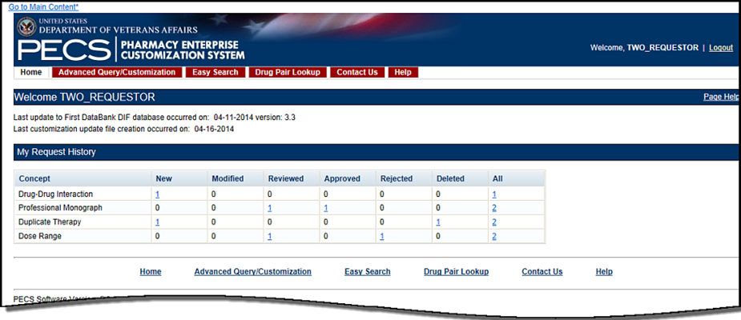

The following information is displayed on the Requestor Home tab:

* My Request History

### My Request History: Requestor

My Request History displays customization requests created by the current user. The results are displayed by Action Status of the requests.

Figure : My Request History

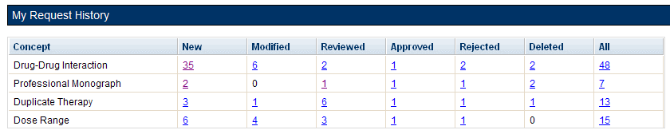

The following table defines the columns found on the My Request History window.

Table : My Request History Columns

| Column Name | Column Definition |
| --- | --- |
| New | The number of active records in the "New" status created by the current user. |
| Modified | The number of active records in the "Modified" status created by the current user. |
| Reviewed | The number of active records in the "Reviewed" and "Delete Reviewed" status created by the current user. |
| Approved | The number of active records in the "Approved" status created by the current user. |
| Rejected | The number of active records in the "Rejected" status created by the current user. |
| Deleted | The number of active records in the "Deleted" status created by the current user. |
| All | The number of all active records in any status, created by the current user. |

Clicking the links within the summary table open pre-defined queries to provide details of the requests. For example, clicking the New - Professional Monograph link will display a query with the appropriate criteria and the query results: Concept = Professional Monograph, Request Submitted By = <current user>, Action Status = New.

Figure : Home Tab Summary - Pre-Defined Query

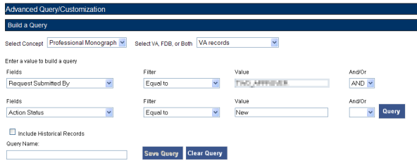

Figure : Query Results

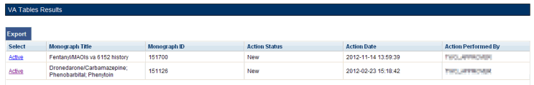

### Additional Tools Available to Requestors

In addition to the Home tab, Requestors see the following tabs on their Home page:

* Advanced Query/Customization – See Using Advanced Query/Customization for additional information.
* Easy Search – see Easy Search for additional information.
* Drug Pair Lookup – see Drug Pair Lookup for additional information.
* Contact Us – see Contact Us for additional information.
* Help – see Online Help for additional information.

## Approver

The PECS Approver creates and processes customization requests. In addition to being able to request a customization themselves, they can also Review, Modify, Reject, Approve, and Delete customization requests made by other PECS users.

An Approver performs the following tasks related to customization requests:

* Create a Customization Request
* Modify Customization Requests
* Review Customization Requests
* Approve Customization Requests
* Reject Customization Requests
* Delete Customization Requests

### Approver Home Page

The Home Page for the Approver role displays links to customization requests in many different states:

* Customization requests made by the current user (My Request History: Approver)
* Customization requests made by other users that are assigned to the current user for review (My Assigned Requests for Review)
* Customization requests made by other users that are assigned to the current user for approval (My Assigned Requests for Approval)
* Customization requests made by other users that are assigned to the current user for deletion (My Assigned Requests for Deletion)
* Customization requests made by other users that are not currently assigned to an Approver (Unassigned Requests)
* Customization requests made by any user in any state (All Requests)

Figure : Approver's Home Page

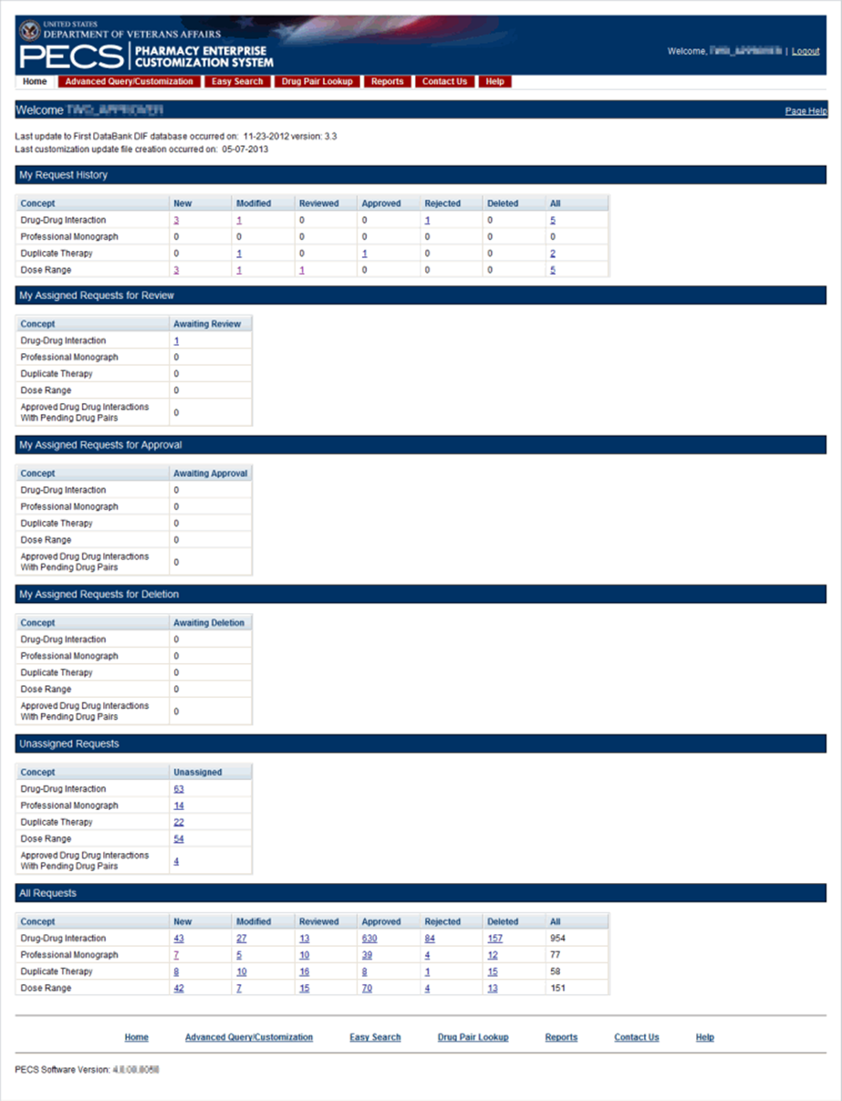

### My Request History: Approver

My Request History displays active customization records created by the current user (Requestor and Approver roles only). The results will be broken down into numbers of active records, created by the current user by the following Action Statuses: New, Modified, Reviewed, Approved, Rejected, Deleted and All.

Figure : My Request History



The following table defines the columns found on the My Request History window.

Table : My Request History Columns

| Column Name | Column Definition |
| --- | --- |
| New | The number of active records in the "New" status created by the current user. |
| Modified | The number of active records in the "Modified" status created by the current user. |
| Reviewed | The number of active records in the "Reviewed" and "Delete Reviewed" status created by the current user. |
| Approved | The number of active records in the "Approved" status created by the current user. |
| Rejected | The number of active records in the "Rejected" status created by the current user. |
| Deleted | The number of active records in the "Deleted" status created by the current user. |
| All | The number of all active records in any status, created by the current user. |

Clicking the links within the summary table open pre-defined queries to provide details of the requests. For example, clicking the New - Professional Monograph link will display a query with the appropriate criteria and the query results: Concept = Professional Monograph, Request Submitted By = <current user>, Action Status = New.

Figure : Home Tab Summary - Pre-Defined Query



Figure : Query Results



### My Assigned Requests for Review

My Assigned Requests for Review are active customization records assigned to the current user to be reviewed. The Awaiting Review count is the number of records that are in the "New" or "Modified" status, that have been assigned to the current user for review. To see the records, click the corresponding link.

Figure : My Assigned Request for Review Example

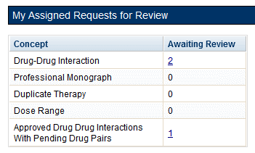

### My Assigned Requests for Approval

My Assigned Requests for Approval are active customization records assigned to the current user to be approved. These records have been reviewed by another Approver. To see the records, click the corresponding link.

Figure : Approver's List of Requests for Approval

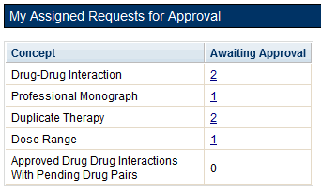

### My Assigned Requests for Deletion

My Assigned Requests for Deletion are active customization records assigned to the logged in user to be deleted. The records have been "delete reviewed" by another "Approver" in the system. To see the records, click the corresponding link.

Figure : Approver's List of Requests for Deletion

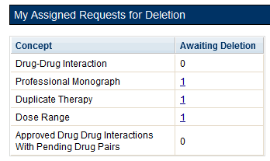

### Unassigned Requests

Unassigned Requests are either New, Modified, or Reviewed customization requests that have not been assigned to any user. To see the records, click the corresponding link.

Figure : Approver's List of Unassigned Requests

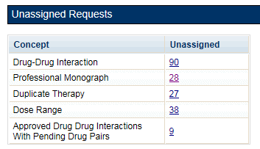

### All Requests

All Requests displays all customization requests currently in the system by Action Status. The result detail will display the active records associated with the selected custom table summary.

The categories are:

Table : All Request Columns

| Column Name | Column Definition |
| --- | --- |
| New | The number of active records in the "New" status. |
| Modified | The number of active records in the "Modified" status. |
| Reviewed | The number of active records in the "Reviewed" and "Delete Reviewed" status. |
| Approved | The number of active records in the "Approved" status. |
| Rejected | The number of active records in the "Rejected" status. |
| Deleted | The number of active records in the "Deleted" status. |
| All | The number of all active records in any status. |

### Additional Tools Available to Approvers

In addition to the Home tab, Approvers see the following tabs on their Home page:

* Advanced Query/Customization – See Using Advanced Query/Customization for additional information.
* Easy Search – see Easy Search for additional information.
* Drug Pair Lookup – see Drug Pair Lookup for additional information.
* Reports – see Reports for additional information.
* Contact Us – see Contact Us for additional information.
* Help – see Online Help for additional information.

## Release Manager

The primary task of a PECS Release Manager is to create Custom Updates. Since they are not directly involved in the creation or processing of customization requests, the customization-related panels that appeared on the Requestor and Approver Home Pages do not appear on the Release Manager Home page.

Custom Updates are created at the instruction of the PECS Administrator and/or the National Drug File (NDF) Support Group. Once the Custom Update has been created, the Release Manager should send an Outlook email to the PECS Administrators.

### Release Manager Home Page

The Home Page for the Release Manager does not display links associated with customization requests.

Figure : Release Manager's Home Page

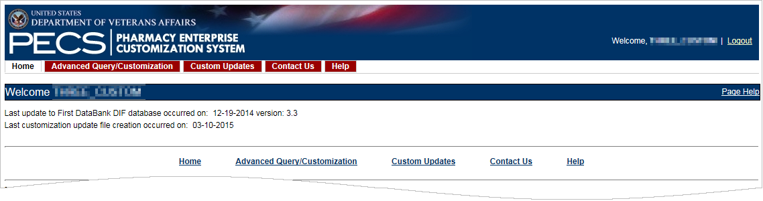

### Custom Update Tab

The Custom Update tab contains the Release Manager-specific functions and is available only to PECS Release Managers.

Figure : The Custom Update Tab

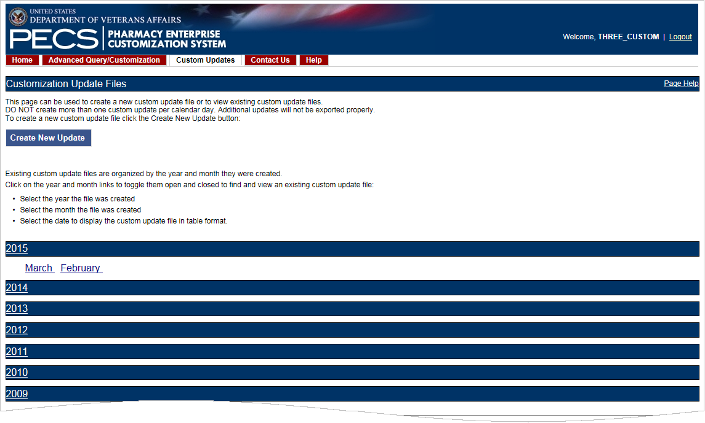

### Custom Update Overview

A Custom Update is a set of files that

* Transmit Approved customization requests to MOCHA (via DATUP) so that the customizations can be used in Order Check decisions.
* Transmit contain Deleted customization requests so that previously approved customizations can be removed from the MOCHA Order Check decision process
* Transmit updates received from FDB

### Update Files Explained

A Custom Update produces two files. The Full Custom Update includes the entire FDB data distribution. The Incremental Update file contains updates from FDB to their database, as well as Approved and Deleted customizations from PECS. These updates will be incorporated in the national and regional databases for use in order check decisions (MOCHA).

Custom Update files use the following file naming standard:

CstmUpdFile_{FDB Version}.{PECS Generated Version Number}_{Date/Time Stamp}.zip

For example, the CstmUpdFile_3.2.751_20120503154622.zip has an FDB Version number of "3.2," a PECS-generated Version Number of "751," and was created on May 3, 2012 at 15:46:22 (military time). The contents of the zip file will determine if this is an Incremental or a Full update.

Incremental Update File

The Incremental Update File contains just the updates delivered by FDB and Approved and Deleted customizations from PECS. The custom zip file contains a proddefinition.xml, FDBPRODCONTROL.DAT and several data files that have an extension of UPD.

Figure : Custom Update Zip File

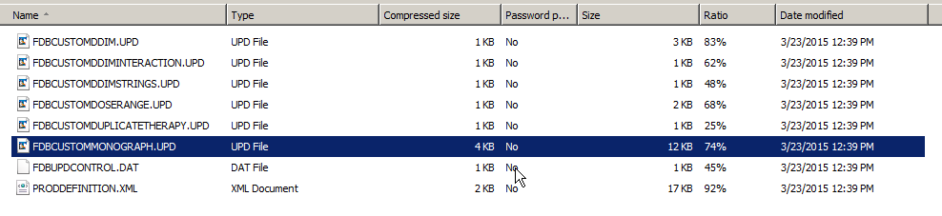

The proddefinition.xml file is a file from FDB that defines the table structures for the FDB tables in an XML format. The FDBUPDCONTROL.DAT file contains control information used by the FDB Data Updater software when determining if this Incremental update should be applied to a database. The UPD files contain data updates for a particular FDB table in the database.

Here is a sample: Note that the “D”, “C”, and “A” in the left column mean Delete, Change, and Add, respectively.

Figure : Custom Update Text File

H|fdb_custom_ddim|44|0|2|3.3|W|20150320|USA

F|10|1|rtgenid1|2|rtgenid2|3|interactionid|4|seqno|5|uicategory1|6|uicategory2|7|uicategory3|8|uicategory4|9|uicategory5|10|uicategory6

P|4|1|2|3|4

D|1051388|1052759|2021496|1

D|1052759|1051388|2021496|2

A|2102962|1050197|2021486|1|'VA'|''|''|''|''|''

A|1050197|2102962|2021486|2|'VA'|''|''|''|''|''

A|11538519|12584957|2021486|1|'VA'|''|''|''|''|''

A|12584957|11538519|2021486|2|'VA'|''|''|''|''|''

A|11538519|23070717|2021486|1|'VA'|''|''|''|''|''

A|23070717|11538519|2021486|2|'VA'|''|''|''|''|''

A|11538519|1050621|2021486|1|'VA'|''|''|''|''|''

Full Update File

The Full Update File contains the complete FDB distribution. The files are:

* CTVERSION.TXT
* FDBCUSTOMDDIM.TXT
* FDBCUSTOMDDIMINTERACTION.TXT
* FDBCUSTOMDDIMSTRINGS.TXT
* FDBCUSTOMDOSERANGE.TXT
* FDBCUSTOMDUPLICATETHERAPY.TXT
* FDBCUSTOMMONOGRAPH.TXT
* FILECOUNTS.DAT
* PRODDEFINITION.XML

Here is a sample of the full update of Drug-Drug Interactions:

Figure : Custom Drug-Drug Interaction Full Update File

1048627|1050000|2004892|1|VA|||||

1050000|1048627|2004892|2|VA|||||

1048627|1050001|2004892|1|VA|||||

1050001|1048627|2004892|2|VA|||||

1048627|1050014|2004892|1|VA|||||

1050014|1048627|2004892|2|VA|||||

1048627|1050015|2004892|1|VA|||||

1050015|1048627|2004892|2|VA|||||

1048627|1052651|2004892|1|VA|||||

1052651|1048627|2004892|2|VA|||||

1048627|23070090|2004892|1|VA|||||

23070090|1048627|2004892|2|VA|||||

### Create a Custom Update

Note: Custom Updates can be only be created by Release Managers

To create a Custom Update:

1. Click the Custom Updates tab:
2. Click Create New Update:
3. After processing, the two new update files will appear in the list.

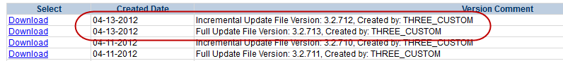

1. Verify today’s date in Created Date column. The dates in the Created Date column should match the current date.
2. If an error message is received, report it to PECS Administrator. See Contact Us for additional information.

### Review Custom Update History

The existing Custom Updates are organized by Year and Month. Click the Year to display the months containing custom updates for that year, then click a month to display the custom updates performed during that month. The custom updates for more than one month can be displayed simultaneously. Clicking a month a second time will collapse (hide) the custom updates for that month.

Figure : Existing Custom Updates by Year and Month

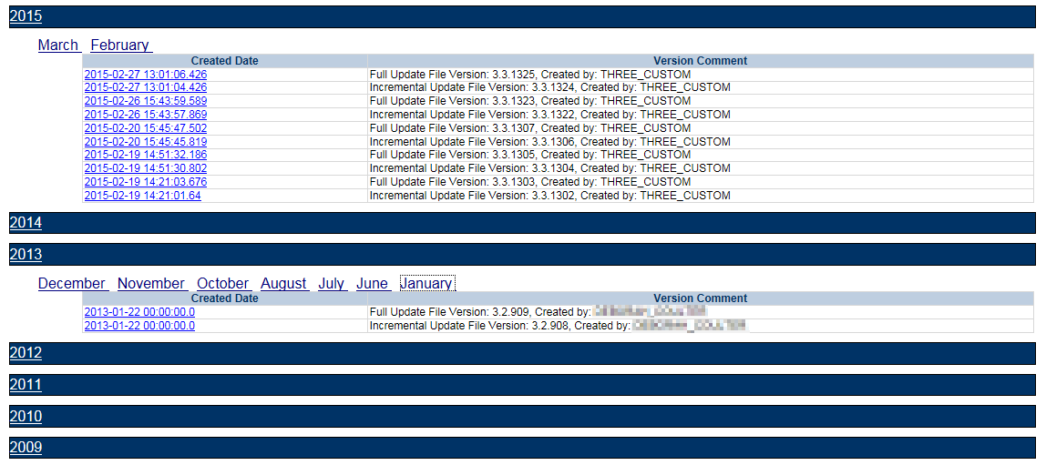

### Additional Tools Available to Release Managers

In addition to the Home tab and Custom Updates, Release Managers role see the following tabs on their Home page:

* Advanced Query/Customization – See Using Advanced Query/Customization for additional information.
* Contact Us – see Contact Us for additional information.
* Help – see Online Help for additional information.

## Administrator

The PECS Administrator performs limited maintenance on the PECS system through the Administration tab. The administrator can modify the page display for the PECS records (both FDB and VA). Demote existing Approvers, remove Null Drug Pairs, and change what is displayed on the Contact Us page. The Administration tab displayed only to Administrator users.

Since they are not directly involved in the creation or processing of customization requests, the customization-related panels that appeared on the Requestor and Approver Home Pages do not appear on the Administrator Home page.

The unique tasks performed by an Administrator are:

* Customize Settings
* Change Field Display Order
* Null Drug Pair Removal Process
* Editing Contact Us

Most Administrator functions are performed on the Administration tab. Editing the Contact Us page occurs on the Contact Us page itself.

### Administrator Home Page

The Home Page for the Administrator does not display links associated with customization requests.

Figure : Administrator's Home Page



### Administration Tab

The Administration tab contains most of the Administrator-specific functions and is available only to PECS Administrators.

Figure : The Administration Tab

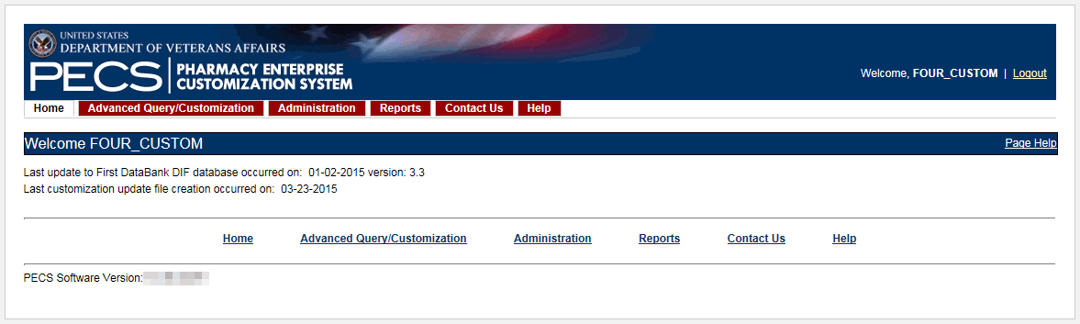

### Customize Settings

The Customize Settings panel allows Administrators to change the label name for the Field (Display Name), and whether the field should appear in Queries, Detail Pages, and Reports. It also allows you to change the order the individual fields are displayed on their respective pages.

To access Customize Settings:

1. Log in as an Administrator.

Click the Administration tab.

Click the appropriate concept to change the way data appears in relation to that concept.

Figure : The Customize Setting Panel

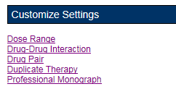

Customize Settings Table Description

There are currently five Customize Settings pages, one for each concept: Drug Pair, Drug-Drug Interaction, Dose Range, Duplicate Therapy and Professional Monograph.

Table : Customize Table Settings Columns

| Column | Description |
| --- | --- |
| Name | Name is the database field name for items displayed for the selected concept. Name cannot be changed; it identifies the field in the database table. |
| Display Name | Display Name is what appears within PECS for the field defined by the entry in the Name column. The contents of Display Name will appear in query selection, data entry field and reports for the selected table. |
| Display in Query | Display in Query allows you to set if the field will be displayed in the Advance Query/Customization results tables. Some fields are required and cannot be turned off. |
| Display in Details | Display in Details allows you to set if the field will be displayed on the Detail page of the selected concept. |
| Include in Reports | Include in Reports allows you to set if the field will be displayed in any applicable reports. |
| Display Order | A numeric value designating the order the field will be displayed in. |

**Warning:** Changes made on the Settings page will affect all PECS users. Please proceed cautiously.

Figure : Customize Settings Example (Drug Pairs)

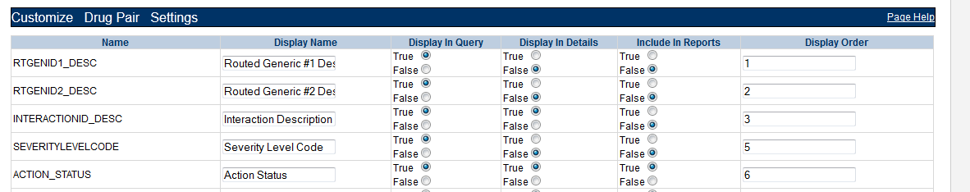

Change Field Display Name

To change how the name of a field is displayed on the page, modify the contents of the Display Name field.

1. In the Customize <Concept> List, find the name of the database field you want to change.
2. Modify the contents of the field in the Display Name column.
3. Repeat the process as necessary.
4. Click Save to save your changes; click Cancel to abandon the changes and return to the Settings page.

**Note:** Cancel is immediate; you will not be warned that you are about to lose your changes.

Add/Remove Field from Query Options

To add (or remove) a field from Query options

1. In the Customize <Concept> List, find the name of the database field you want to change.
2. In the Display in Query column, select True to display the field in Query options, select False to prevent the field from displaying in Query options.

**Note:** “Display in Query” options are not available for all fields; some fields are explicitly required to be displayed in the Query options while others are forbidden from being displayed. In these cases, the required display option (True or False) will be the only options displayed and cannot be changed.

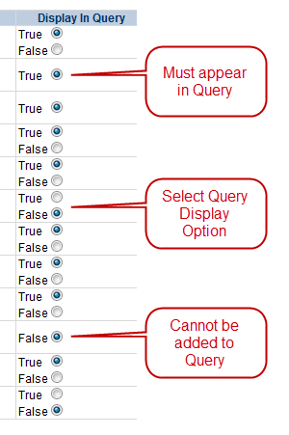

1. Repeat the process as necessary.
2. Click Save to save your changes; click Cancel to abandon the changes and return to the Settings page.

**Note**: Cancel is immediate; you will not be warned that you are about to lose your changes.

Add/Remove Field from Detail Pages

To add (or remove) a field from Detail pages

1. In the Customize <Concept> List, find the name of the database field you want to change.
2. In the Display in Detail column, select True to display the field on the concept Detail page, select False to prevent the field from displaying on the concept Detail page.

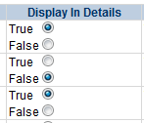

1. Repeat the process as necessary.
2. Click Save to save your changes; click Cancel to abandon the changes and return to the Settings page.

**Note**: Cancel is immediate; you will not be warned that you are about to lose your changes.

Add/Remove Field from Reports

To add (or remove) a field from Reports

1. In the Customize <Concept> List, find the name of the database field you want to change.
2. In the Include in Reports column, select True to display the field on concept-related reports, select False to prevent the field from displaying on the concept-related reports.

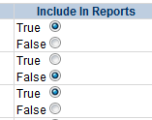

1. Repeat the process as necessary.
2. Click Save to save your changes; click Cancel to abandon the changes and return to the Settings page.

**Note**: Cancel is immediate; you will not be warned that you are about to lose your changes.

### Change Field Display Order

To change the order that the fields appear in Detail pages and drop-down lists, change the adjacent number in the Display Order field. Note that changing the Display Order is an entirely manual process; each field must be changed individually and the order is not validated in any way. Multiple fields can have the same display order.

When all changes are complete, click Save; click Cancel to abandon the changes and return to the Settings page.

Figure : Display Order List

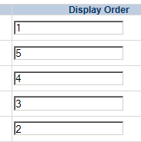

### Update User Roles

PECS Administrators can add PECS users and modify the roles of existing users. By default, PECS users are assigned Requestor privileges. Once added, the user privileges can be elevated to Approver, Release Manager, and Administrator by an Administrator provided the user also has the corresponding VistA Security Keys. Privileges can also be removed from a user at any time.

**NOTE Release Manager or Approvers should immediately be assigned the appropriate roles to avoid giving them access to inappropriate privileges (creating customizations).**

Figure : Update User Roles

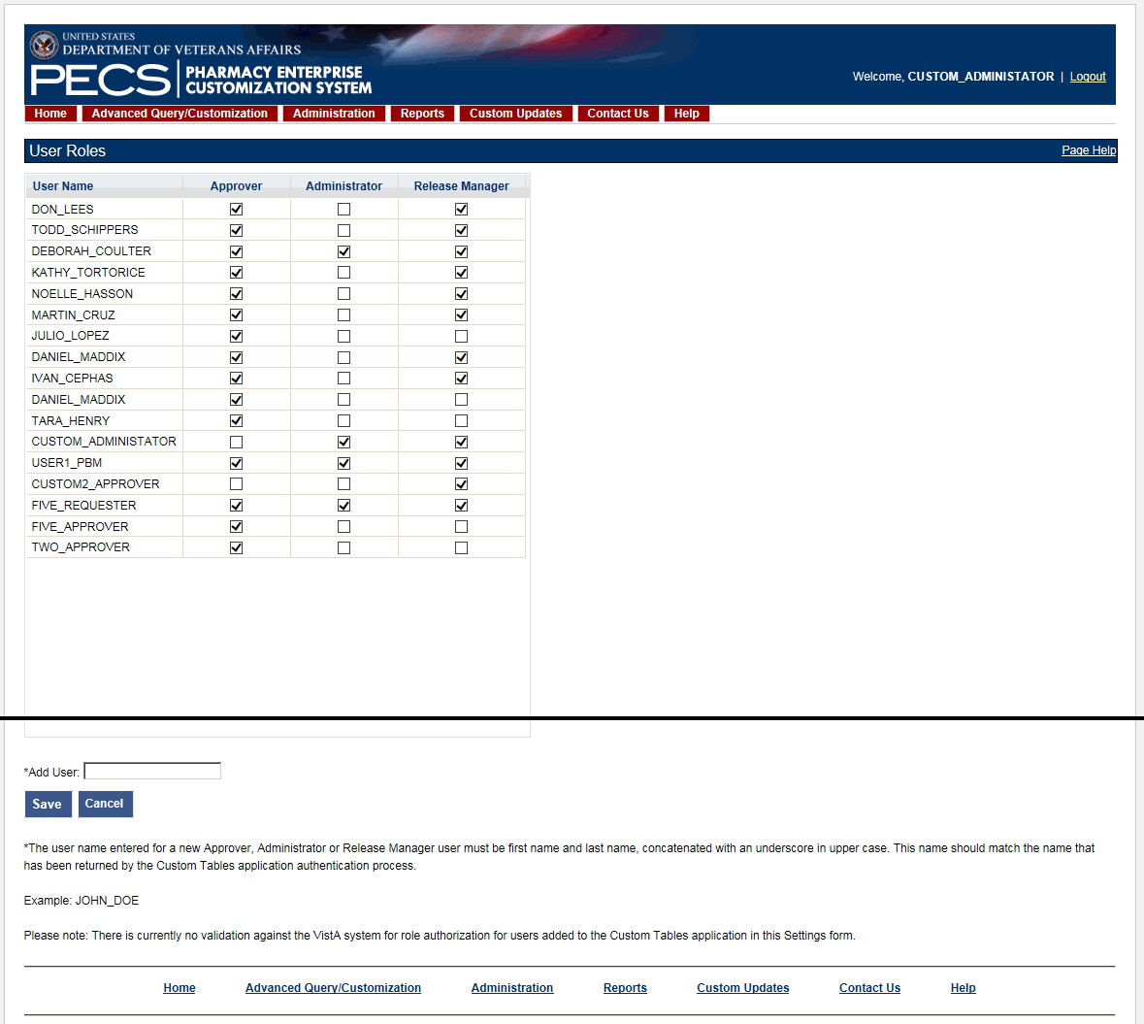

#### Add a PECS User

Administrators can add users to PECS. In order to successfully log in, the user must have a VistA account. See Identity Management for additional information.

To add a user to PECS

1. From the Administration tab, click Update User Roles.
2. In the Add User field, type in the name of the person you want to add. The name must be in ALL CAPS and include both the first and last name (in that order) separated by an underscore. Examples: FIRSTNAME_LASTNAME, JOHN_DOE.
3. Click Save.
4. Click OK to add the user; click Cancel to abandon the add user operation.

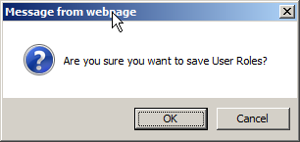

1. If the add user operation is successful, an informational message will appear confirming it. If the user you are trying to add already exists, the following error message is displayed: ”The user you are attempting to add already exists. Please review and/or update this user’s existing settings.”

#### Add User Roles

To add user roles

1. From the Administration tab, click Update User Roles.

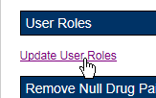

1. Select one or more roles for one or more users from the User Name list. Remember—if the user does not have the appropriate VistA Security Key, the enhanced privileges will not be granted. If you are not seeing the tabs that you think you should be seeing based on your role, check to be sure you have the appropriate VistA Security Keys.

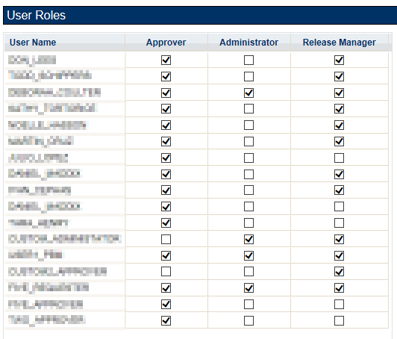

1. Click Save.
2. Click OK to add the user roles; click Cancel to abandon the add role operation and return to the Settings page.



#### Remove User Roles

To remove a role from a user

1. From the Administration tab, click Update User Roles.



1. Clear one or more roles for one or more users from the User Name list.



1. Click Save.
2. Click OK to add the user roles; click Cancel to abandon the add role operation and return to the Settings page.



### Null Drug Pair Removal Process

The Null Drug Pair Removal changes the status of any VA Drug Pair that contains a null Routed Generic to “Deleted”, and removes the null drug pairs from their associated VA Drug-Drug Interactions. VA Drug Pairs have null Routed Generics because one or both of the Routed Generics that make up the Drug Pair has been deleted by FDB. PECS applies the FDB Routed Generic deletes as part of the weekly FDB-DIF update, so it is recommended that the Null Drug Pair Removal process be run weekly, after the FDB-DIF update completes.

The Administrator may initiate this process at any time by clicking the “Null Drug Pair Removal” button on the following window:

Figure : Null Drug Pair Removal Button on Administration Tab

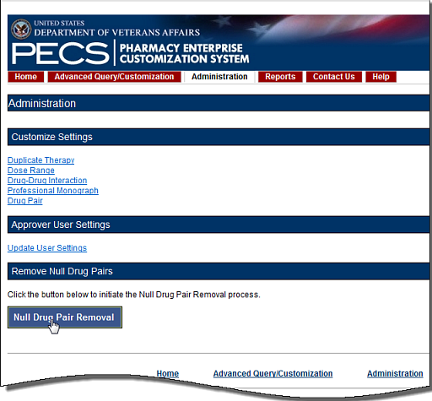

When the process is complete, a message will appear at the top of the page to indicate that the process has completed.

Figure : Null Drug Pair Removal Process Complete

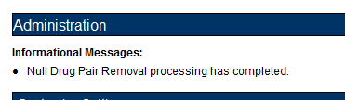

**Note:** The Null Drug Pairs Customization Report can be used to identify *approved* VA Drug-Drug Interactions that contain null Drug Pairs. However, the Null Drug Pair Removal Process removes null drug pairs from *any* VA Drug-Drug Interaction, regardless of status. All VA Custom drug pairs that contain a null routed generic drug are updated as follows: the action status of the drug pair is changed to “Deleted” and the current action reason is “FDB Deleted,” with the value of the FDB issue date when the custom drug pair was deleted. The FDB issue date is the date associated with the FDB update file that includes the deletion.

### Editing Contact Us

In addition to viewing it, Administrator users can edit the content of the Contact Us page. To edit the Contact Us page:

1. Click the Contact Us tab.
2. Click the Edit Content link on the right side of the page. This will display a word processor-like editor.

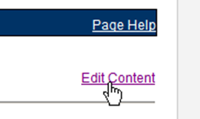

1. Add or change the content on the page. To add or edit a link, see the appropriate sections below.

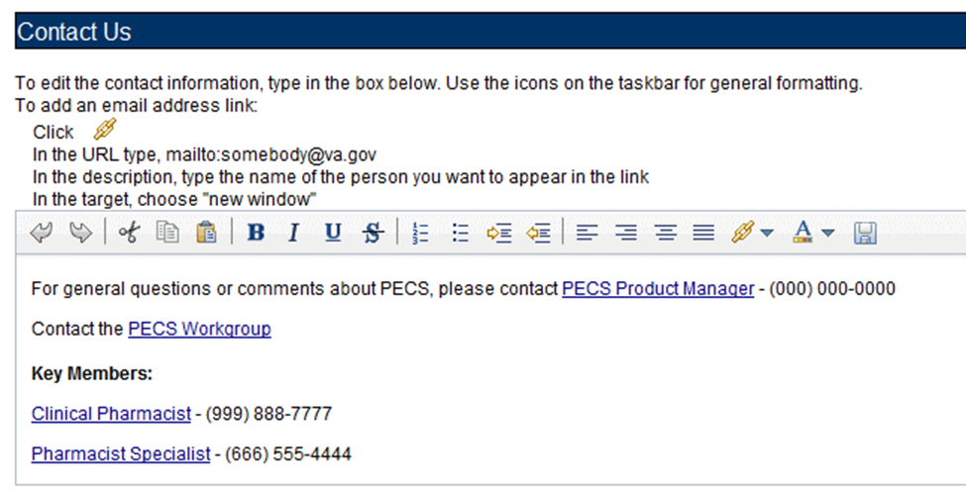

1. When the edits are complete, click the Save button.

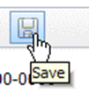

### Add a Contact Link

To add a link while editing the Contact Us page:

1. Click the Create Link button. This will display the Link Properties dialog box.

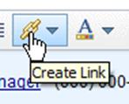

1. Enter the mailto URL for the person whose contact information you are adding in the URL field. A mailto URL is the word "mailto" followed by a colon followed by the appropriate email address. VA email addresses are usually (but not always) firstname.lastname@va.gov. Verify the contact information in the Outlook Global Address List (GAL) for the correct email address. Example: <mailto:firstname.lastname@va.gov>.



1. Enter the contact name in the Description field. This is the text the user will actually see on the Contact Us page.



1. On the Target list, select New Window.

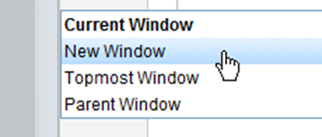

1. Click the Set button.

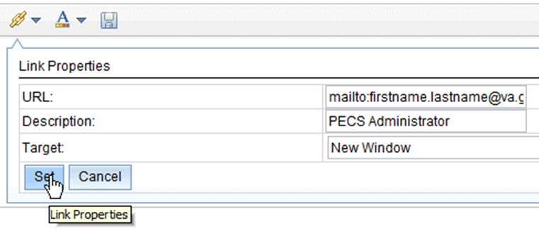

### Edit a Contact Link

To modify an existing contact link while editing the Contact Us page:

1. Double-click the existing link.
2. Make the necessary adjustments in the Link Properties dialog box.
3. Click the Set button.

### Additional Tools Available to Administrators

In addition to the Home tab and Administration, Release Managers role see the following tabs on their Home page:

* Advanced Query/Customization – See Using Advanced Query/Customization for additional information.
* Contact Us – see Contact Us for additional information.
* Help – see Online Help for additional information.

*(This page included for two-sided copying.)*

# Easy Search

Easy Search provides a simple way to display commonly-requested PECS information. Easy Search differs from other methods for finding information in that the results are display-only; the records displayed as a result of an Easy Search query cannot be modified. However, in some cases, a link is provided to an editable version of the resulting records.

The Easy Search queries are handled slightly differently depending on which type of search you want to perform. There are three types of Easy Search Query:

* Dose Range
* Drug-Drug Interaction with Professional Monograph and/or Duplicate Therapy
* Interactions for a Single Drug

## Easy Search Drug-Drug Interaction with Professional Monograph and/or Duplicate Therapy Query

The Drug-Drug Interaction with Professional Monograph and/or Duplicate Therapy query allows the user to easily search for any Drug-Drug Interaction (and associated Professional Monographs) and/or Duplicate Therapy records that may exist within PECS for at least two and up to ten drugs that are selected by the user. This page also allows the user to search for Duplicate Therapy information for any drug they select.

Figure : Easy Search Results Page

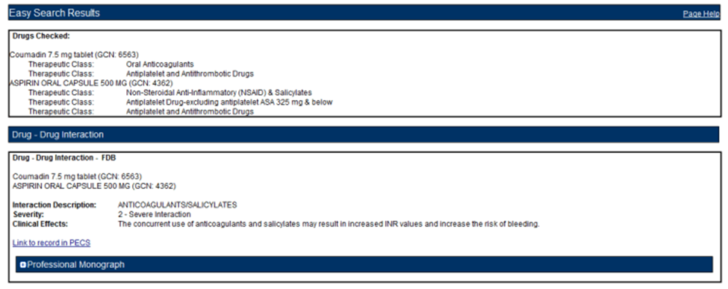

To perform a Drug-Drug Interaction Easy Search Query

1. From the Select Search Type drop-down list, select 'Drug-Drug Interaction with Professional Monograph and/or Duplicate Therapy.' After selecting this value, the system will then display the 'Select Information Type', 'Search and Select Drugs', 'Search Results' and 'Drugs to Check' panels.

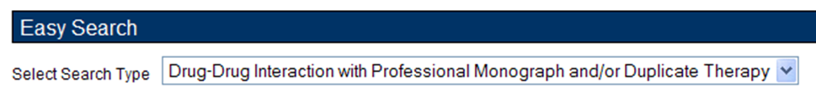

1. Choose the appropriate options from the Select Information Type panel:

* Select Drug-Drug Interaction with Professional Monograph to find Drug-Drug Interactions with the associated Professional Monograph. If you select the Drug-Drug Interaction with Professional Monograph checkbox, the system will display two options: Display Severity Levels 1 (contraindicated) and 2 (severe) and Display All Severity Levels. You must select one of these options.
* Select Duplicate Therapy checkbox to display Duplicate Therapy records (if any) for the selected drugs.

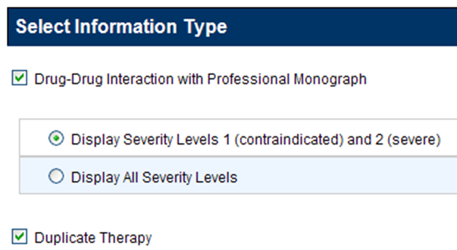

1. Enter a partial string or whole drug name into the Drug field and click Search. The system returns all drugs, that is, both routed generic drugs and dispensable drugs that contain the partial string/whole drug name entered.

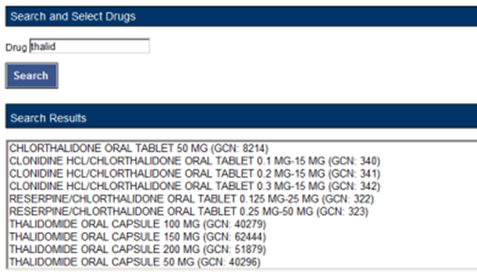

1. Select a drug from the Search Results window and click Add to Drugs to Check. The selected drug will appear in the Drugs to Check box.

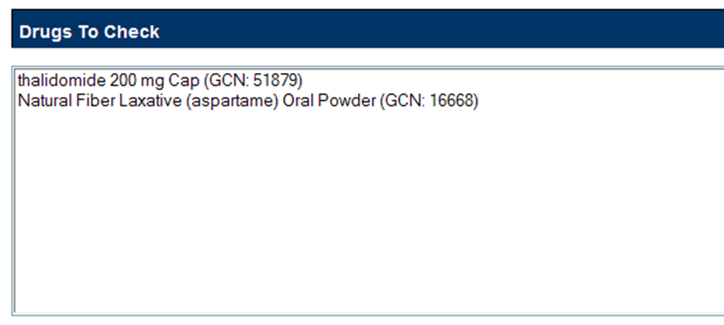

1. If necessary, repeat the Search/Select process to add more drugs to the check. For Drug-Drug Interaction queries, you must select at least two drugs and can select up to ten. For Duplicate Therapy, you can select multiple drugs to find duplicate therapies; you can also select a single drug to display the associated Therapeutic Class.
2. When all drugs have been added, click Submit. The query results will appear on a results page.

Results

The Drug-Drug Interaction with Professional Monograph and/or Duplicate Therapy query will produce the following results based on the selections made in the query.

Drugs Checked

* All Drugs that were selected by the User are listed first on the page after 'Drugs Checked'.
* After each drug name, the Therapeutic Class(es) that drug belongs to are listed for reference.

Figure : Easy Search Results for DDI with PM, Drugs Checked

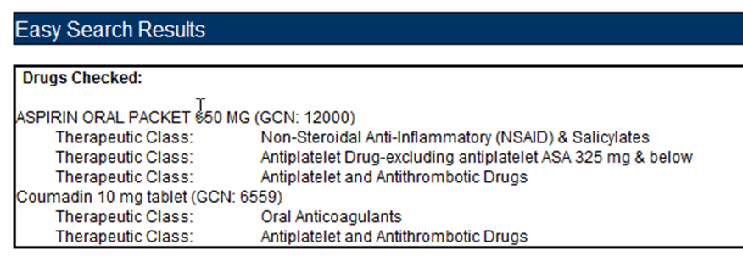

Drug-Drug Interaction

The Easy Search query Drug-Drug Interaction with Professional Monograph information will display any Drug-Drug Interactions that apply to any combination of the drugs searched. Click the Link to record in PECS link to display the record in the standard PECS application where it can undertake additional processing.

Figure : DDIs Shown Applicable to Drugs Checked

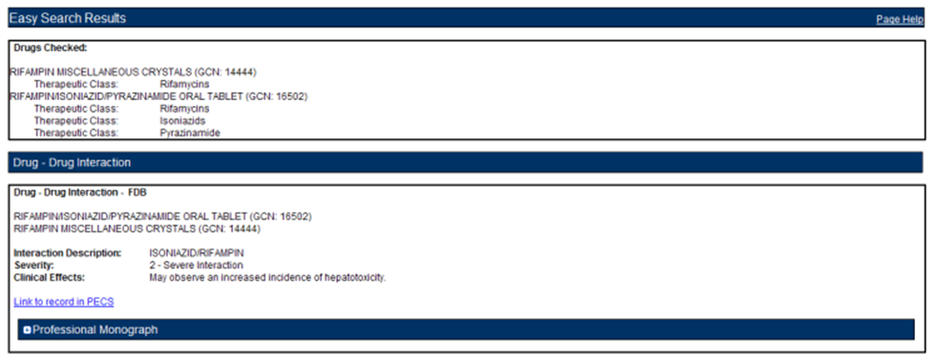

Professional Monograph

Any associated Professional Monographs to those Drug-Drug Interactions will be listed after the Drug-Drug Interaction information. Click the + symbol to expand the Professional Monograph (collapsed by default). If there is no Professional Monograph associated to the Drug-Drug Interaction returned by the Easy Search query, this option will not expand.

Figure : The Professional Monograph Associated with the DDI/PM Easy Search

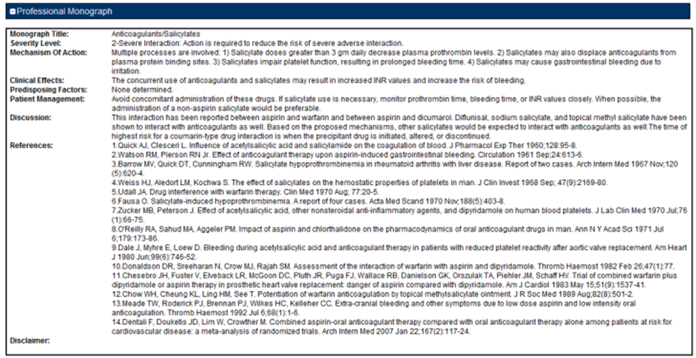

Duplicate Therapy

Duplicate Therapy results the Duplicate Therapy for the drugs selected in the Drugs to Check box. The record contains the Therapeutic Drug Class that the two drugs belong to and Duplicate Allowance numerical value (0,1, 2, 3, or 4) followed by a short message stating these two drugs may represent a duplication in therapy. To view the Duplicate Therapy record in PECS, click Link to record in PECS.

Figure : Duplicate Therapy Easy Search Results

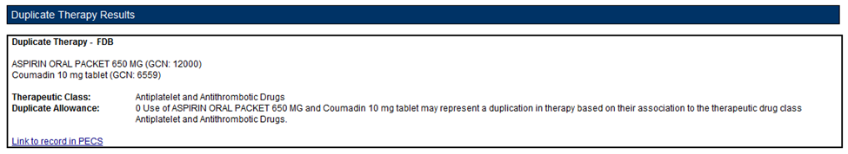

## Easy Search Interactions for a Single Drug Query

Interactions for a Single Drug allows you to generate a report for all the drug pairs that would be returned in VistA for the selected drug. The report displays FDB and Approved VA custom drug pairs with the specified severity level. FDB drug pairs will display only if there is not a corresponding Approved VA customized drug pair.

To perform an Interactions for a Single Drug Query:

1. Select "Interactions for a Single Drug" from the Select Search Type drop-down list.

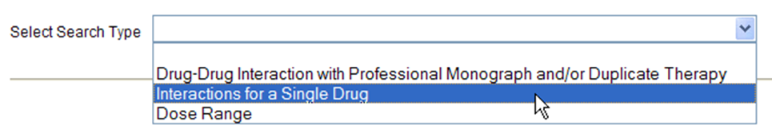

1. From the Select Information Type panel, choose the desired Severity Level with the appropriate radio button - Severity Level 1 (contraindicated), Severity Level 2 (severe), or Severity Levels 1 (contraindicated) and 2 (severe).

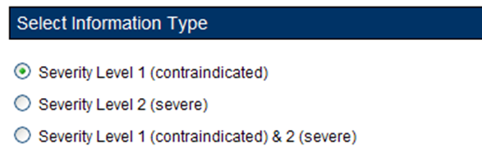

1. Enter a partial string or whole drug name into the Drug field and click Search. Items that match the search string are displayed in the Search Results box. The drug list displays the drug name, dose, route of delivery, and the drug’s GCN sequence number. Note that if both a dispensable generic drug and dispensable drug are found that have the same GCN sequence number, only the dispensable drug are displayed on the list. Select an entry from the list.

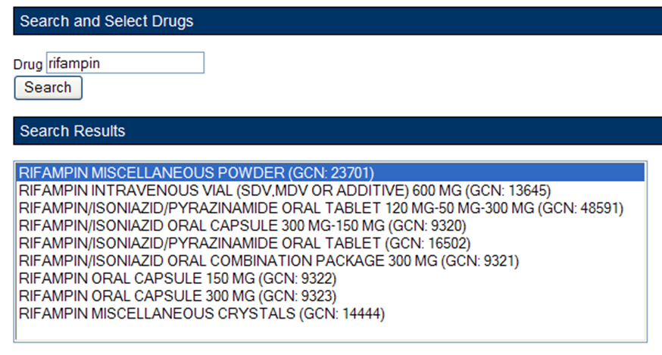

1. Click the Generate Report button. The report generates in Excel. It contains the FDB and VA custom drug pairs whose severity level matches the selected severity level and contain a routed generic drug that corresponds to the selected generic dispensable drug or dispensable drug.

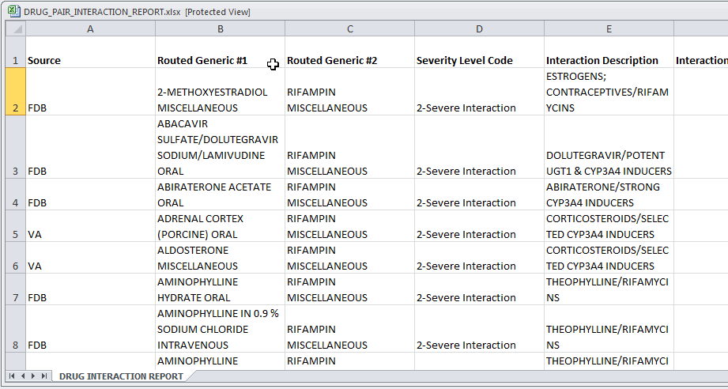

Interactions for a Single Drug Report Details

Table : Interactions for a Single Drug Report Fields

| Field | Description |
| --- | --- |
| Source | Source of the record; either VA or FDB |
| Routed Generic #1 | A generic drug name, e.g. "Rifampin Oral" |
| Routed Generic #2 | A generic drug name, e.g. "Rifampin Oral" |
| Severity Level Code | The severity of the interaction. |
| Interaction Description | A brief description of the interaction. |
| Interaction ID | A numerical identifier assigned to the interaction. |
| Corresponding FDB Interaction ID | VA records only: the interaction as described by First Databank. If there is no corresponding interaction, this field will contain '0'. |
| Action Date | The date and time of the most recent update to the record. |

## Easy Search Dose Range Query

The Dose Range query allows you to easily the appropriate dosage information for a specific drug based on the patient and dose particulars entered for a selected drug. The results of this query allow the user to ensure the amount being prescribed is an acceptable amount. An Easy Search Dose Range query allows you to find the acceptable dose range for a drug quickly and easily, and presents the results in an easy to understand format.

To perform an Easy Search Dose Range query:

1. From the Select Search Type drop-down list on the Easy Search page, select 'Dose Range.'

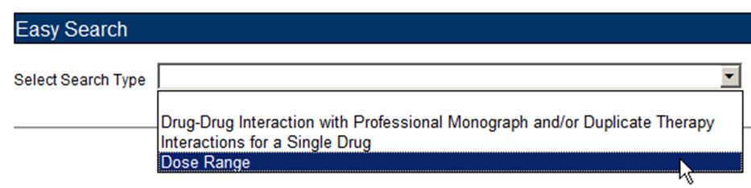

1. Enter a partial string or whole drug name into the 'Drug' field. Note that you can enter multiple partial strings, and the system returns drugs that match on both strings -- the order of the strings and case are ignored.
2. Click the Search button. The system returns all drugs, that is, both routed generic drugs and dispensable drugs that contain the partial string/whole drug name entered.
3. Select the appropriate drug from the Search Results list. Note that if the drug does not have a defined dose route and/or a defined dose unit, the query cannot be performed and an error message is displayed.

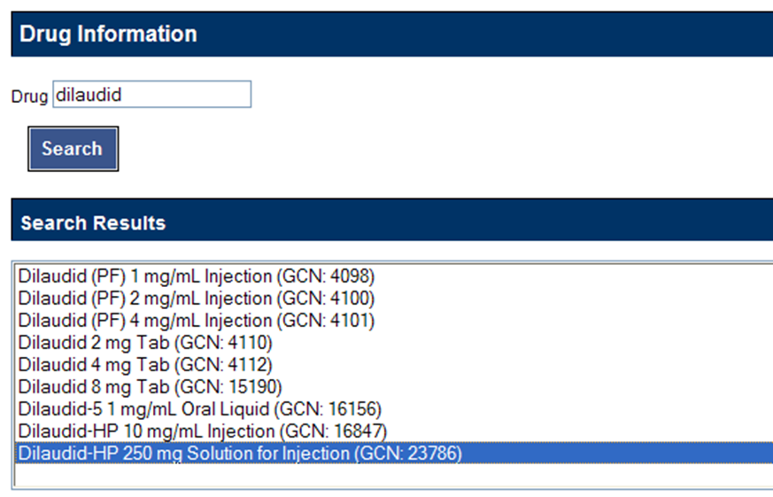

1. In the Selected Drug section, select the Dose Type and Dose Route. The available selections will be limited to those appropriate for the selected drug; in some cases, the default values may be the only options available.

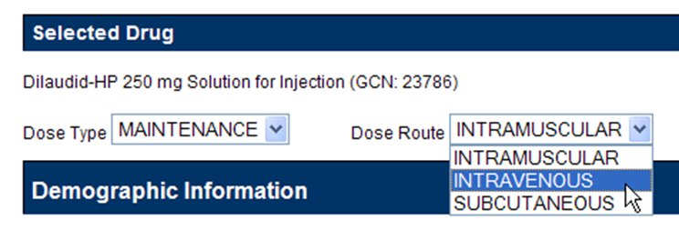

1. The Demographic Information section will automatically be populated with standard values. If more appropriate patient information is available, the default values can be replaced. Factors included are:

* Age (years)
* Weight (kg or lbs.)
* Height (cm or in)

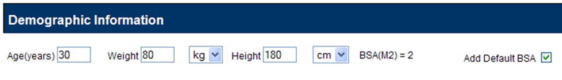

In the Dosing Information section, enter information about the proposed dose. Factors include:

* Single Dose
* Dose Unit
* Dose Rate Unit
* Frequency

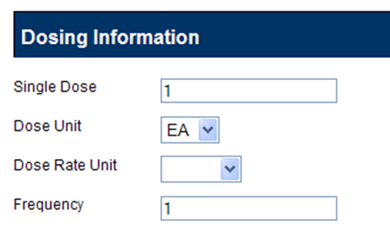

Dose Range Query Results

If available, the Dose Range Results section displays the appropriate dose range for the selected drug. You can also view the Dose Range record in PECS by clicking Link to record in PECS.

**Note**: Due to a limitation in the FDB database, not all PECS Dose Range records can be linked directly from Easy Search Results. If the record cannot be linked, “Link to record in PECS Not Available” will appear at the bottom of Dose Range Results. Use Advanced Query/Customization to find and view the record in PECS.

Figure : Results for a Dose Range Easy Search

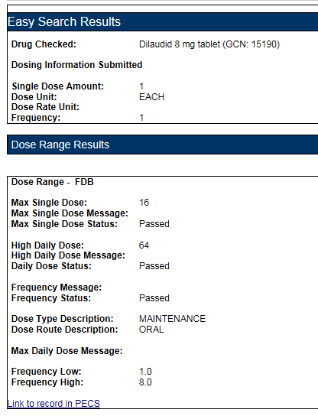

Drug Information

The Easy Search Results section displays the information you entered in the query.

* Drug Checked
* Drug Information Submitted
  + Single Dose Amount
  + Dose Unit
  + Dose Rate Unit
  + Frequency

Dose Range Information

The Dose Range Results section displays (if available) the appropriate dose range for the selected drug.

* Max Single Dose
* Max Single Dose Message
* Max Single Dose Status
* High Daily Dose
* High Daily Dose Message
* Daily Dose Status
* Frequency Message
* Frequency Status
* Dose Type Description
* Dose Route Description
* Max Daily Dose Message
* Frequency Low
* Frequency High

**Note: When PECS can’t retrieve the selected dose type, dose unit, and dose route for a drug, it displays a message in a popup:**

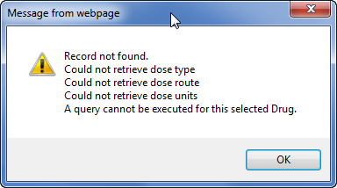

## Potential Easy Search Result and PECS Record Discrepancy

The custom detail pages in PECS show the custom record as it exists in PECS. These detail pages are accessed through either the Advanced Query/Customization tab, or by clicking the “Link to record in PECS” link found on the Easy Search Results screens.

When you use Easy Search to look up Drug-Drug Interactions or Duplicate Therapy, Easy Search uses a different database table than the one used to store the actual PECS record. The Easy Search results page shows only data from custom records in an Approved state that have been exported in a custom update and processed by an external process named DATUP. If a custom record has not gone through this process, you will see the FDB record and there will be a discrepancy.

Also, if a previously approved/exported custom record is updated, Easy Search will not show the updated data in the results page until the record is approved, exported, and processed by DATUP. Instead, Easy Search will show the custom record results that were last uploaded to DATUP.

Below are examples of discrepancies. Remember that these discrepancies cannot be duplicated and re-displayed after a custom update has been approved and run through DATUP, so do not try to re-create them. They are for informational purposes only, and even show an older screen capture of PECS (no Contact Us tab).

Example #1, from Easy Search:

Figure : Easy Search DDI Record

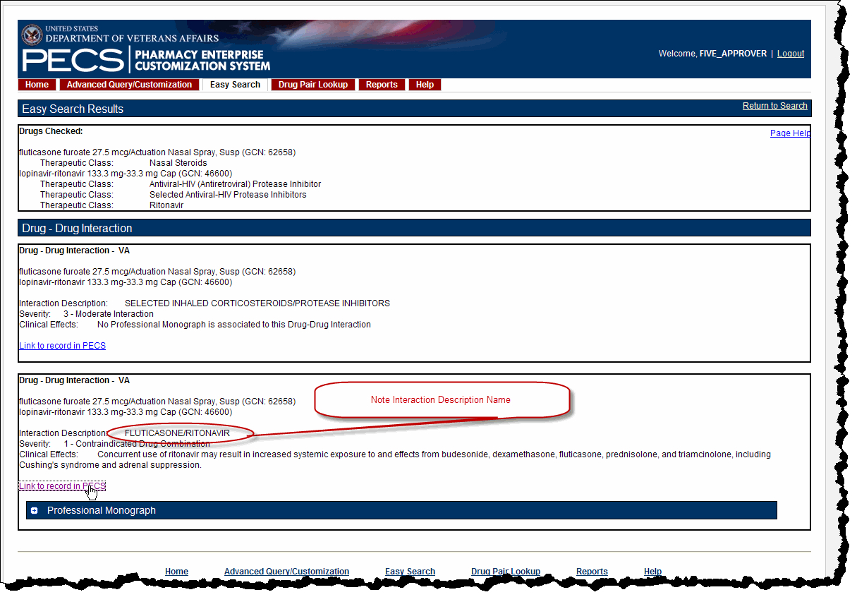

Example #2, shown by clicking the “Link to record in PECS” link as is shown above. This discrepancy means the custom record has not been approved and/or not processed through DATUP. This potential discrepancy applies to Drug-Drug Interaction, Professional Monograph, Duplicate Therapy, and Dose Range concepts.

Figure : Referenced PECS Record with Name Discrepancy

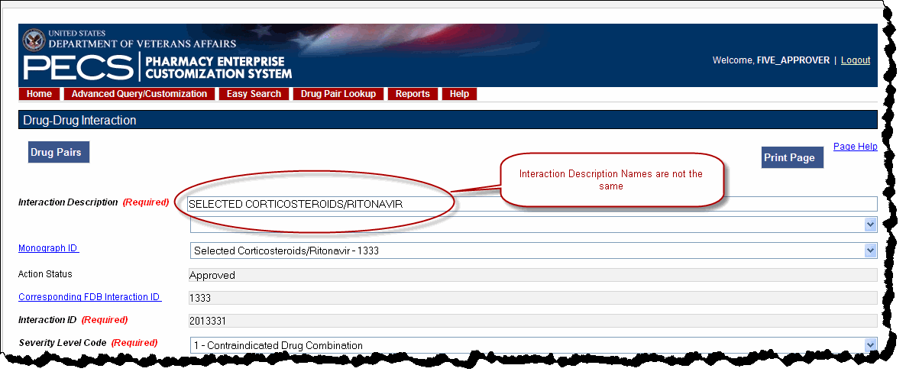

# Drug Pair Lookup

A Drug Pair is a combination of drugs known to cause a drug interaction. A drug interaction is a situation in which a substance (usually another drug) affects the activity of a drug when both are administered together. Drug Pair Lookup provides a quick and easy way to search both the FDB and VA databases for these drug pairs.

When performing a Drug Pair Lookup query, enter query criteria in any or all of the four entry fields. The results are displayed under the VA Table Results and FDB Table Results panels. These consist of active customized Drug Pair records from the VA custom database that are available for modification, as well as their related Drug Pair records from the FDB database from which they were customized.

Field names are as follows:

* Drug A (Generic) - The name (or partial name) of one generic drug associated with an interaction.
* Drug B (Generic) - The name (or partial name) of a second generic drug associated with an interaction.
* Interaction - An assigned drug interaction number and description associated with the drug pair. This can be entered in conjunction with the Drug A and Drug B entries or can be used on its own. Enter either *all* of the Interaction ID, or all or part of the interaction description.
* Severity Level Code - A drop-down list of available severity codes that are allowed for an interaction. This can be used on its own, but is most useful to limit the results produced by the other criteria.

## Performing a Drug Pair Lookup Query

To perform a Drug Pair Lookup query:

1. Fill the query form with your search criteria; greater detail will yield more relevant results.

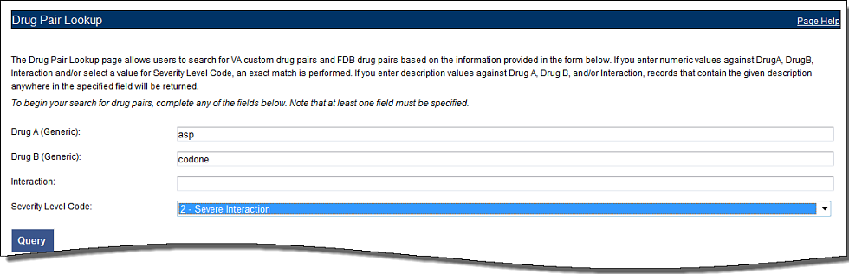

1. Click Query.
2. Drug Pairs matching the query criteria (both VA and FDB) will display in their respective panels. If the results are unsatisfactory, you can adjust the query criteria and click Query again.

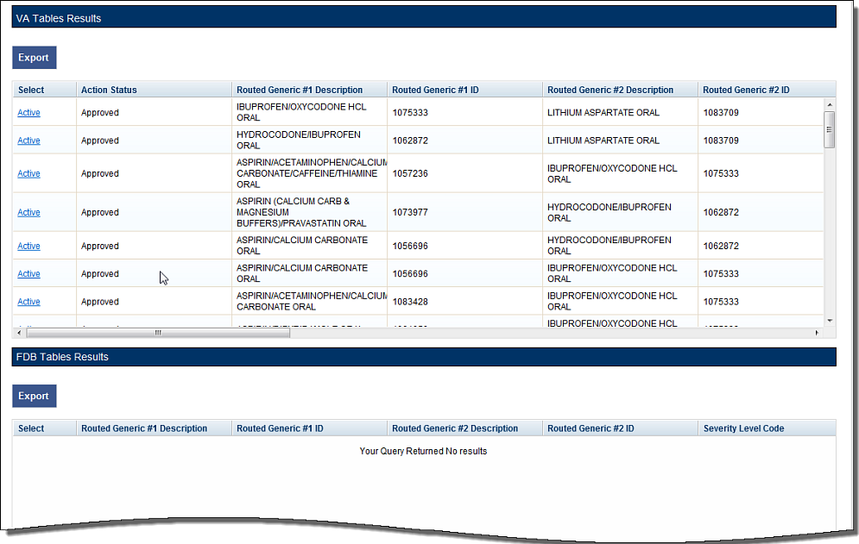

1. Click the link in the Select column to view the drug pair record. VA records will display and Active link; FDB records display an Open link.

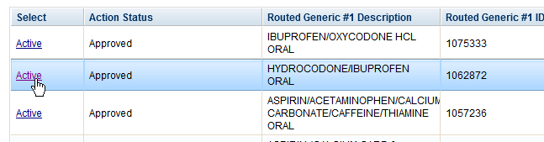

1. To further customize the record, click the Interaction ID link to display the Drug-Drug Interaction (and the associated Drug Pairs).

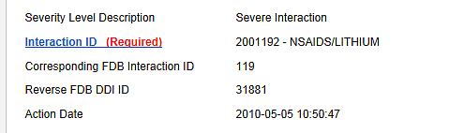

## Export Query Results

You can export the results of a Drug Pair Lookup query to an Excel spreadsheet.

1. Perform a Drug Pair Lookup Query.
2. Click the Export button associated with the Results list. The Export option is available for both VA and FDB results.

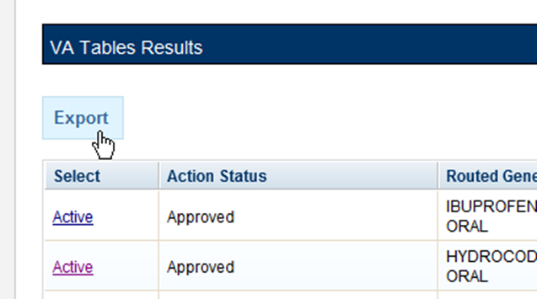

1. Click Open to display the Drug Pair Report; click Save to save a copy of the report to your system.



The spreadsheet contains two tabs:

1. The Drug Pair tab (either VA or FDB) displays the results of the query.

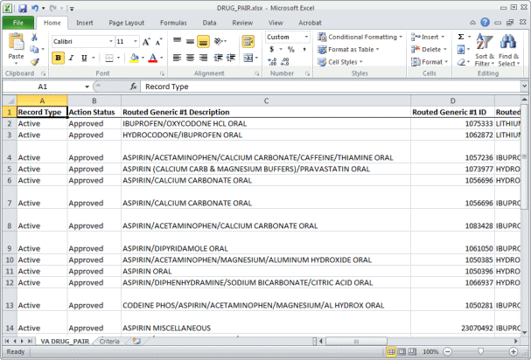

1. The Criteria tab displays the criteria used in the query.

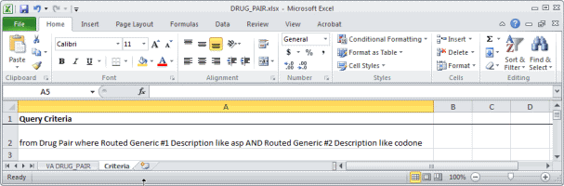

Export Query Line Limit

There is a 1,000,000 line limit for exporting to the spreadsheet. If your query returned more than 1,000,000 records and you submitted the records for export anyway, the Criteria tab on the report gives you the following message: “The number of rows returned in the search (XXXXXX) is greater than the maximum number of rows that can be exported (1,000,000).”

Figure : Export Query Line Limit Message



# Detail Pages

Detail Pages are the display mechanism for PECS records. The display the information contained in the record and, in the case of FDB records, provide a means to customize that record. There are detail pages for each of the five concepts (Drug-Drug Interaction, Drug Pairs, Professional Monograph, Duplicate Therapy, and Dose Range.

## Detail Page Overview

Detail Pages display the details of the record appropriate to the concept being viewed for both FDB and VA records. The sections below are taken from a Drug-Drug Interaction records, but the detail page behaviors are consistent among the different Concepts.

FDB Records

Figure : FDB DDI Record

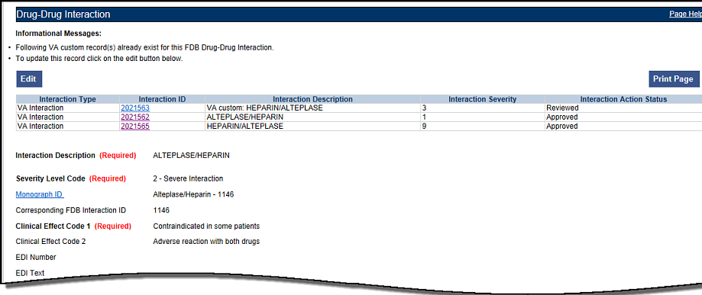

With FDB records, you can:

* View Record Details
* Customize the FDB Record
* View Associated Record Links

VA Records

Figure : VA Custom DDI

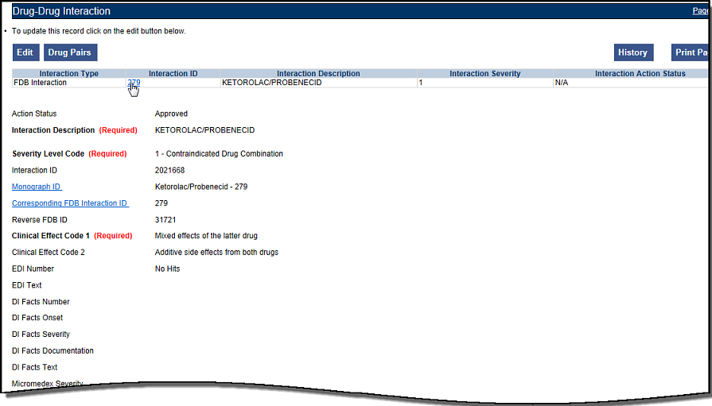

With VA records, you can:

* View Record Details
* Edit a Record
* Print a Record
* Add Pre-Customization Comments
* View Associated Record Links
* View History Report
* View Field-Level History
* View Export Date

### Informational and Warning Messages

Some records have informational and warning messages associated with them. These messages provide information about the record itself and not necessarily the contents of the record.

Figure : Informational and Warning Messages

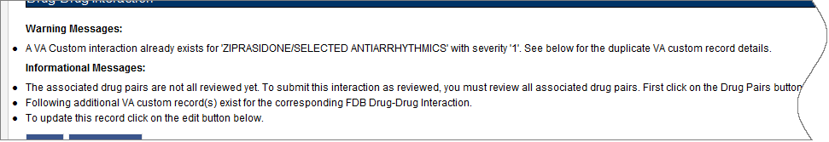

## Using Detail Pages

Detail pages provide information about the PECS records. The information on the page is slightly different for each concept, but the basic functions are the same.

Figure : Example of a Detail Page

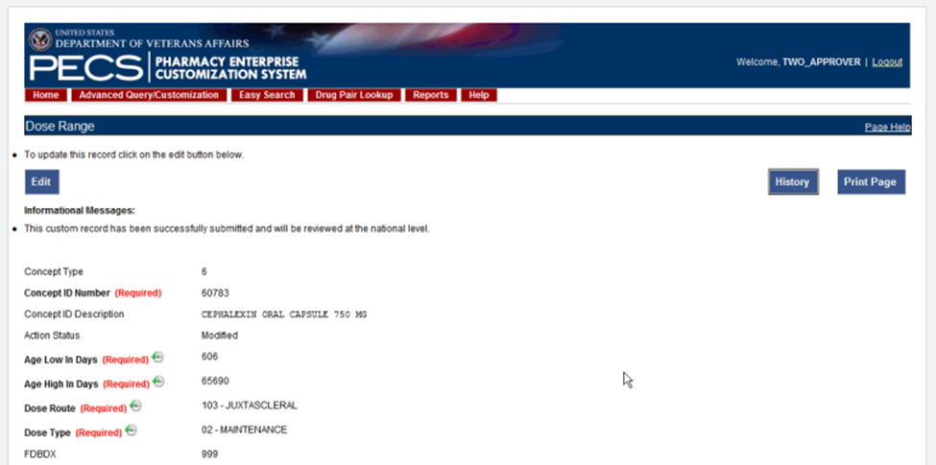

### Viewing Record Details

The Home Page for Requestors and Approvers contains links to pre-defined queries that facilitate viewing records. Requestors can use these links to view details of records that they have created.

Approvers can use the links to view details of records they created, records currently assigned to them for some action, unassigned records, and All records.

All users can use Advanced Query/Customization to find and view record details.

### Edit a Record

Editing a record is different depending on the type of record it is, and the current state of that record. For example, if viewing an FDB record, editing it produces a customization. If viewing a VA record, editing could mean:

* Changing the record details (modify)
* Reviewing an existing record as part of the approval process
* Approving an existing record
* Rejecting an existing record
* Deleting an existing record

In all cases, click Edit to begin the modification process. See Working with Customization Requests for additional information on the modifications you can perform on a record.

Figure : Use the Edit button to Modify Record Details

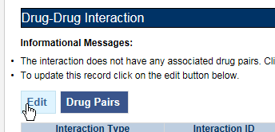

Only Requestor and Approvers can modify a record. Requestors can only modify FDB records (customize) or VA records they have created. Approvers can also modify/customize FDB records and can also modify most VA records with the following exception: they cannot Review a record they created. See Working with Customization Requests for additional information.

**NOTE If you are a Release Manager or Administrator but have not yet been assigned that role by a PECS Administrator, you will have Requestor privileges until your appropriate role is assigned.**

In some cases, PECS will display the Edit button and allow you to view the record in Edit mode. However, any changes you make to the record cannot be saved; use Cancel Edit to return to the detail page in read-only mode.

### Print a Record

The Print Page button calls the browser Print function, allowing you to print the page to any printer you have connected to your system.



### Add Pre-Customization Comments

Approver users can add comments to FDB records that do not have customized VA versions. The comments are visible on the FDB record and contain the text of the comment as well as the date and time it was entered and the PECS User ID of the person who entered it. Once entered, these comments cannot be edited or deleted.

If the FDB record is customized, the pre-customization comments will become part of the customized record. Once customized, you cannot add additional pre-customization comments to an FDB record.

To add a pre-customization comment:

1. Click the Add Comment button:

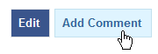

1. Enter the comment in the Enter Comments dialog box:

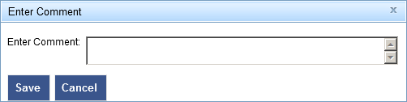

1. Click Save to save your changes; click Cancel to abandon the enter comments process and return to the record. The comments appear in the Pre-Customization Comment History of the record.

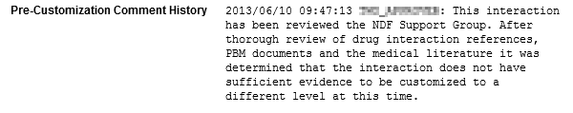

### View Associated Record Links

If an FDB record has been customized, links to the VA-customized records are provided.

Figure : VA Custom Record ID Links

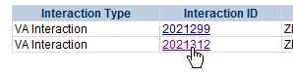

VA records provide links to the original FDB record as well as any additional customizations created from the original FDB record.

Figure : VA Custom and FDB Record Links

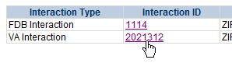

### History Report

History Reports detail all the changes made to the current record. Changes to most editable fields will appear in the report as red text with an asterisk (*). Changes to the Current Action Reason are not highlighted (red) in the History Report. It is presented as a Microsoft Excel spreadsheet.

To display a History Report:

1. From the Detail page, click the History button.



1. Click Open to display the History Report; click Save to save a copy of the report to your system:



1. If you chose to Open the report, it will be displayed. If you chose Save, the report can be opened at any time using Excel.

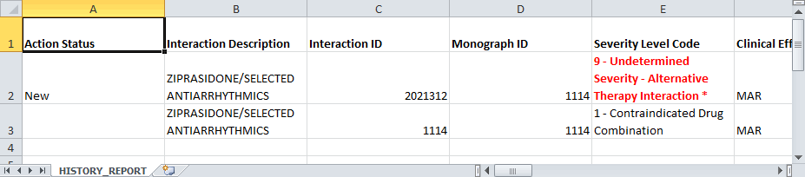

### Field-Level History Table

You can review a list of changes to an individual field by hovering over the History Table icon next to a field that has been changed. Field-level history is retained only while the record is in its current state. The field-level history is reset when the state changes to Approved or Deleted (Modified or Reviewed doesn’t cause a reset). Field-level history is only displayed for Required Fields with the exception of Current Action Reason; field-level history is not retained for Current Action Reason, but it can be viewed on the History Report along with changes to non-required fields.

Figure : At-a-Glance History Icon



Figure : On-Screen History Table from Icon

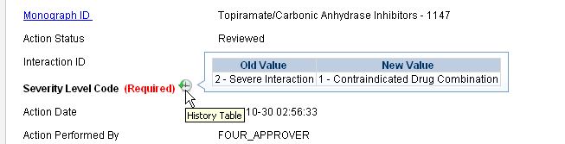

### Export Date

The Export Date field appears on the VA Custom Detail Pages and in the Customization Reports. It contains the date and time an Approved or Deleted record was included in the Incremental Update File, so it is only populated on records with Action Status’ equal to Approved or Deleted.

Note: If an Incremental Update File has not been created since the record Action Status was change to Approved or Deleted, the Export Date will be blank until the next Incremental File is created.

Sometimes an Approved or Deleted record included on an Incremental Update File needs to be changed. Any change to that record will cause the Export Date field to be cleared (blank) in the active record. The only way to determine that the record has been exported is to view the History report or search for the record using Advanced Query/Customization and select Include Historical Records.

If the change to the record causes a change to the Action Status, and that modification is later Rejected, the following happens:

If a “Modified after Approved” (displays as Modified in PECS) record is Rejected:

The Action Status “rolls back” to Approved, and the record will be included in the next Incremental Update File and the Export Date will be updated.

If a “Modified after Delete” (displays as Modified in PECS) record is Rejected:

The Action Status “rolls back” to Deleted. However, records that roll back to a Deleted Action Status are NOT included in the next Incremental Update File, so the Export Date will NOT be updated and will remain blank on the active record.

## Drug-Drug Interaction Detail

The Drug-Drug Interaction Detail page allows users to view the details of both FDB and VA Drug-Drug Interaction records. FDB Drug-Drug Interactions can be customized to become VA Drug-Drug Interactions. See Working with Customization Requests for additional information on creating a VA customization request.

Figure : Detail Page of VA Customized DDI, Top and Bottom

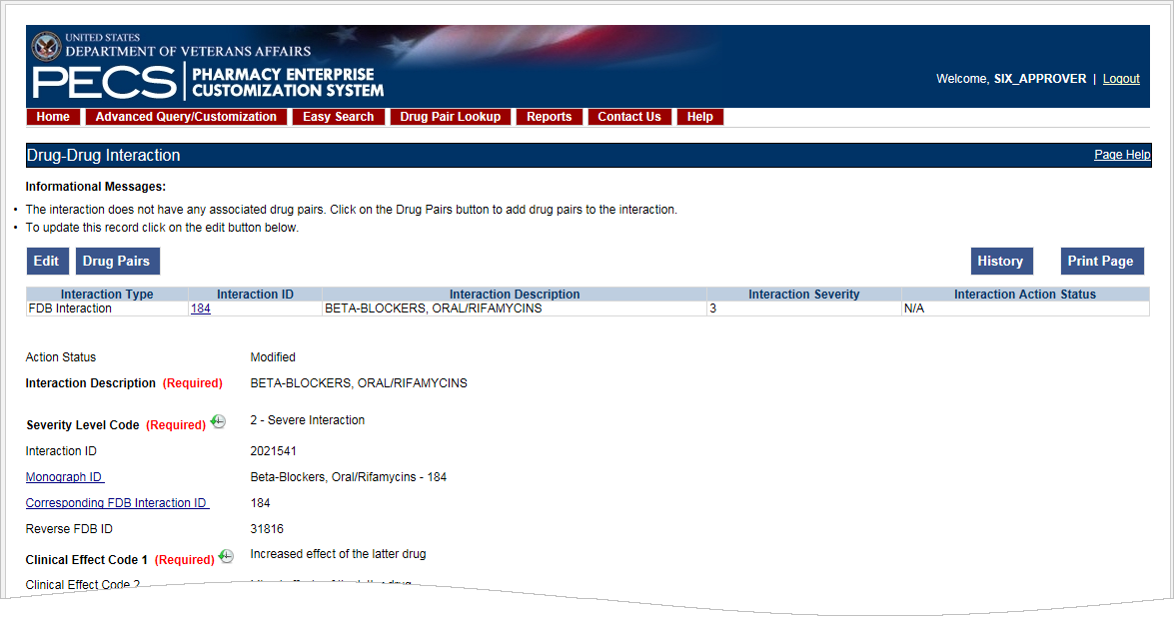

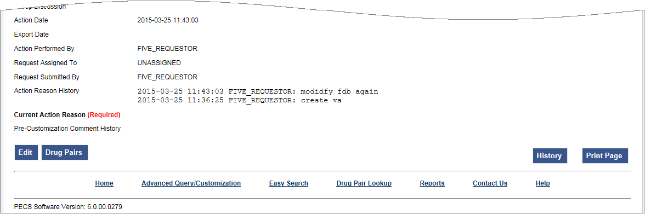

### Multiple VA Customizations for One FDB Record

You can create multiple VA Custom Drug-Drug Interactions (DDIs) from one corresponding FDB Record. If you open an FDB DDI record on the Advanced Query/Customization page, the DDI Detail page will open. If there are any VA custom records for this FDB DDI, you’ll see a message stating that “The following VA custom record(s) already exist for this FDB Drug-Drug Interaction,” and a table and a link to any interactions displays. See Figure 78.

Figure : Multiple VA Custom DDIs to One FDB Record

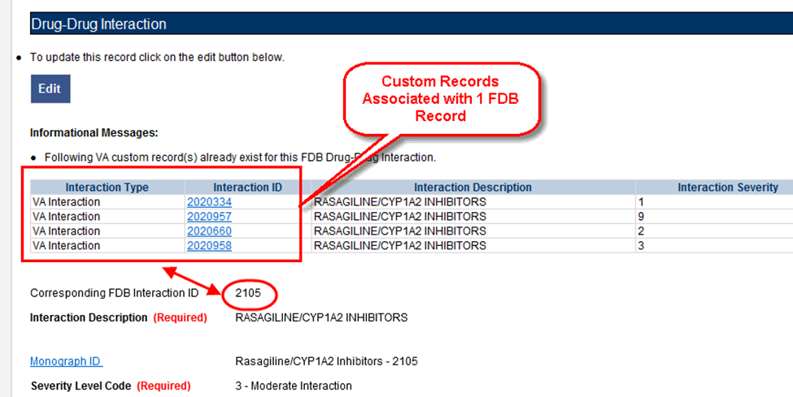

From here, you can create another custom record if you wish. Checks exist in the system so that the same user cannot make duplicate DDIs or another user cannot come in and make the same DDI that another user just made.

### Create Multiple Customizations from One FDB Record

Drug-Drug Interactions and Dose Range records can be customized multiple times from a single FDB record.

To create multiple customizations from one FDB record:

1. Find and display the FDB record you want to customize using Advanced Query/Customization.
2. Click Edit.
3. Create the custom record by changing something and clicking Customize.
4. Your new record is created. The record ID is displayed on the Interaction ID field. If you have any duplicates or other discrepancies, you will see a warning message (such as an identical interaction severity):

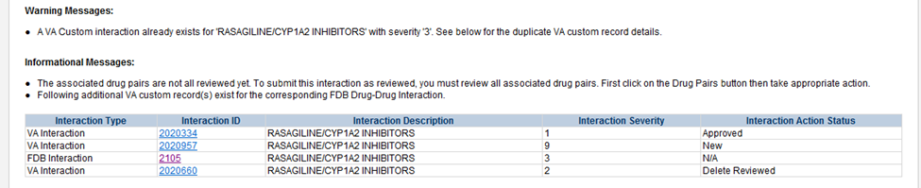

1. Repeat the process using the same FDB record as many times as necessary.

### Cannot Add Identical Drug Pairs to Same DDI

After you have created a new DDI or added new drug pairs to an existing DDI, a second user can come in and attempt to add the same drug pairs. One cannot add a drug pair that currently exists for the selected DDI:

Figure : Error for Duplicate Drug Pairs for One DDI



You will also receive an error if you attempt to customize a drug pair for a DDI in Reverse Order:

Figure : Error for Duplicate Drug Pairs in Reverse Order for One DDI

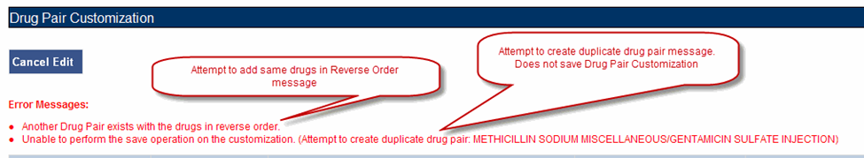

### Reverse Drug-Drug Interactions

Multiple Drug-Drug Interaction records may exist for the same drugs listed in reverse order. For example, FDB Interaction ID 1234 is Drug A/Drug B and FDB Interaction ID 30766 is Drug B/Drug A. Information about reverse DDIs is displayed in the table at the top of the detail page. The screen shot below displays FDB record 1637, which has a DDI customization and a reverse DDI customization.

Figure : FDB DDI with a Customization and a Reverse Customization

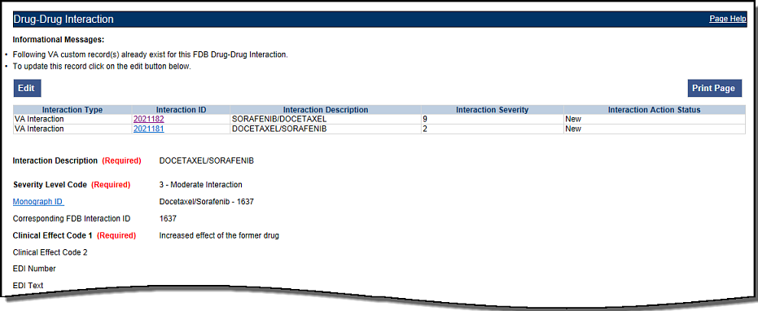

If you click the link associated with the reverse DDI, you will see its detail page (next screen shot):

Figure : Choosing the Reverse VA DDI Customization

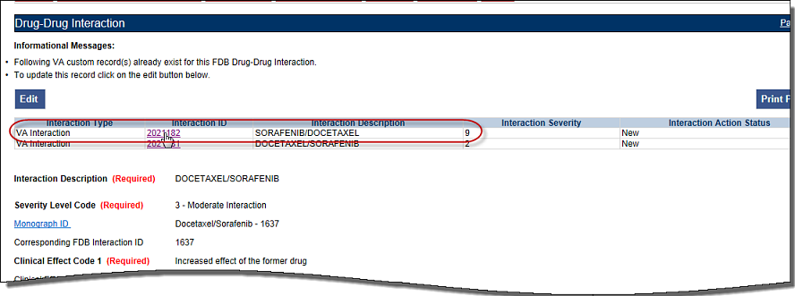

The detail page of the Reverse VA Customization is displayed:

Figure : Reverse FDB Interaction ID

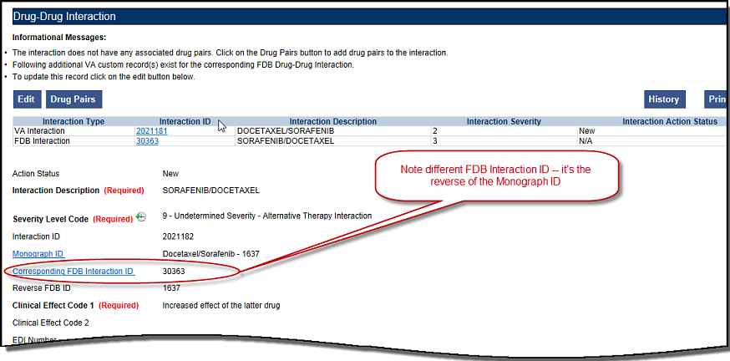

Displaying the Reverse FDB DDI Interaction ID

The Reverse FDB DDI Interaction ID is displayed in the VA custom DDI and DP Detail pages, in the results of DDI and Drug Pair queries and on the FDB Custom DDI Report. The Reverse FDB DDI Interaction ID is defined as the reverse of the FDB DDI ID and is obtained by executing this equation:

32,000 – (minus) FDB Monograph ID.

For example:

* If FDB monograph ID is 2246, the reverse FDB DDI ID is 29745 (32,000 – 2246 = 29745)
* If FDB monograph ID is 29754, the reverse FDB DDI ID is 2246 (32,000 – 29754 = 2246)
* If FDB monograph ID is 0, the reverse FDB Interaction ID is 0 ( i.e., DDI was created from scratch using the Open Blank Form option)

Displaying the reverse FDB DDI Interaction ID in the DDI and DP detail pages, query results, and reports enables you to find information about reverse DDIs easily.

### Working with Drug Pairs within the DDI

Note that you can work with a drug pair only by starting from the Drug-Drug interaction page, and clicking the Drug Pairs button.

See the Drug Pair Detail for additional information.

### Fields

Table : DDI Fields

| Table Heading Name | Table Heading Description |
| --- | --- |
| Monograph ID | The Professional Monograph ID associated with the drug interaction pair. |
| Action Status | Applicable to VA record only. The point this customization is at, within the VA Approval Workflow. |
| Corresponding FDB Interaction ID | The system ID of the FDB record from which the VA customization was created. |
| Interaction ID | The system ID of this VA customization. |
| Reverse FDB ID | The FDB ID associated with a customized reverse interaction ID. |
| Severity Level Code | The level of severity for this Drug-Drug Interaction. |
| Action Date | Applicable to VA record only. The date of the last action taken on the record. |
| Action Performed By | Applicable to VA record only. The name of the user that performed the last action. |
| Request Submitted By | Applicable to VA record only. The name of the user that submitted this VA request. |
| Action Effective Date | Applicable to VA record only. The date of the last action taken on the record. |
| Request Assigned To | Applicable to VA record only. A drop down list to assign an approver. |
| Clinical Effect Code 1 | Clinical effect code. |
| Clinical Effect Code 2 | Clinical effect code |
| EDI Number | The severity level from the Evaluations of Drug Interactions (EDI) system. |
| EDI Text | The interaction text found in EDI. |
| DI Facts Number | Severity number of interaction found in DI Facts. |
| DI Facts Onset | The onset of the interaction as found in DI facts. |
| DI Facts Severity | The severity level of the interaction found in DI facts. |
| DI Facts Documentation | Documentation of the interaction found in the DI Facts. |
| DI Facts Text | The text of the interaction from DI facts. |
| Micromedex Severity | The severity found in Micromedex. |
| Micromedex Onset | The onset of the interaction as found in Micromedex. |
| Micromedex Substantiation | Level of documentation of the interaction found in the Micromedex. |
| Micromedex Text | The interaction text found in Micromedex. |
| Medline Hits | A dropdown list to select whether or not this reference was checked. |
| Medline Text | Brief description of literature results. |
| Package Insert | A dropdown list to select whether or not this reference was checked. |
| Package Insert Text | The interaction text found in the package insert. |
| PBM Criteria | A dropdown list to select whether or not this reference was checked. |
| PBM Criteria Text | Text information found in PBM criteria. |
| AIDS Guidelines | A dropdown list to select whether or not this reference was checked. |
| AIDS Guidelines Text | Text information from the AIDS guidelines. |
| Interaction Source | A drop-down list to select source. |
| Interaction Type | A drop-down list to select type. |
| Highest Level of Evidence | A drop-down list to select the source of the evidence to support the described drug-drug interaction. |
| Group Discussion | General comment from meeting. |
| Action Reason History | Applicable to VA record only. All historical current action reason comments for this record, in one viewable field. |
| Current Action Reason (optional) | Applicable to VA record only. Free form text that can be used to specify the reason for taking the specific action of creating new, modifying, assigning, rejecting, reviewing, approving, or deleting the customization. |
| Export Date | For Approved or Deleted records. Indicates the date of the last Custom Update. See Export Date for additional information. |
| Pre-Customization Comment | Approvers can add comments to un-customized FDB records in this field and click the add comment button to save the comment |
| Pre-Customization Comment History | Displays all comments that have been added to this record prior to customization |

## Drug Pair Detail

Drug Pairs are sets of drugs that are associated with a drug-drug interaction. The Drug Pair detail page allows you to view the details of a drug pair associated with a Drug-Drug Interaction. Unlike other detail pages, there is no way to directly edit a drug pair from a drug pair detail page. Instead, you must make the modifications through the associated Drug-Drug Interaction. See Drug Pair Customization (Non 508-Compliant) Detail or Section 508 Compliant Drug Pair Customization Detail for additional information.

Figure : The Drug Pair Detail Page – VA

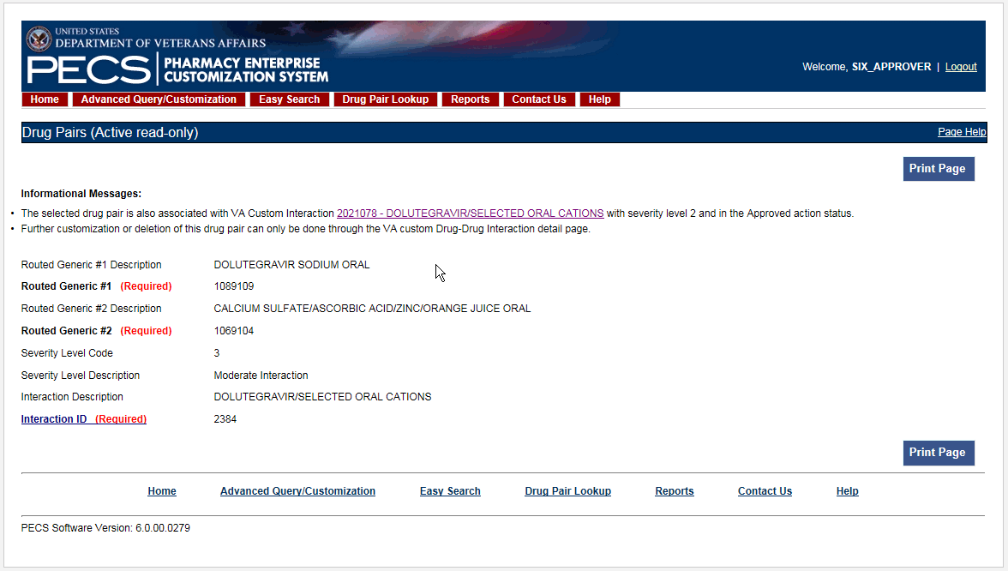

Figure : Drug Pair Detail Page - FDB

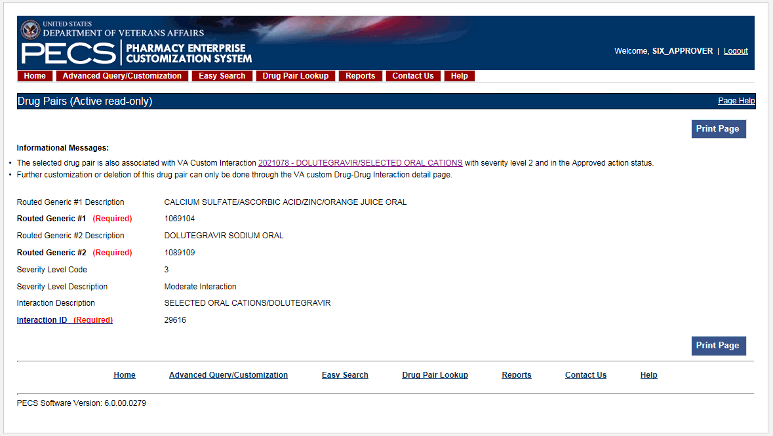

### Fields and Other Information

The information presented on a drug pair detail page is also different from other record types.

Informational Messages

Informational messages are critical with drug pairs; they associate the displayed drug pair with any associated Drug-Drug Interaction.

Figure : Example of Informational Messages for Drug Pair Detail



Table 13 describes the fields for a Drug Pair record. Not all fields are applicable to all record types (FDB or VA).

Table : Field Descriptions for Drug Pair Detail

| Field Name | Field Description |
| --- | --- |
| Action Status | Applicable to VA record only. It is the status of this customization within the VA Approval Workflow. |
| Routed Generic #1 | The ID of the first drug in this Drug Pair. |
| Routed Generic #1 Description | Applicable to FDB record only. The description of the first drug in this Drug Pair. |
| Routed Generic #2 (required) | The ID of the second drug in this Drug Pair. |
| Routed Generic #2 Description | The description of the second drug in this Drug Pair. |
| Severity Level Code | Applicable to FDB record only. The severity level code for this Drug-Drug Interaction. |
| Severity Level Description | The description of the severity level code for this Drug-Drug Interaction. |
| Interaction ID | The ID number of the FDB or VA Custom Drug-Drug Interaction associated with the drug pair. |
| Interaction Description | Applicable to FDB record only. The description of the Interaction ID that the drug pair is associated with. |
| Corresponding FDB Interaction ID | Applicable to VA records only. It is the Interaction ID of the FDB record from which the VA Drug interaction customization was created. |
| Reverse FDB ID | Applicable to VA records only. It is the Reverse FDB Drug-Drug Interaction ID, or the Reverse Interaction ID of the DDI FDB record from which the DDI custom record was created. For more information about the Reverse FDB DDI ID, see “Displaying the Reverse FDB DDI Interaction ID”. |
| Action Performed By | Applicable to VA records only. The name of the user who performed the action. |
| Request Assigned To | Applicable to VA records only. The name of the PECS user assigned to process the customization request. |
| Request Submitted by | Applicable to VA records only. The name of the user that submitted this VA request. |
| Reference Text | Applicable to VA records only. Field for the user to enter any reference text needed to support customization of the drug pair. |
| Action Reason History | Applicable to VA records only. All historical 'current action reason' comments for this record, in one viewable field. |
| Current Action Reason | Applicable to VA records only. Free form text that can be used to specify the reason for taking the specific action of creating new, modifying, assigning, rejecting, reviewing, approving, or deleting the customization. |
| Export Date | Applicable to VA records only. Date that the approved or deleted drug pair record was exported to the incremental update file |
| Action Date | Applicable to VA records only. The date of the last action taken on the record. |

### Finding Drug Pairs

Drug pairs are usually found and processed directly from the Drug-Drug Interaction they are associated with. However, you can search for them directly using either Advanced Query/Customization or Drug Pair Lookup. When searching for drug pairs directly, what is displayed is dependent the record type (VA or FDB) and whether the associated Drug-Drug Interaction has been customized. In all cases, drug pair records cannot be edited directly; you must work through an associated Drug-Drug Interaction.

* If the results locate a customized VA Drug Pair, the VA Drug Pair detail page for that Drug Pair is displayed. The detail page contains a link to the associated Drug-Drug Interaction(s).
* If the results locate an FDB drug pair record that has been customized by VA, the FDB Drug Pair Detail page is displayed. The detail page contains a link to the FDB Drug-Drug Interaction and the customized VA Drug-Drug Interaction created from the FDB Drug-Drug Interaction.
* If the results locate an FDB drug pair record that has NOT been customized by VA, the associated FDB Drug-Drug Interaction detail page is displayed.

Using Advanced Query/Customization

To find a drug pair using Advanced Query/Customization:

1. Click the Advanced Query/Customization tab.
2. Select Drug Pair from the Select Concept List and select the appropriate drug pair type from the Select VA, FDB, or Both list.
3. Build the query to find the appropriate drug pair and click Query.
4. Click the link in the Select column to open the record. The record that is displayed depends on the record type.

See Using Advanced Query/Customization for additional information.

Using Drug Pair Lookup

To find a drug pair using Drug Pair Lookup:

1. Click the Drug Pair Lookup tab.
2. Build the query to find the appropriate drug pair and click Query.
3. Click the link in the Select column to open the record. The record that is displayed depends on the record type.

See Drug Pair Lookup for additional information.

### FDB Drug Pair Detail Page

When a user opens an FDB Drug Pair that is not customized, but the associated FDB Drug-Drug Interaction is customized, the FDB Drug Pair Detail Page is displayed. The informational message will contain all VA Custom Drug-Drug Interactions associated with the FDB Drug-Drug Interaction(s) associated with the drug pair. To customize the drug pair, click the appropriate linked interaction in the informational message.

Figure : Uncustomized FDB Drug Pair

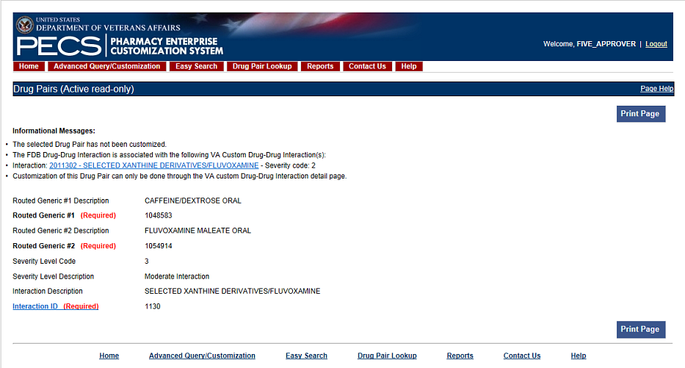

FDB Drug Pair Not Customized, Not Associated with Customized Drug-Drug Interaction

When you open an FDB drug pair that has not been customized and is not associated with a customized Drug-Drug Interaction, the FDB Drug-Drug Interaction associated with the drug pair is displayed. To customize the FDB Drug-Drug Interaction and the associated drug pairs, click the Interaction ID link.

Figure : FDB Drug-Drug Interaction without Customized Drug Pairs

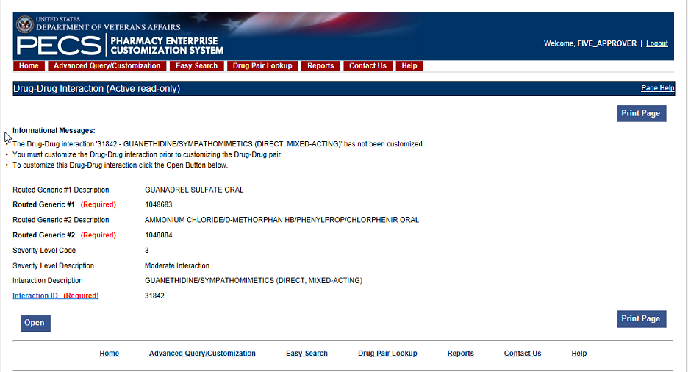

FDB Drug Pair Customized Once

When a user opens an FDB Drug pair that has been customized once, they will be presented with the VA customized drug pair and a link to the associated VA Drug-Drug Interaction ID.

Figure : Drug Pair Detail Page (Read Only)

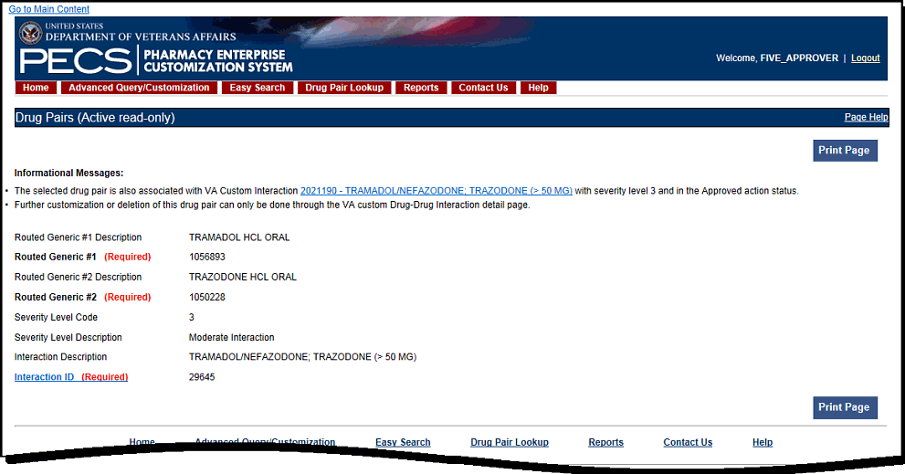

FDB Drug Pair Customized More Than Once

An FDB Drug Pair can be customized more than once. For example; a Drug Pair can be customized for a VA Drug-Drug Interaction and subsequently rejected or deleted. It can then be customized a second time for a different VA DDI. In this case, when the user opens the FDB Drug Pair record, they will not only get information about the FDB drug pair and its associated FDB DDI, they will see two messages about the drug pair and the custom VA DDIs it is associated with. One message says that the drug pair is rejected and another message says that it is in the New Action Status. Two examples follow:

1. The following example shows what will display if the user opens an FDB Drug Pair that was customized for and subsequently rejected from DDI 2021210, and then customized a second time for DDI 2021211. Note the informational messages and the links to the FDB and custom VA DDIs:

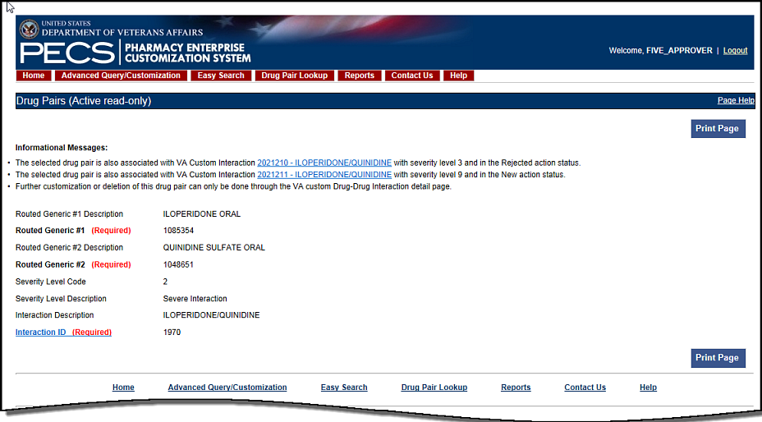

1. The following example shows what will display if the user opens an FDB Drug Pair that was customized and subsequently rejected from DDI 2021212, customized a second time and subsequently deleted from DDI 2021213, and customized for DDI 2021214. Note the informational messages and links to all customizations:

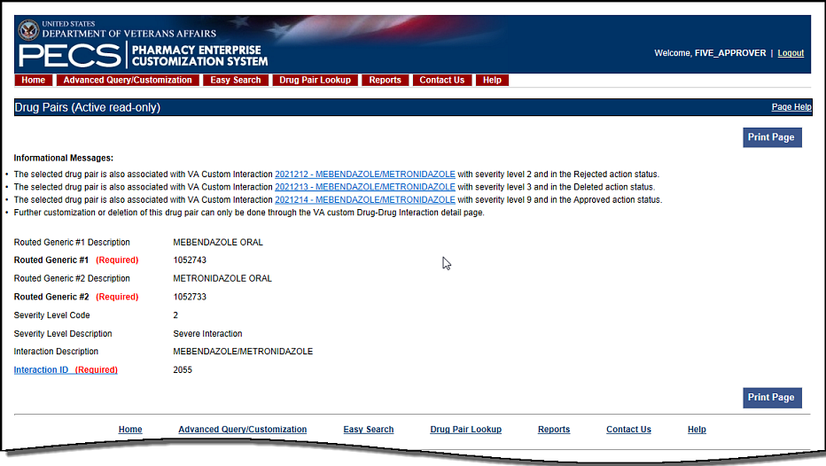

### VA Customized Drug Pair Detail Page

When the user opens a VA Customized drug pair, they will be presented with the customized Drug Pair Detail page.

Figure : VA Customized Drug Pair

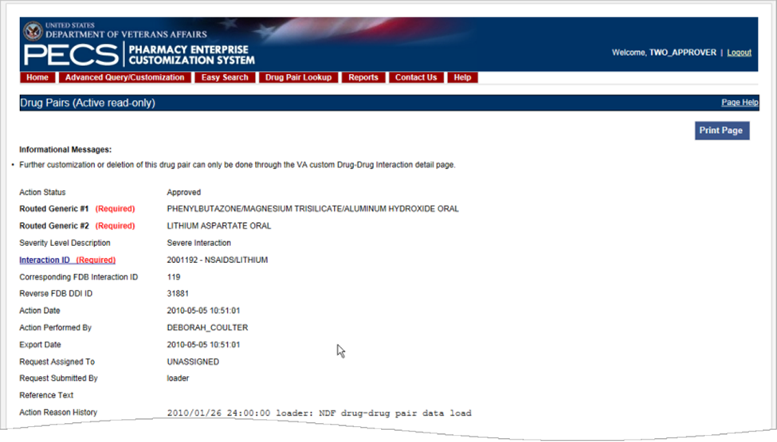

## Drug Pair Customization (Non 508-Compliant) Detail

The Drug Pair Customization (Non 508 Compliant) page allows users to create or delete drug pairs associated with the VA Customized Drug-Drug Interaction as well as perform mass VA Workflow updates to all associated Drug Pairs. To reach this page, click the 'Drug Pairs' button on a VA customized Drug-Drug Interaction detail page.

Figure : Drug Pair Customization Window

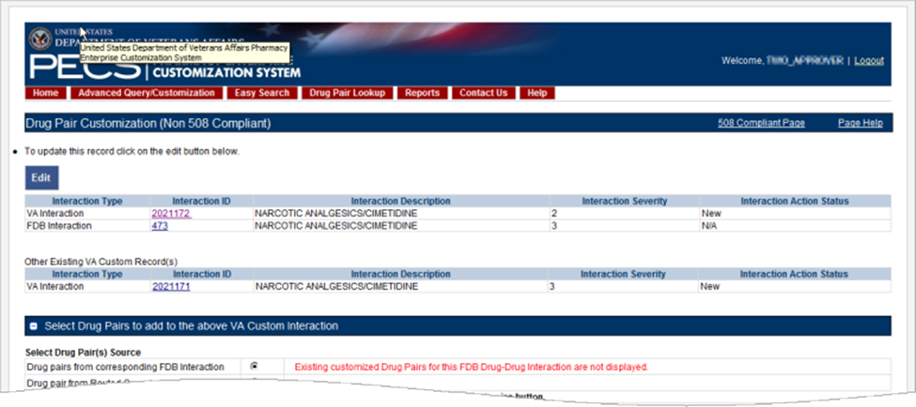

Table 14 on the page displays information related to the drug pair.

Table : Drug Pair-related Information

| Field Name | Field Description |
| --- | --- |
| Interaction Type | The type of interaction displayed, either VA or FDB. |
| Interaction ID | The numerical reference number assigned to the interaction by the agency referenced in the Interaction Type field. |
| Interaction Description | The name of the drug pair associated with the interaction. |
| Interaction Severity | A numerical indicator of the severity of the interaction. |
| Interaction Action Status | The status of the interaction in the VA Approval Workflow. The Action Status for FDB Records will always be 'N/A,' as it does not go through the VA Approval Workflow |

There are two methods to add drug pairs to a drug-drug interaction customization: from existing FDB Drug Pairs (see page ) and from Routed Generics (see page ).

Fields

| Field Name | Field Description |
| --- | --- |
| Reference Text | Field for the user to enter any drug pair reference text needed to support the addition of this/these drug pair(s). |
| Current Action Reason | Applicable to VA record only. Free form text that can be used to specify the reason for taking the specific action of creating new, modifying, assigning, rejecting, reviewing, approving, or deleting the customization. |

Buttons

| Button Name | Button Description |
| --- | --- |
| Customize | Creates the Drug Pair record and associates it to the VA Customized Drug-Drug Interaction. |
| Cancel Edit | Disregards chosen Drug Pair and any text entered into fields and collapses this panel. |

### Drug Pairs Panel

The Drug Pairs panel contains all the VA Customized Drug Pairs already associated to the VA Customized Drug-Drug Interaction (noted at the top of the page). The panel contains

* Interaction Description - VA Customized Drug-Drug Interaction Description
* Routed Generic #1 Description - First drug in the drug pair
* Routed Generic #2 Description - Second drug in the drug pair
* Action Status - current status of the Drug Pair
* Request Submitted By - User ID of the PECS user who made the initial customization request
* Action Date - The date of the most recent action
* Action Performed By - User ID of the PECS user who performed the most recent action
* Request Assigned To - User ID of the PECS user who is responsible for reviewing the drug pair information
* Interaction ID - The numerical identifier for the Drug-Drug Interaction
* Severity Level Description - A text description of the interaction severity
* Reference Text - Contents of the Reference Text field
* Severity Level Code - A numerical identifier for the severity of the Drug-Drug Interaction

The checkboxes at the top allow you to filter what is displayed in the interaction table by Action Status (Historical records are not displayed). You can only process records that are in the same Action Status.

Figure : Drug Pair List Filters



The 'Get Record Counts' button displays count of all VA customized drug pairs associated with the Drug-Drug Interaction. This helps the user to determine how many drug pairs to select to perform an action against at one time. It is recommended that quantities be limited to 200 drug pairs at a time to prevent negative impacts to system performance.

For more information, see the following:

* Customizing Drug Pairs from the Selection List
* Drug-Drug Interaction Detail

### Notification of Drug Pairs Needing Action for an Approved Drug-Drug Interaction

The drug pairs that are associated with a Drug-Drug Interaction (DDI) need to go through the approval/status change process themselves (be approved, rejected, modified, or deleted), separately from the DDI. If the drug pairs are acted upon at the same time as the DDI is acted upon, there is no problem in an Approver knowing that the drug pair needs to be acted upon. However, drug pairs may be added or modified even after a DDI has been acted upon. The way an Approver will know if they need to act on a drug pair associated with an already-approved DDI is by the row on the home page tables that displays the row “Approved Drug-Drug Interaction with Pending Drug Pairs.”

Figure : Approved DDIs with Pending Drug Pairs on Home Page

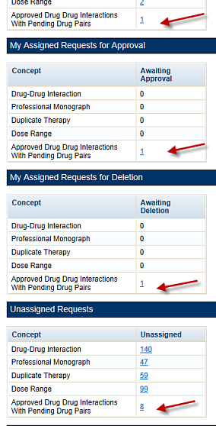

From the screen above, if you select the link "My Assigned Drug Pairs Associated with Approved Drug-Drug Interactions" for one of the states listed that has actual counts (not zero), you are taken to the Advanced Query/Customization page that displays the results for all Drug-Drug Interactions with associated Drug Pairs assigned to you in that state. Here you can act on the drug pairs.

Figure : My Assigned DDIs with Pending Drug Pairs List

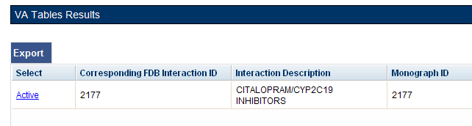

Here is the Interaction window shown after the link is clicked from the Advanced Query Page (Figure 94). On the Interaction window you can act on the drug pairs -- to do so, click the Drug Pairs button:

Figure : DDIs with Needed Drug Pairs – Add with Drug Pairs Button

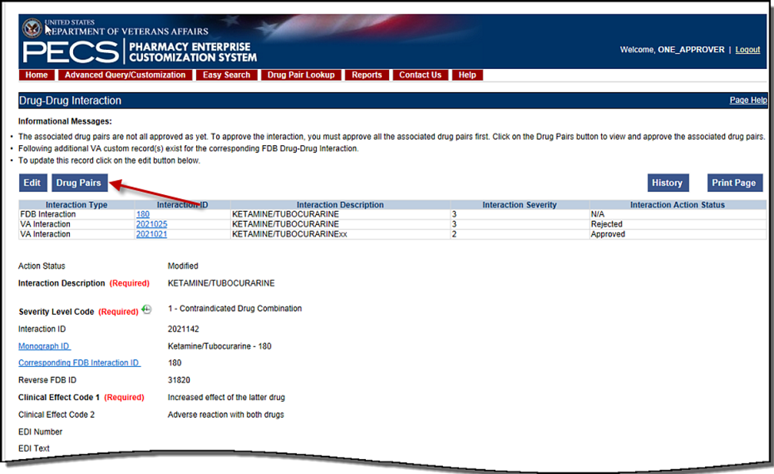

After you click the Drug Pairs button, you can go through the process described in Customizing Drug Pairs from the Selection List (after you click the Edit button).

The paragraphs below describe in detail the process for assigning the request to other Approvers for action.

When you are working with the Drug Pair customization window, there is a drop-down where you can assign the request to a user ID. The default is the Approver who is assigned to the DDI, but you can change that.

Figure : Assigned To: Drop-Down

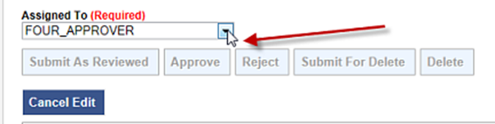

If you change the status of the drug pairs to Submit as Reviewed or Submit for Delete, the drug pairs are automatically reassigned to the "Unassigned" User ID if the user who is assigned to the DDI is the same user who is making the status change. The reassignment happens because the person who submits can’t also do the approval or delete the drug pairs.

Notes:

If you change the status of the drug pairs to Submit as Reviewed or Submit for Delete, the drug pairs are automatically reassigned to the “Unassigned” category.

If you wish to put a Drug-Drug Interaction (DDI) into the Delete_Reviewed status, the Drug Pairs associated with the DDI must be in either a “Delete Reviewed,” “Rejected” or “Deleted” status.

A routed generic Drug Pair that was deleted and then customized in the reverse order will be listed with those in the New Action Status and displayed in reverse order in the Drug Pairs table on the Drug Pairs Customization page.

### Customizing Drug Pairs from the Selection List

PECS allows you to create multiple drug pairs for an interaction at one time. This same multi-select method allows you batch process drug pairs for other operations such as Review, Reject, and Delete. The process differs slightly between drug pairs created from a corresponding FDB interaction or using routed generic drugs.

Adding Drug Pairs from Corresponding FDB Interaction

When adding FDB Drug Pairs to an interaction on the Batch Customization page, you may select single drug pairs, groups of consecutive drug pairs, or a combination of both.

**Note:** The following instructions are written for the screen that is non-compliant for Section 508. See Section 508 Compliant Drug Pair Customization Detail for instructions on how to use the compliant screen.

To select single drug pairs, simply click on the corresponding checkboxes of the drug pairs you want to select.

Figure : Drug Pair Selection List

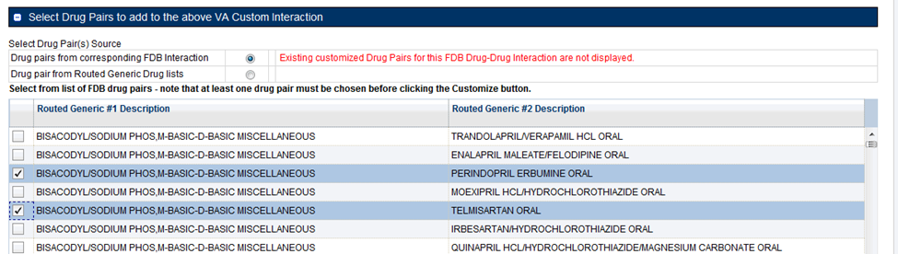

To select groups of consecutive drug pairs, click on the first checkbox in the group and then Shift + click on the last checkbox in the group. All drug pairs between the first and last checkboxes will be selected. If you wish to add another group to your selection, simply click on the first checkbox in the second group and shift/click on the last checkbox in the group. You will now have two groups of drug pairs selected. To add other non-consecutive drug pairs, click on the corresponding checkbox.

Figure : Large Group of Selected Drug Pair for Batch Update

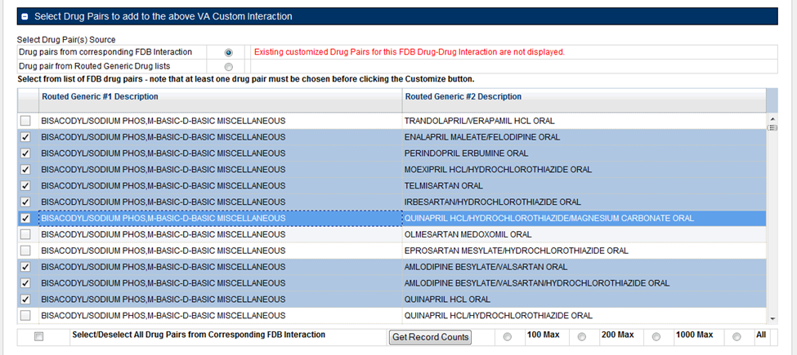

Drug Pairs from Routed Generic Drugs

To select multiple drug pairs from Routed Generic drugs:

1. On the Drug Pair Customization window, select Drug pair from Routed Generic Drug lists from the Select Drug Pair(s) Source list.

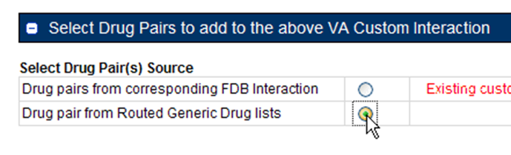

1. Click Edit.
2. Enter all or part of a routed generic drug name in the Routed Generic 1 field. To display all routed generic drugs, enter *. The list will populate automatically, but the process may take some time based on server load and the specificity of the search term.
3. Enter all or part of a routed generic drug name in the Routed Generic 2 field. To display all routed generic drugs, enter *. The list will populate automatically, but the process may take some time based on server load and the specificity of the search term.
4. To select a range of routed generic drugs from the results list, click the first item in the range, then Shift + click (click while holding down the shift key) the last item in the range. You can use the scroll bar on the results list if the last item in the range is not immediately visible.

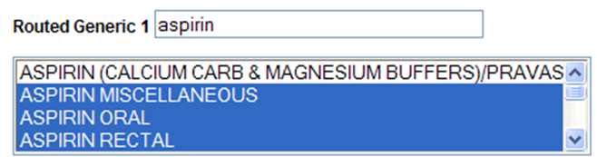

1. To select non-contiguous items in the results list, click to select the first item, then Ctrl + click (click while holding down the Ctrl key) any additional items. You can use the scroll bar on the results list if the last item in the range is not immediately visible. This technique can also be used to de-select items within a previously selected range of items.

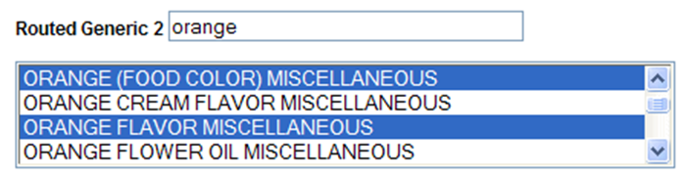

1. Click the Customize button. After processing, the new drug pairs will appear in the Drug Pairs list. In this example, six new drug pairs were created: each of the three selected Routed Generic 1 drugs is now paired with the two selected Routed Generic 2 drugs.

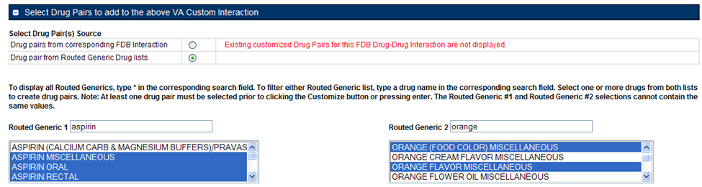

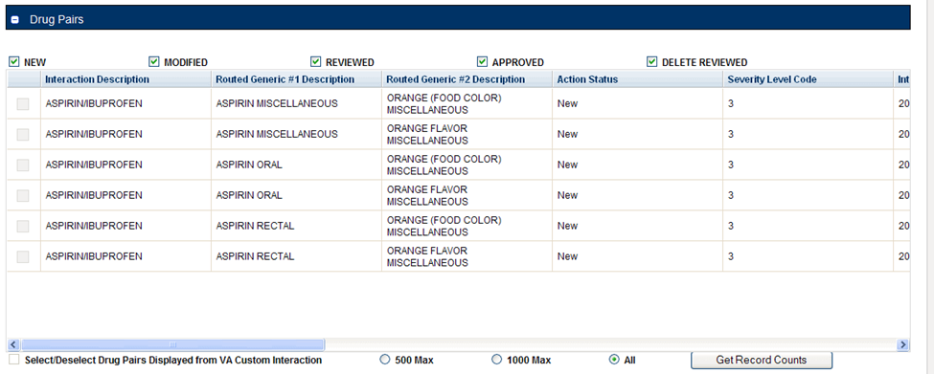

Batch Update Drug Pairs

You can use the quick selection processes describe above to change the actions status of multiple drug pairs at the same time. The Action buttons available are dependent upon the action status of the selected drug pairs. Only mutually appropriate actions will be available.

### Review a Drug Pair

An Approver may be assigned to review drug pairs associated with a drug-drug interaction. Your options are to either Submit as Reviewed, indicating that the Drug Pair associated with the drug-drug interaction is appropriate, or Reject the Drug Pair as inappropriately associated with the Drug-Drug interaction.

To review a drug pair associated with an interaction customization:

1. From the Drug-Drug Interaction record, click Drug Pairs.

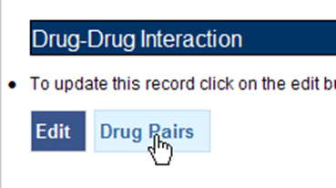

1. When the Drug Pair Customization page appears, click Edit.

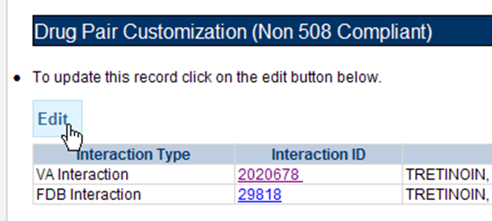

1. In the Drug Pairs panel, select one or more drug pairs currently associated with the drug-drug interaction. For information on selecting multiple items within a list, see Customizing Drug Pairs from the Selection List.

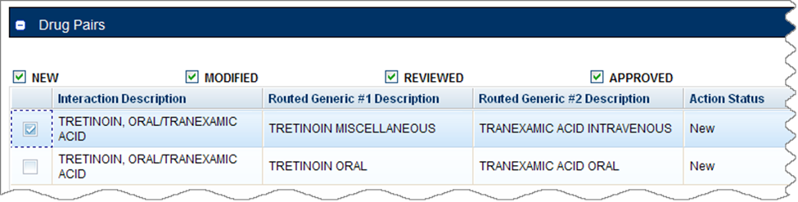

1. Using the Assigned To list, select the person to Approve the drug pair association with the selected drug-drug interaction. If you are not sure who this should be, select Unassigned.

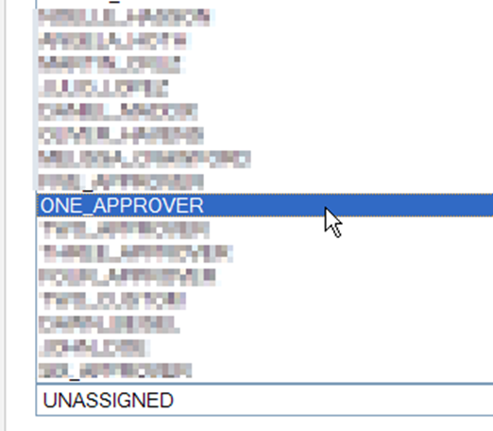

1. Click Submit as Reviewed to indicate that you have reviewed and agree that the drug pair is correctly associated with the selected drug-drug interaction; Click Reject to indicate that you do not agree that the drug pair is correctly associated with the selected drug-drug interaction-- this will remove the drug pair from the record; Click Cancel Edit to abandon the current editing session and leave the record unchanged.

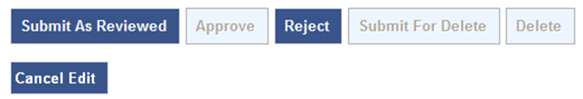

**Note:** Drug Pair records can be modified after they have been Reviewed.

## Section 508 Compliant Drug Pair Customization Detail

**Note:** These are the instructions for the Section 508 compliant version of the Drug Pair Customization page. For Non-compliant Drug Pair customization, see Drug Pair Customization (Non 508-Compliant) Detail.

To reach the Section 508-Compliant version of the Drug Pair Customization page:

1. Click the 'Drug Pairs' button on a VA customized Drug-Drug interaction detail page.
2. Click the 508-Compliant Page link in the Drug Pair Customization banner.

Figure : Link to Access 508-Compliant Drug Pair Selection Page



### Select Drug Pairs to Add to the Above VA Custom Interaction Panel

These are instructions on how to select drug pairs on the Section 508 Compliant Drug Pair Customization page.

Add Routed Generic to VA Custom Interaction

If the interaction is customized from a blank form, there are no FDB drug pairs to choose from. The user will choose drug pairs from Routed Generic drug lists. The user will select the first drug “Routed Generic #1 Description” and then select the second drug “Routed Generic #2 Description” for the Drug Pair they are associating to this VA customized Drug-Drug Interaction. Note that a drug pair must be chosen before clicking the “Customize button”. “Routed Generic #1” and “Routed Generic #2” fields cannot contain the same chosen value. “'Routed Generic #1” and “Routed Generic #2”' must follow the same order as the Interaction Description. The user must be careful to select all routed generics that contain the desired drug as an ingredient. Combination products may not fall alphabetically close to single ingredient products. The Routed Generic drug lists can also be used to add drug pairs to a drug-drug interaction customized from an FDB record if the drug pairs to be added do not exist in the FDB database.

Figure : Routed Generic Drug List on 508-Compliant Page

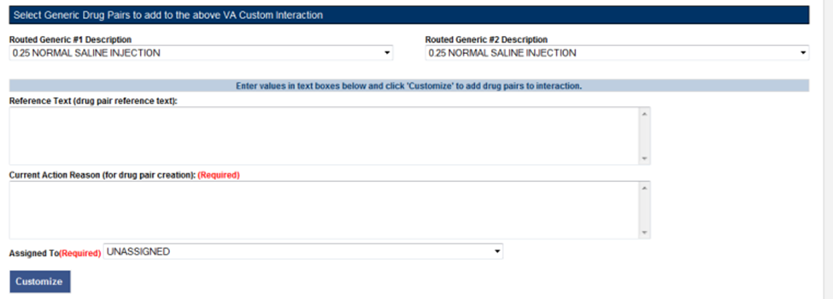

To add a Routed Generic drug pair:

1. Click the Edit button.

In the "Select Generic Drug Pairs to add to the above VA Custom Interaction" panel, select the first drug from the Routed Generic #1 Description list.

Select the second drug from the Routed Generic #2 Description list.

Add any available reference text to the Reference Text field. This is not required.

Add a reason for your current action in the Action Reason field. This is required.

Select a PECS user to review your action in the Action Reason field.

Click the Customize button.

Add FDB Drug Pairs to VA Custom Interaction

If the interaction is customized from an FDB record, you can select any or all of the corresponding FDB drug pairs. Each FDB drug pair consists of Routed Generic #1 and Routed Generic #2. Select the checkbox adjacent to the drug pair or pairs to select it to add to the custom interaction.

Figure : Corresponding FDB Drug Pairs, 508-Compliant Page

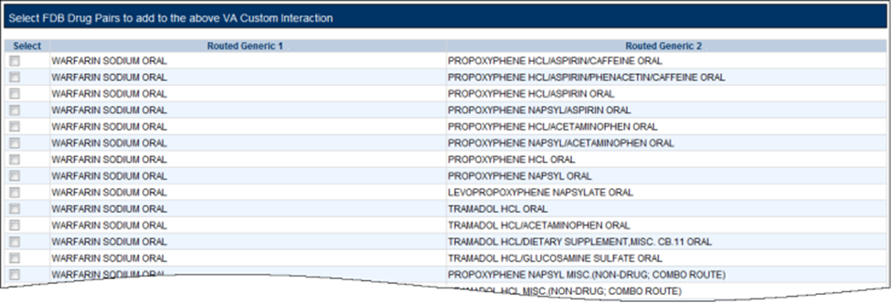

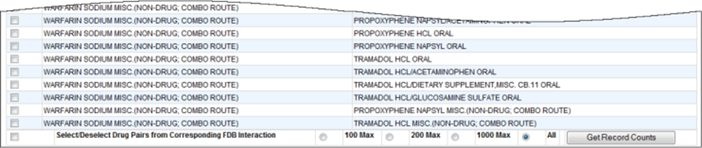

To add a FDB drug pair:

1. Click the Edit button.
2. In the "Select FDB Drug Pairs to add to the above VA Custom Interaction" panel, select the check box adjacent to the drug pair you want to add to the customization. You can select more than one drug pair. To select all the drug pairs, select the 'Select/Deselect All Drug Pairs Displayed from Corresponding FDB Interaction' check box; to limit the number selected, select one of the number-specific radio buttons.
3. Add any available reference text to the Reference Text field. This is not required.
4. Add a reason for your current action in the Action Reason field. This is required.
5. Select a PECS user to review your action in the Action Reason field.
6. Click the Customize button.

Drug Pairs Panel

The Drug Pairs panel contains all the VA Customized Drug Pairs already associated to the VA Customized Drug-Drug Interaction (noted at the top of the page). The panel contains:

* Interaction Description - VA Customized Drug-Drug Interaction Description
* Routed Generic #1 Description - First drug in the drug pair
* Routed Generic #2 Description - Second drug in the drug pair
* Action Status - current status of the Drug Pair
* Request Submitted By - User ID of the PECS user who made the initial customization request
* Action Date - The date of the most recent action
* Action Performed By - User ID of the PECS user who performed the most recent action
* Request Assigned To - User ID of the PECS user who is responsible for reviewing the drug pair information
* Interaction ID - The numerical identifier for the Drug-Drug Interaction
* Severity Level Description - A text description of the interaction severity
* Reference Text - Contents of the Reference Text field
* Severity Level Code - A numerical identifier for the severity of the Drug-Drug Interaction

The checkboxes at the top allow the user to what is displayed in the interaction table by Action Status (Historical records are not displayed). The drug pairs must be in the same state before an action can be performed on them.

Figure : Drug Pair List Filters



The 'Get Record Counts' button will display the count of all VA customized drug pairs associated with the Drug-Drug Interaction. This helps you to determine how many drug pairs require processing. It is recommended that no more than 200 drug pairs are processed at a time to prevent negative impacts to system performance.

To perform a batch update on the drug pairs:

1. Use the Action Status checkbox filters to make sure all drug pairs selected are in the same Action Statuses
2. Select the amount that will be updated in this one action
3. Select all or the individual drug pairs
4. Select the allowed Approval Workflow action to be performed (Submit as Reviewed, Approve, Reject, etc.)

Repeat this process for all of the drug pairs until the entire set of drug pairs is in the desired point in the Approval Workflow.

## Professional Monograph Detail

A Professional Monograph is a document containing drug interaction information written for healthcare professionals. The Professional Monograph Detail Page allows the user to view the details of a Professional Monograph and customize it for VA use.

FDB monographs are not generally customized, however some Professional Monographs have been created from blank documents at the national level for drug interactions that do not appear in the FDB database

Figure : Professional Monograph Detail, Top and Bottom

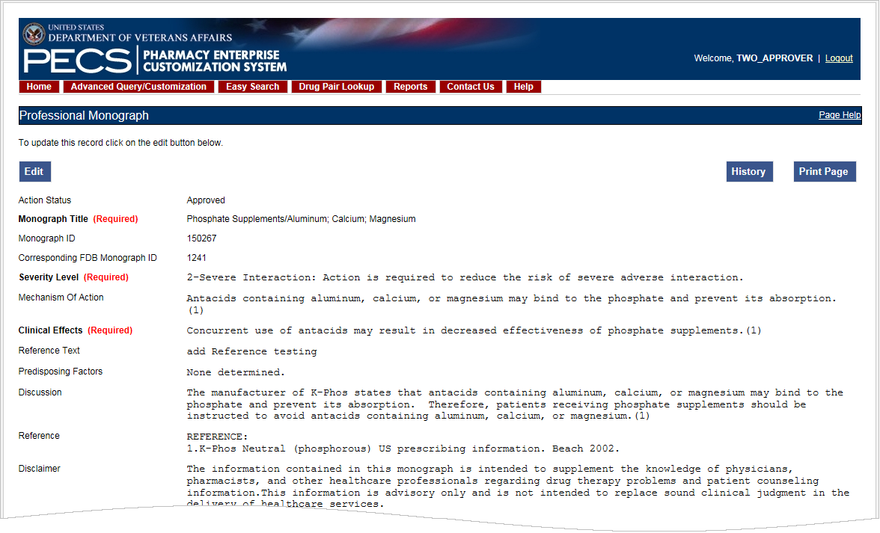

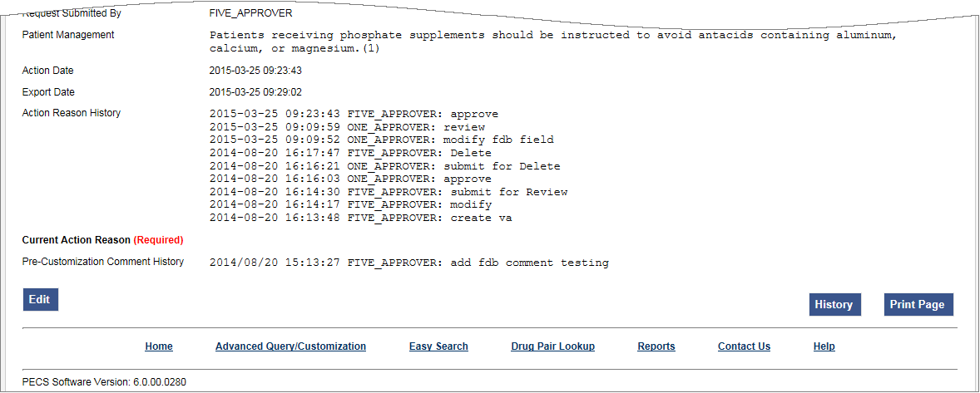

### Fields

Fields that cannot be modified are shaded within PECS.

Table : Professional Monograph Fields

| Field Name | Field Description |
| --- | --- |
| Monograph Title | The title Monograph is usually the two drugs that have the interaction. |
| Monograph ID | The VA-assigned numerical identifier for the Monograph. |
| Action Status | Applicable to VA record only. The point this customization is at, within the VA Approval Workflow. |
| Action Date | Applicable to VA record only. The date of the last action taken on the record. |
| Action Performed by | Applicable to VA record only. The name of the user that performed the last action. |
| Action Effective Date | Applicable to VA record only. The date of the last action taken on the record. |
| Corresponding FDB Monograph ID | The First Databank (FDB)-assigned numerical identifier for the Monograph. |
| Request Assigned To | Applicable to VA record only. Approver the request is assigned to. |
| Request Submitted By | Applicable to VA record only. The name of the user that submitted this VA request. |
| Severity Level | The severity level associated with the interaction. |
| Mechanism Of Action | The specific biochemical interaction through which a drug interaction occurs. For instance, pharmacokinetic drug interactions may include:   * Inhibition of absorption * Enzyme inhibition increasing the risk of toxicity * Enzyme inhibitors resulting in reduced drug effect * Enzyme induction resulting in reduced effect * Enzyme induction resulting in toxic metabolites * Altered renal elimination   Pharmacodynamic drug interactions include:   * Additive effects * Antagonistic pharmacodynamic effects |
| Clinical Effects (required) | The Clinical effects associated with the interaction. |
| Predisposing Factors (optional) | The factors or conditions that render an individual vulnerable to a drug interaction? |
| Patient Management (optional) | Describe the management options available to the provider, for example:  Discontinuation of the medication  Increased monitoring  Laboratory tests  Scheduling the medication at different times |
| Discussion | Usually case reports or discussion. |
| Reference | Cited reference information. |
| Disclaimer | Textual reminder that the information provided is not intended to replace the user's clinical judgment. |
| Reference Text | Applicable to VA record only. Field for the user to enter any reference text needed to support customization of the Professional Monograph. |
| Action Reason History | Applicable to VA record only. All historical current action reason comments for this record, in one viewable field. |
| Current Action Reason | Free form text that can be used to specify the reason for taking the specific action of creating new, modifying, assigning, rejecting, reviewing, approving, or deleting the customization. |
| Export Date | For Approved or Deleted records. Indicates the date of the last Custom Update. See Export Date for additional information. |

### Buttons

Print Page - Allows the user to print the page being viewed.

History - Allows the user to open the history of changes report.

Comment - Add a pre-customization comment (FDB Only)

### Forward and Reverse Professional Monograph

A single VA Custom Drug-Drug Interaction could be associated with a separate custom Professional Monograph for the forward and reverse interactions. An interaction described as Drug A and Drug B would have a different Custom Monograph from an interaction described as Drug B and Drug A. These different monographs may be necessary because there could be a different Clinical Effect Code between forward and reverse interactions (DrugA+DrugB: Clinical Effect Code = Adverse effects of the former drug; DrugB+DrugA: Clinical Effect Code = Adverse effects of the latter drug).

The following VA Custom Professional Monograph pairs will be associated with each other. This means that when a Monograph is assigned to a VA Custom Drug-Drug Interaction, the corresponding Monograph will be automatically assigned to the reverse Drug-Drug Interaction (DDI1 = DrugA + DrugB; DDI2 = DrugB+DrugA).

Here is a list of the monograph IDs and titles, and the paired Monograph ID and title.

Table : Forward and Reverse Professional Monograph Pairs

| Monograph ID and Title | Paired Monograph ID and Title |
| --- | --- |
| 150022 VA Customized: Adverse Effects of Former Drug (Critical) (ARF1) | 150024 VA Customized: Adverse Effects of Latter Drug (Critical) (ARL1) |
| 150023 VA Customized: Adverse Effects of the Former Drug (Significant) (ARF2) | 150025 VA Customized: Adverse Effects of the Latter Drug (Significant) (ARL2) |
| 150030 VA Customized: Decreased Effects (Critical) (DEF1) | 150032 VA Customized: Decreased Effects (Critical) (DEL1) |
| 150031 VA Customized: Decreased Effects (Significant) (DEF2) | 150033 VA Customized: Decreased Effects (Significant) (DEL2) |
| 150034 VA Customized: Increased Effects (Critical) (INF1) | 150036 VA Customized: Increased Effects (Critical) (INL1) |
| 150035 VA Customized: Increased Effects (Significant) (INF2) | 150037 VA Customized: Increased Effects (Significant) (INL2) |
| 150040 VA Customized: Mixed Effects of Former Drug (Critical) (MXF1) | 150103 VA Customized: Mixed Effects of Latter Drug (Critical) (MXL1) |
| 150041 VA Customized: Mixed Effects of the Former Drug (Significant) (MXF2) | 150104 VA Customized: Mixed Effects of the Latter Drug (Significant) (MXL2) |

When viewing a Drug-Drug Interaction, the PECS user interface will only display the Professional Monograph associated with the Forward interaction. The associated Reverse Professional Monograph will only be visible in the custom updates file created by the Release Manager.

Figure : Forward/Reverse DDIs with Professional Monographs, Custom Update File Created by Release Manager

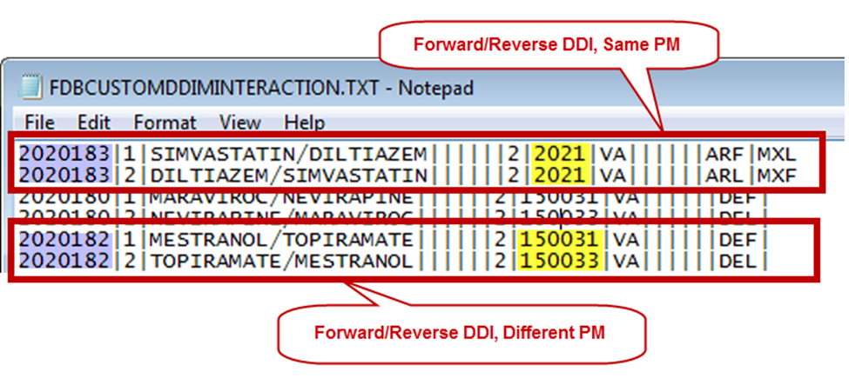

## Duplicate Therapy Detail

The Duplicate Therapy Detail page allows you to view and edit the details of a Duplicate Therapy record. If you edit an FDB record, the result is a VA Customization Request. For FDB records that have not been customized, you also have the option of adding a comment that will be retained with the record; if the record is later customized, these pre-customization comments will be displayed with the customized record. Once the FDB record has been customized, a link to the VA customized record will be provided. FDB Duplicate Therapy records can be customized only once; if the record has already been customized, it displays in Read-only mode, and you will not be able to customize it again (the Edit button will not display).

Figure : Duplicate Therapy Detail

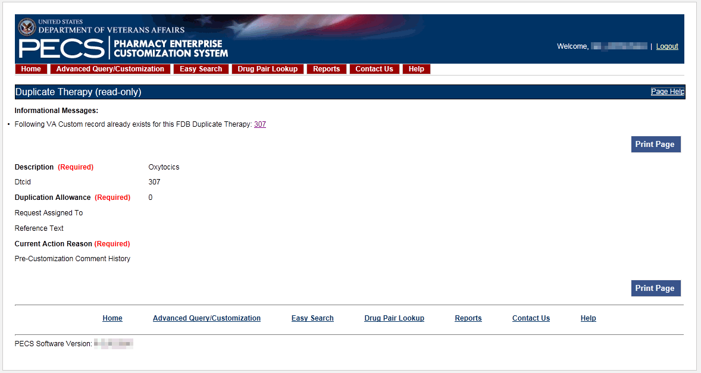

### Fields

Table : Duplicate Therapy Detail Fields

| Field Name | Field Description |
| --- | --- |
| DTCID | Duplicate therapy ID assigned by First Databank (FDB). |
| Custom Dup Allowance | The number of drugs a patient can be prescribed, within a Therapeutic Drug Class, before an alert is generated. A 0 duplicate allowance means only 1 medication from that Therapeutic class can be on the patient profile without getting an order check (zero duplication). If a second drug from that class is added the provider gets the order check. If the allowance is 1, two drugs can be on the patient profile at once, the 3rd drug added would get the check (one duplication), etc. |
| Description | The name of this Therapeutic Drug Class. |
| Action Status | Applicable to VA record only. The point this customization is at, within the VA Approval Workflow. |
| Action Date | Applicable to VA record only. The date of the last action taken on the record. |
| Export Date | For Approved or Deleted records. Indicates the date of the last Custom Update. See Export Date for additional information. |
| Action Effective Date | Applicable to VA record only. The date of the last action taken on the record. |
| Action Performed By | Applicable to VA record only. The name of the user that performed the last action. |
| Request Assigned To | Applicable to VA record only. A drop down list to assign an approver. |
| Request Submitted By | Applicable to VA record only. The name of the user that submitted this VA request. |
| Action Reason History | Applicable to VA record only. All historical current action reason comments for this record, in one viewable field. |
| Reference text | Field for the user to enter any reference text needed to support customization of the Duplicate Allowance. |
| Current Action Reason | Applicable to VA record only. Free form text that can be used to specify the reason for taking the specific action of creating new, modifying, assigning, rejecting, reviewing, approving, or deleting the customization. |

### Buttons

Print Page - Allows the user to print the page being viewed.

History - Allows the user to open the history of changes report.

Add Comment - Uncustomized FDB Records Only: Add a Pre-Customization comment to the FDB record.

## Dose Range Detail

A Dose Range is the allowable dosage of a drug based on a number of factors such as patient age, weight, and Dose Route. The Dose Range Detail page allows you to view the details of a Dose Range record. If the FDB record is Concept Type 6 (Generic Dispensable Drug) you can customize it. For FDB records of concept type other than 6, the only action you can take is to add a comment. Once the FDB record has been customized, a link to the VA customized record (or records) will be provided. For VA records, a link to the original FDB record (if one exists) is provided as well as any additional customizations to the same FDB record.

Figure : Dose Range Detail, Top and Bottom

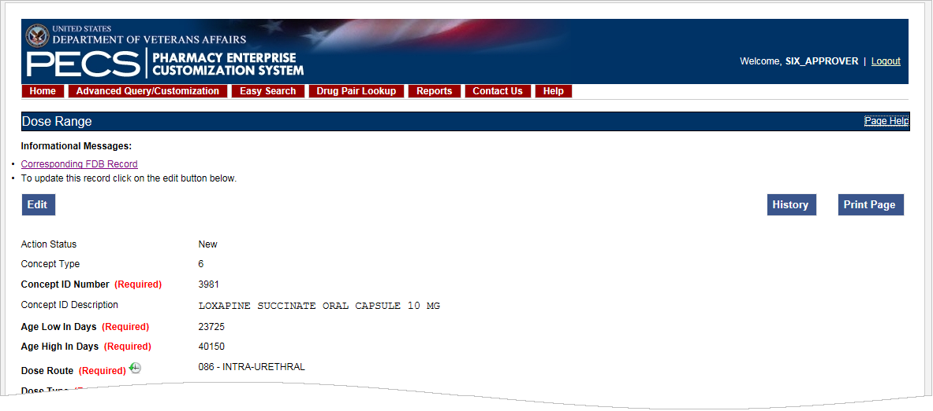

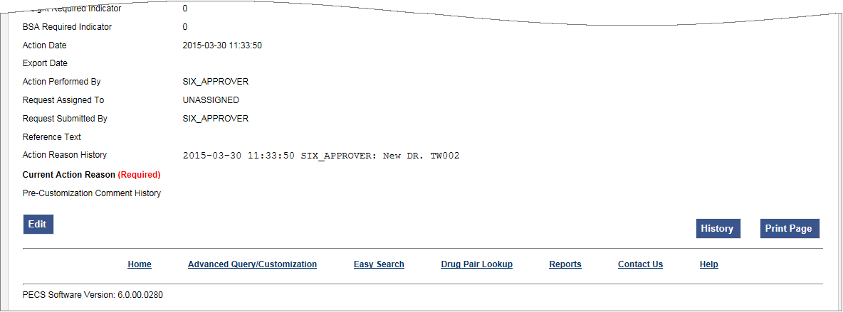

### Dose Range Concept Types

FDB Dose Range records can be associated to different drug Concept Types (a type associated in the FDB drug database that PECS uses). However, only Concept Type 6 - Generic Dispensable Drug can be customized. The Concept Types are:

1 -- Drug Name

2 -- Routed Drug

3 -- Dispensable Drug

4 -- Generic Drug Name

5 -- Generic Routed Drug

6 -- Generic Dispensable Drug

7 -- Routed Dosage Form Drug

8 -- Generic Routed Dosage Form Drug

100 -- Packaged Drug

101 -- Manufactured Drug

102 -- Reference Only Item

103 -- Compound

104 -- Ingredient

105 -- Regional Packaged Drug

106 -- Total Parenteral Nutrition Solution

### Fields

Table : Dose Range Detail Fields

| Field | Description |
| --- | --- |
| Concept Type | Number identifying the drug's concept type (FDB dose range category) |
| Concept ID Number | Number identifying the drug (For Concept Type = 6, Concept ID number = GCNSEQ code - an FDB product code) |
| Concept ID Description | The name of the drug being described. |
| Action Status | Applicable to VA record only. The point this customization is at, within the VA Approval Workflow. |
| Age Low in Days | Lowest patient age in days to which dosing information applies |
| Age High in Days | Highest patient age in days to which dosing information applies |
| Action Effective Date | Applicable to VA record only. The date of the last action taken on the record. |
| Dose Route | Dose route |
| Dose Type | Dose type |
| FDBDX | A nine-character alphanumeric coding system developed by First DataBank that identifies specific disease states or side effects. |
| DXID | DXID type code to identify a Medical Condition |
| Dose Low | Minimum amount to be administered per day |
| Dose Low Units | Unit of measure for low dose per day |
| Dose High | Highest amount to be administered per day |
| Dose High Units | Unit of measure for high dose per day |
| Dose Form Low | Low dose for a given dose form |
| Dose Form Low Units | Unit of measure for the dose form |
| Dose Form High | High dose for a given dose form |
| Dose Form High Units | Unit of measure for the dose form |
| Frequency Low | Indicates the low end of a drug's frequency of administration per day |
| Frequency High | Indicates the high end of a drug's frequency of administration per day |
| Duration Low | Indicates the lowest recommended duration of therapy (in days) |
| Duration High | Indicates the highest recommended duration of therapy (in days) |
| Max Duration | Indicates the maximum recommended duration of therapy (in days) |
| Max Single Dose | Maximum amount to be administered in a single dose |
| Max Single Dose Units | Unit of measure for the maximum single dose |
| Max Single Dose Form | Maximum single dose for a given form |
| Max Single Dose Form Units | Unit of measure for the dose form |
| Max Daily Dose | Maximum amount to be administered per day |
| Max Daily Dose Units | Unit of measure for the maximum daily dose |
| Max Daily Dose Form | Maximum daily dose for a dose form |
| Max Daily Dose Form Units | Unit of measure for the dose form |
| Max Lifetime Dose | Maximum amount to be administered over a patient’s lifetime, if available |
| Max Life Time Dose Units | Unit of measure for maximum lifetime dose |
| Max LifeTime Dose Form | Maximum lifetime dose for a given dose form |
| Max LifeTime Dose Form Units | Unit of measure for the dose form |
| Dose Rate Low | Minimum amount to be administered per dose rate (hours or minutes) |
| Dose Rate Low Units | Unit of measure for low dose rate (hours or minutes) |
| Dose Rate High | Highest amount to be administered per dose rate (hours or minutes) |
| Dose Rate High Units | Unit of measure for high dose rate (hours or minutes) |
| Dose Form Rate Low | Low dose for a given dose form rate (hours or minutes) |
| Dose Form Rate Low Units | Unit of measure for the dose form rate (hours or minutes) |
| Dose Form Rate High | High dose for a given dose form rate (hours or minutes) |
| Dose Form Rate High Units | Unit of measure for the dose form rate (hours or minutes) |
| Max Single Dose Rate | Maximum amount to be administered in a single dose rate (hours or minutes) |
| Max Single Dose Rate Units | Unit of measure for the maximum single dose rate (hours or minutes) |
| Max Single Dose Form Rate | Maximum single dose for a given dose form rate (hours or minutes) |
| Max Single Dose Form Rate Units | Unit of measure for the dose form rate (hours or minutes) |
| Max Daily Dose Rate | Maximum amount to be administered per dose rate (hours or minutes) |
| Max Daily Dose Rate Units | Unit of measure for the maximum daily dose rate (hours or minutes) |
| Max Daily Dose Form Rate | Maximum daily dose for a dose form rate (hours or minutes) |
| Max Daily Dose Form Rate Units | Unit of measure for the dose form rate (hours or minutes) |
| Hepatic Impairment IND | Boolean (0/1) indicating whether dosing needs to be adjusted for hepatic impairment |
| Renal Impairment IND | Boolean (0/1) indicating whether dosing needs to be adjusted for renal impairment |
| CRCL Threshold | Number indicating lowest creatinine clearance to which dosing applies |
| CRCL Threshold Units | Unit of measure for the creatinine clearance threshold |
| Low Elimination Half Life | Indicates the low end of the drug's half-life range |
| High Elimination Half Life | Indicates the high end of the drug's half-life range |
| Half Life Units | Unit of time for the half-life range of a drug |
| Weight Required IND | Boolean (0/1) indicating whether weight is required for dosing |
| BSA Required IND | Boolean (0/1) indicating whether body surface area is required for dosing |
| Request Submitted By | Applicable to VA record only. The name of the user that submitted this VA request. |
| Request Assigned To | Applicable to VA record only. A drop down list to assign an approver. |
| Action Performed By | Applicable to VA record only. The name of the user that performed the last action. |
| Action Date | Applicable to VA record only. The date of the last action taken on the record. |
| Export Date | For Approved or Deleted records. Indicates the date of the last Custom Update. See Export Date for additional information. |
| Reference Text | Applicable to VA record only. Field for the user to enter any reference text needed to support customization of this Dose Range. |
| Action Reason History | Applicable to VA record only. All historical 'current action reason' comments for this record, in one viewable field. |
| Current Action Reason | Applicable to VA record only Free form text that can be used to specify the reason for taking the specific action of creating new, modifying, assigning, rejecting, reviewing, approving, or deleting the customization. |

### Buttons

Print Page - Allows the user to print the page being viewed.

History - Allows the user to open the history of changes report.

Comment - Add a pre-customization comment (FDB Only)

*(This page included for two-sided copying.)*

# Sample Modification Scenarios

The following scenarios are examples of the types of modifications a typical user may perform. It is not a step-by-step guide in instructing users how to perform actual modifications. Sample steps are given, but these could differ based on the customizations being modified.

## Duplicate Therapy Modification

Sample case: You are making a Duplicate Therapy customization for Topical Pine Tar.

### Process Steps

Edit duplicate therapy allowance:

1. From the Home Page, click the Advanced Query/Customization tab.
2. Select “Duplicate Therapy” from the *Select a Concept* drop-down and select ‘FDB’ from the *Select VA, FDB, or Both* drop-down
3. Build the query as follows: Fields=Description; Filter=contains; Value=Tar.
4. Click the Query button.
5. Look at the query results at the bottom of the page.
6. Click the Open link for the desired class of drug.
7. You see the following:

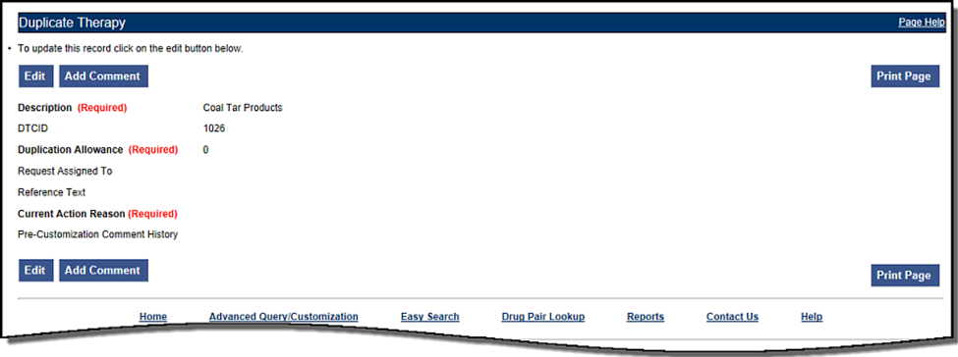

1. Click the Edit button to edit the record.
2. Click the drop down arrow on Custom Dup Allowance (required) and select another number.
3. Enter a Description (required).
4. Enter the Current Action Reason (required).
5. Add any reference text you think is needed (optional).
6. Click the Customize button.

## Duplicate Therapy Approval

Sample Case: After the duplication allowance has been edited for the above situation, you need to submit the request for approval. Assign this request to FOUR_APPROVER.

### Process Steps

1. From the Home page, look at My Request History.
2. Click the link to the NEW Duplicate Therapy requests.
3. Look at the query results at the bottom of the page.
4. Click the link for the desired class of drug (Topical Pine Tar).
5. Review the information.
6. Click the Edit button to edit the record.
7. Select the next business reviewer’s name in Request Assigned To (optional) field.
8. Indicate the action reason in Current Action Reason (optional) field.
9. Click the Submit As Reviewed button.

## Drug Interaction Research

Sample Case: The chief of urology has been told by the Pfizer sales rep that the VA has no drug-drug interaction between Sildenafil and Tamsulosin. The chief insists that a significant (severity level 2) interaction be added to the system.

### Process Steps for Severity Check, Case 1

Check severity of an existing drug-drug interaction.

1. From the Home page, click the Drug Pair Lookup tab.
2. Fill in known information (Drug A: Sildenafil; Drug B: Tamsulosin).
3. Click the Query button.
4. Review the VA custom records and FDB record.
5. Note existing VA custom interaction between Sildenafil and Tamsulosin with severity level 2 and FDB interaction with severity level 3.
6. No action needed.

## Drug Interaction Severity Change

Sample Case: The FDA recently issued a black box warning stating that Cyclosporine and Tolterodine should never be used together due to risk of renal toxicity. This interaction is considered severity level 3 (moderate) by First Data Bank. Based on the issuance of this black box warning, the NDF support group is recommending the severity level be changed to 1 (critical). Create custom drug-drug pairs for this new VA custom drug-drug interaction.

### Process Steps for Editing Case 1

Edit the severity of an existing FDB drug interaction

1. From Home page, choose the Advanced Query/Customization tab.
2. Select “Drug-Drug Interaction” from the *Select a Concept* drop-down and select ‘FDB’ from the *Select VA, FDB, or Both* drop-down.
3. Build the Query: Fields=Interaction Description; Filter=contains; Value=Cyclosporine; And/Or=Or.
4. Build Query: Column=Interaction Description; Constraints=contains; Value=Tolterodine.
5. Click the Query button.
6. Look at the query results at the bottom of the page.
7. Click the Open link for desired Interaction Description.
8. Click the Edit button to edit the record.
9. Click the drop down arrow on Severity Level Code (required).
10. Select the new desired severity level code (1).
11. Indicate the action reason in the free text Current Action Reason (required) field.
12. Click the Customize button.
13. Click Drug Pairs button.
14. Click the Edit button to edit the Drug Pairs.
15. If the section is not expanded, click the plus sign on Select Drug Pairs to add to the above VA Custom interaction bar.
16. If the radio button is not selected, click the radio button for “Drug Pairs from Corresponding FDB Interaction.”
17. Select desired drug pairs to add to the custom interaction.
18. Indicate the action reason in the free text Current Action Reason (required) field.
19. Click the Customize button.

To Submit as Reviewed:

1. From the home page, look at My Request History.
2. Click the NEW Drug-Drug Interactions link.
3. Look at the query results at the bottom of the page.
4. Click the link for the desired interaction description (Tolterodine/Cyclosporine).
5. Click the Drug Pairs button.
6. Click the Edit button.
7. Scroll down to Drug Pairs section, and select the newly added Drug Pair
8. Click the Submit as Reviewed button.
9. Click the link at the top of the page for the VA interaction
10. Click the Edit button.
11. Review the information.
12. Indicate the Action Reason in the free text Current Action Reason (required) field.
13. Click the Submit as Reviewed button.

## Drug Interaction Severity Change

Sample Case: Over the past six months, several local VA facilities have reported adverse reactions (ADRs) involving the use of Digoxin and Metoclopramide resulting in Digoxin toxicity requiring hospital admissions for management. This interaction is classified as severity level 3 (moderate) by FDB and therefore does not create an alert in the physician order entry process. The NDF support group has approved the change of the severity level from 3 to 2 (severe) to provide for order alerts and has assigned you to perform this task. Create custom drug-drug pairs for this new VA custom drug-drug interaction. Then submit the new interaction and drug pairs as reviewed.

### Process Steps for Editing Case 2

Edit the severity of an existing FDB drug interaction

1. From the Home page, choose the Advanced Query/Customization tab.
2. Select “Drug-Drug Interaction” from the Select a Concept drop-down and select ‘FDB’ from the Select VA, FDB, or Both drop-down.
3. Build the Query: Fields=Interaction Description; Filter=contains; Value=Digoxin; And/Or=And.
4. Build the Query: Fields=Interaction Description; Filter=contains; Value=Metoclopramide.
5. Click the Query button.
6. Look at the query results at the bottom of the page.
7. Click the Active link for the desired Interaction Description.
8. Click the Edit button.
9. Click the drop down arrow on Severity Level Code (required).
10. Select the desired new severity level code (2).
11. Indicate the action reason in the free text Current Action Reason (required) field.
12. Click the Customize button.
13. Click Drug Pairs button.
14. Click the Edit button.
15. If the section is not expanded, click the plus sign on Select Drug Pairs to add to the above VA Custom interaction bar.
16. If the radio button is not selected, click the radio button for ‘drug pairs from corresponding FDB interaction.’
17. Click the checkbox for ‘Select/Deselect all drug Pairs from corresponding FDB interaction.’
18. Indicate the action reason in the free text Current Action Reason (required) box
19. Click the Customize button.
20. From the Home page, look at My Request History.
21. Click the NEW Drug-Drug Interactions link.
22. Look at the query results at the bottom of the page.
23. Click on the Active link for the desired interaction description (digoxin/metoclopramide).
24. Click Drug Pairs button (Drug pairs should be submitted as reviewed prior to submitting the interaction for review)
25. Scroll to the Drug Pairs Bar
26. Click the Edit button
27. Click the checkbox for ‘Select/Deselect All Drug Pairs Displayed from VA Custom Interaction’
28. Click the Submit as Reviewed button.
29. Click on the VA Interaction ID at top of page to navigate to Drug Interaction Detail page
30. Click the Submit as Reviewed button.

## Remove Drug Pair from Interaction

Sample Case: You have been asked to remove the drug pair Sumatriptan Nasal/Tranylcypromine Sulfate Oral from the existing VA custom drug-drug interaction Selected 5HT-1D Agonists/MAO Inhibitors.

### Process Steps

Remove or add a drug pair from an existing VA custom drug-drug interaction.

1. Choose the Advanced Query/Customization tab.
2. Select “Drug-Drug Interaction” from the Select a Concept drop-down and select ‘VA’ from the Select VA, FDB, or Both drop-down.
3. Build the Query: Column=Interaction Description; Filter=contains; Value=Selected 5HT.
4. Click the Query button.
5. Look at the query results at the bottom of the page.
6. Select the Active link for the desired Interaction Description.
7. Click the Edit button.
8. Click the Drug Pairs button.
9. Click the Edit button to edit the drug pairs.
10. Click the plus sign on ‘Drug Pairs’ bar.
11. Click on the checkbox associated with Sumatriptan Nasal and Tranylcypromine Sulfate Oral.
12. Click the Submit for Delete button.
13. Alert another Approver that the drug pair needs to be deleted.

## Create Professional Monograph

Sample Case: Create a new VA custom monograph using the current FDB interaction monograph created for Cyclosporine and Tolterodine as the guide. Modify the FDB monograph severity level from level 3 to level 1 – contraindication.

### Process Steps

1. Choose the Advanced Query/Customization tab.
2. Select “Professional Monograph” from the Select a Concept drop-down and select ‘FDB’ from the Select VA, FDB, or Both drop-down.
3. Build the Query: Column=Monograph Title; Filter=contains; Value=cyclosporine.
4. Select OR from the And/Or drop-down.
5. Build the Query: Column=Monograph Title; Filter=contains; Value=tolterodine.
6. Click the Query button.
7. Look at the results at the bottom of the page.
8. Click the link for the desired monograph title in the FDB table results. The Monograph is displayed, as shown.

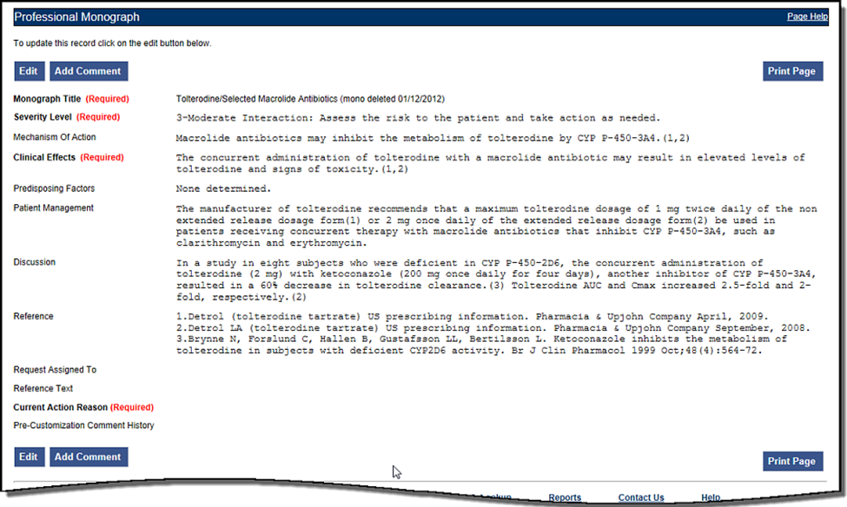

1. Click the Edit button to edit the record.
2. Change the Severity level to 1 – Critical.
3. Indicate the action reason in the free text Current Action Reason (required) field.
4. Click the Customize button.

# Contact Us

The Contact Us page contains a list of PECS Project Contacts should you need additional information about the PECS product. The content of the Contact Us page is created and maintained by users with the Administrator role. In many cases, a linked email address will be included; Click the link associated with the name to send that person (or group) an email.

**Note:** Clicking the link opens your mail application and a new email message to the person specified in the properties of the link. This may produce a warning message. This is normal.

Figure : Contact Us Example



PECS Administrators can edit the content of the Contact Us page. See Editing Contact Us for additional information.

*(This page included for two-sided copying.)*

# Reports

The Reports page displays a list of available reports in PECS. PECS Reports are essentially exported Excel spreadsheets that can be manipulated and formatted as the user sees fit.

**Note**: The Reports tab is not visible to Requestor or Release Manager users.

**Note to Assistive Technology Users**: Please refer the documentation included with your screen reader for commands related to reading column and row headers.

To run a report, click the link associated with it. You will be provided the option of opening the file directly or saving it to copy of the file to a location on your workstation (or accessible network location).

Figure : List of Reports

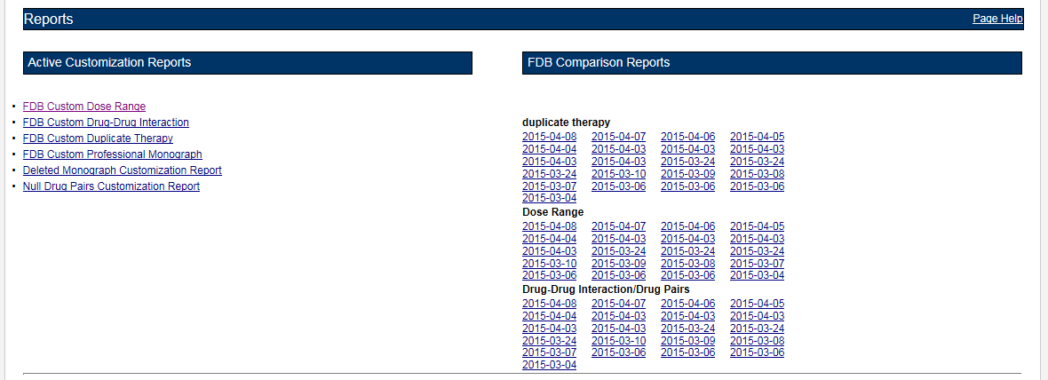

There are two types of Reports:

* Active Customization Reports
* FDB Comparison Reports

## Active Customization Reports

The Active Customization Reports are:

* FDB Custom Dose Range Report
* FDB Custom Drug-Drug Interaction Report
* FDB Custom Duplicate Therapy Report
* FDB Custom Professional Monograph Report
* Deleted Monograph Customization Report
* Null Drug Pairs Customization Report

The first four Active Customization Reports, FDB Custom Dose Range, FDB Custom Drug-Drug Interaction, FDB Custom Duplicate Therapy, and FDB Custom Professional Monograph, display concept records in an Approved status along with their corresponding FDB record data. See the sample below.

Figure : Sample Active Customization Report

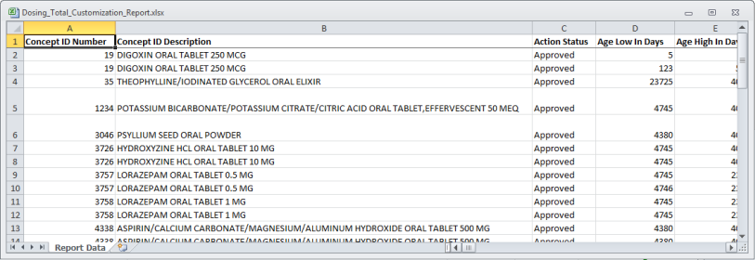

The last two reports on the list, Deleted Monograph Customization Report and Null Drug Pairs Customization Report, look for problems. The Deleted Monograph Customization Report displays DDIs with an associated PM that has been deleted (e.g., the FDB update deleted an FDB PM, and that FDB PM is associated to a custom DDI). The Null Drug Pairs Customization Report displays custom DDIs that have an associated DP in which one or both routed generics is null because an FDB update deleted the routed generic(s).

### FDB Custom Dose Range Report

The FDB Custom Dose Range Report contains active VA custom Dose Range records in an Approved status. The default file name is Dosing_Total_Customization_Report.xlsx.

To Run the FDB Custom Dose Range Report

1. Click the Reports tab on the PECS Application Window.
2. Click the FDB Custom Dose Range Report link.
3. Select Open to view the exported file in Excel; select Save to save a copy of the file to a location on your workstation (or accessible network location). The file name is Dosing_Total_Customization_Report.xlsx.
4. If you selected Open, the report will automatically appear in the Excel application.

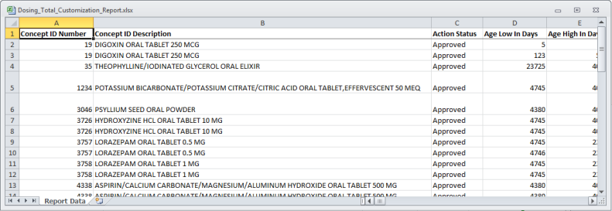

### FDB Custom Drug-Drug Interaction Report

The FDB Custom Drug-Drug Interaction Report contains active VA custom Drug-Drug interaction records in an Approved status along with their corresponding FDB record data.

To Run the FDB Custom Drug-Drug Interaction Report

1. Click the Reports tab on the PECS Application Window.
2. Click the FDB Custom Drug-Drug Interaction Report link.
3. Select Open to view the exported file in Excel; select Save to save a copy of the file to a location on your workstation (or accessible network location). The file name is Ddiminteraction_Total_Customization_Report.xlsx.
4. If you selected Open, the report will automatically appear in the Excel application.

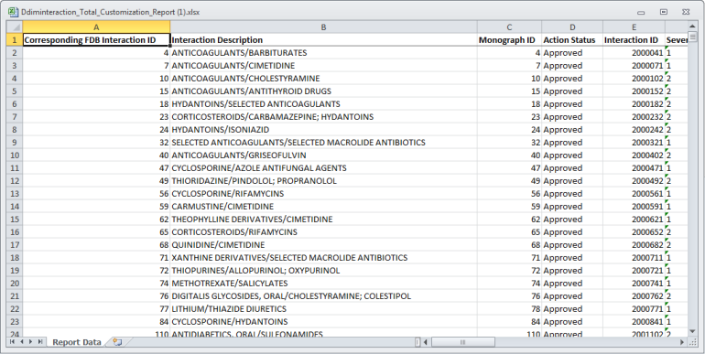

### FDB Custom Duplicate Therapy Report

The FDB Custom Duplicate Therapy Report contains active VA custom Duplicate Therapy records in an Approved status along with their corresponding FDB record data.

To run the FDB Custom Duplicate Therapy Report

1. Click the Reports tab on the PECS Application Window.
2. Click the FDB Custom Duplicate Therapy Report link.
3. Select Open to view the exported file in Excel; select Save to save a copy of the file to a location on your workstation (or accessible network location). By default, the file name is Dtcat_Total_Customization_Report.xlsx.
4. If you selected Open, the report will automatically appear in the Excel application.

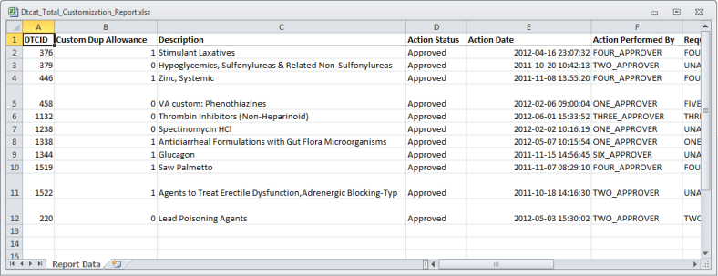

### FDB Custom Professional Monograph Report

The FDB Custom Professional Monograph Report contains active VA custom Professional Monograph records in an Approved status along with their corresponding FDB record data.

To run the FDB Custom Professional Monograph Report

1. Click the Reports tab on the PECS Application Window.
2. Click the FDB Custom Professional Monograph Report link.
3. Select Open to view the exported file in Excel; select Save to save a copy of the file to a location on your workstation (or accessible network location). By default, the file name is Monograph_Total_Customization_Report.xlsx.
4. If you selected Open, the report will automatically appear in the Excel application.

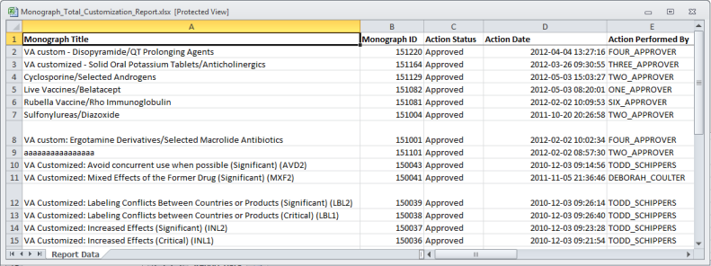

### Deleted Monograph Customization Report

The Deleted Monograph Customization Report contains active VA custom Drug-Drug interaction records in an Approved status that are associated with a deleted FDB Professional Monograph.

To run the Deleted Monograph Customization Report

1. Click the Reports tab on the PECS Application Window.
2. Click the Deleted Monograph Customization Report link.
3. Select Open to view the exported file in Excel; select Save to save a copy of the file to a location on your workstation (or accessible network location). By default, the file name is Deleted_Monograph_Report.xlsx.
4. If you selected Open, the report will automatically appear in the Excel application.

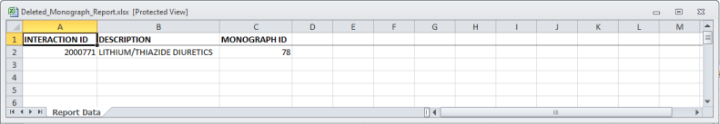

### Null Drug Pairs Customization Report

The Null Drug Pairs Customization Report contains approved VA custom Drug-Drug Interactions that contain Drug Pairs with null Routed Generic #1 or Routed Generic #2 fields. The report will not display drug pairs with Deleted status.

If this report contains any entries, a user in the Administrator role should initiate the Null Drug Pair Removal Process, which deletes Null Drug Pairs listed on the report. After the Null Drug Pair Removal process is complete, the Administrator may want to run the report to verify that these drug pairs have been removed. The null Drug Pairs listed on this report are the ones that will be deleted during the Null Drug Pair Removal process.

To run the Null Drug Pairs Customization Report

1. Click the Reports tab on the PECS Application Window.
2. Click the Null Drug Pairs Customization Report link.
3. Select Open to view the exported file in Excel; select Save to save a copy of the file to a location on your workstation (or accessible network location). By default, the file name is Deleted_Monograph_Report.xlsx.
4. If you selected Open, the report will automatically appear in the Excel application.

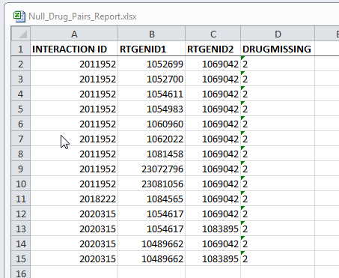

**Note:** This report can be used to identify approved VA Drug-Drug Interactions that contain null Drug Pairs.

For more information, see the section Null Drug Pair Removal Process under Administrator.

## FDB Comparison Reports

The FDB Comparison Reports display the changes to existing data included in the Incremental FDB updates. The reports inform an Approver or Administrator of the latest FDB changes for the Duplicate Therapy, Drug-Drug Interaction, Drug Pair, and Dose Range concepts and provide data that helps the these users decide whether or not to change a custom record. The FDB Comparison Reports help an Approver or Administrator keep PECS customizations in sync with FDB changes.

FDB Comparison Reports display:

* Customized records in all action statuses that have differences between the PECS FDB data and the data in the Incremental FDB Update file.
* Un-customized records that have differences between the PECS FDB data and the data in the Incremental FDB Update file.
* Indications that an FDB record is scheduled to be deleted by DATUP.
* Lists of the drug pairs that will be added or deleted by DATUP.
* A "no data found" message if the Incremental FDB Update file has no changes to the FDB data.

Changed data is marked with an asterisk (*) and colored red. The reports are organized by type and the date of the FDB Incremental Update.

Figure : Changed Data in Report

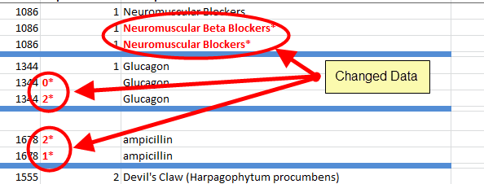

To run an FDB Comparison report, click the appropriate date of an FDB Incremental Update under the appropriate Report Heading:

Figure : FDB Incremental Update Date Samples

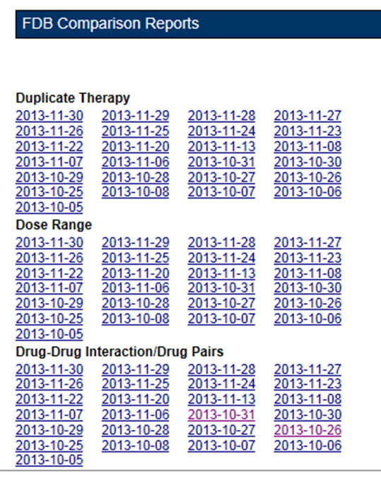

### Structure of the FDB Comparison Report

Figure : Sample FDB Comparison Report - Duplicate Therapy

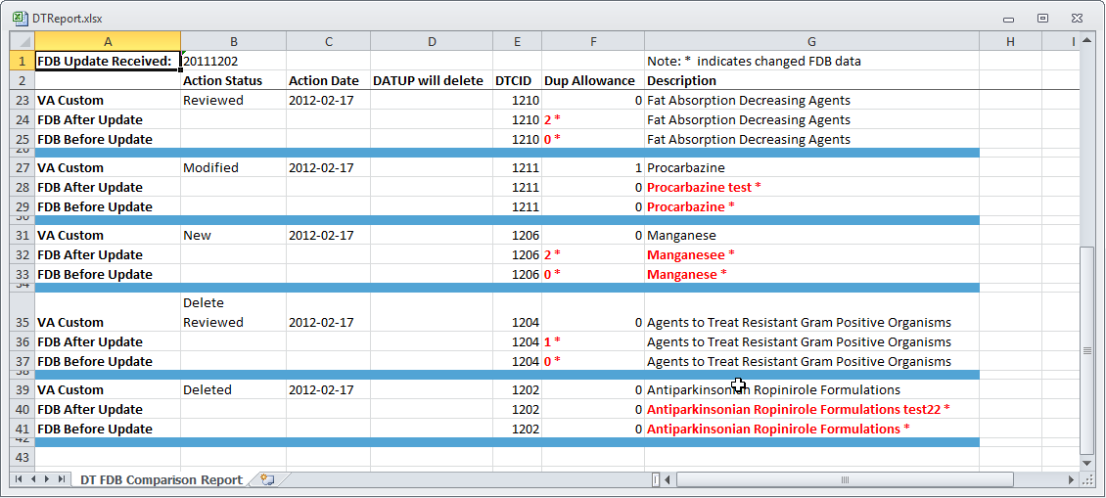

Each FDB Comparison Report lists the "FDB Update Received" date, which is the date listed in the Incremental FDB Update file.

Each report lists comparison sets of VA and FDB data. Each comparison set consists of at least three rows separated by a blue line. The three rows are:

Table : FDB Comparison Report Row Fields

| Row Name | Row Description |
| --- | --- |
| VA Custom | Data in the Custom VA record. If the corresponding FDB record has not been customized, a "Not customized" message will be in the Action Status column and the rest of the row will be blank. |
| FDB After Update | Data in the Incremental FDB Update File. This data will be in the PECS database shortly after the incremental FDB update is done via DATUP. |
| FDB Before Update | Data in the PECS FDB record. This data will be replaced by the 'FDB After Update' data. If the FDB After Update and FDB Before Update data of the same type are different, they are marked with an asterisk (*) and colored red. Records that do not have any differences between the FDB Before Update and FDB After Update data of the same type are not listed in the report. |

Each FDB Comparison Report has the following columns:

Table : FDB Comparison Report Statuses

| Column Name | Column Description |
| --- | --- |
| Action Status | The state of the associated VA record based on the most recent action performed. PECS compares FDB data with VA customizations in any Action Status, including Rejected or Deleted. |
| Action Date | The date the current action (Action Status) was taken. |
| DATUP will delete | YES in this column Indicates the associated FDB record will be deleted by DATUP. If the column is blank, the associated FDB record will not be deleted by DATUP.  If the FDB record will be deleted by DATUP, only the FDB Interaction ID and DATUP will delete columns will be filled out in the FDB After Update row. All the other columns will be blank. |

The reports are organized by type and the date of the FDB Incremental Update. Links to the reports are kept for eight weeks on the Reports page.

To run an FDB Comparison report, click the appropriate FDB Incremental Update date under the appropriate Report Heading.

Figure : FDB Incremental Updates

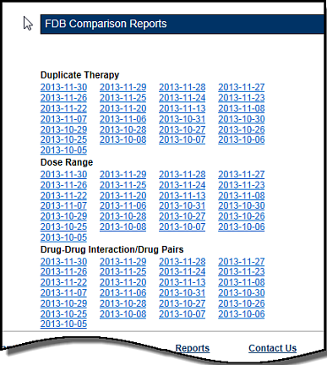

If there are no differences between the FDB After Update and FDB Before Update data of the same type in any of the records, a "No Data Found" message is printed on the FDB Comparison Report.

Figure : Report with No Differences

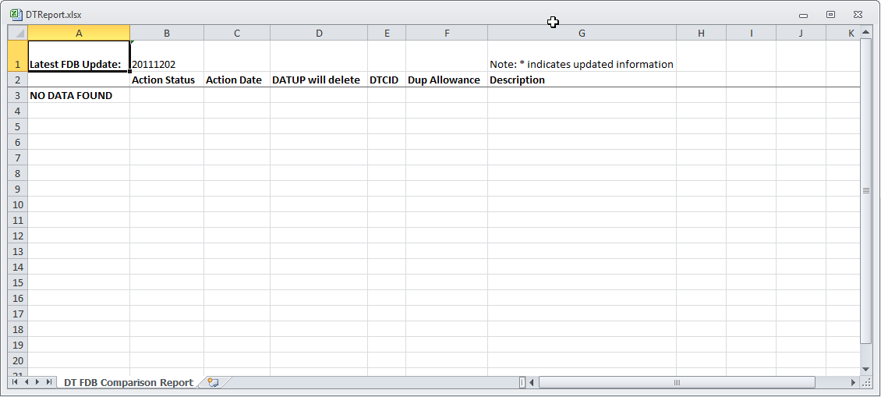

### FDB Comparison Drug-Drug Interaction/Drug Pair Report

The FDB Comparison Drug-Drug Interaction/Drug Pairs Report displays the changes to existing Drug-Drug Interactions included in the Incremental FDB updates. All Action Statuses are compared and are included in the report. The following data points are compared between the FDB update and the VA Drug-Drug Interaction records:

* Corresponding FDB Interaction ID
* Interaction Description
* Monograph ID
* Severity Level Code
* Clinical Effect 1
* Clinical Effect 2
* Deleted Drug Pairs
* Added Drug Pairs

The DDI-DP FDB Comparison Report contains two types of spreadsheets:

* The DDI-DP FDB Comparison Report – gives information about the FDB comparisons and the associated VA custom records.
* FDB Interaction ID-DP – gives information about the added or deleted drug pairs for a specific FDB record. Each FDB update record that has added or deleted drug pairs has its own FDB Interaction ID-DP spreadsheet.

The following DDI-specific fields are included in the DDI-FDB Comparison Report spreadsheet:

Table : FDB Comparison Drug-Drug Interaction/Drug Pair Report Fields

| Field | Description |
| --- | --- |
| VA Interaction ID | A VA-assigned numerical identifier for the interaction. |
| FDB Interaction ID | An FDB-assigned numerical identifier for the interaction. |
| Interaction Description | A text description of the interaction. |
| Monograph ID | A numerical identifier for the Professional Monograph associated with the interaction. |
| Severity Level | A coded severity indicator. |
| Clinical Effect 1 | A three letter code describing the clinical effect. |
| Clinical Effect 2 | A three letter code describing the clinical effect. |
| Drug Pairs | If a DDI has drug pairs scheduled to be added or deleted by DATUP, there will be a message, "See FDB Interaction ID <FDB Interaction ID number>-DP." If a DDI record in the incremental FDB update file does not have added or drug pairs, this column will remain blank. |

If the latest FDB update contains added or deleted drug pairs, these will be displayed on separate tabs titled "FDB Interaction ID <FDB Interaction ID number>-DP".

Each record consists of at least three lines and individual records are by a blank row (blue). There will be more than three lines if there is more than one VA Customization for the described interaction.

Figure : DDI-DP FDB Comparison Report

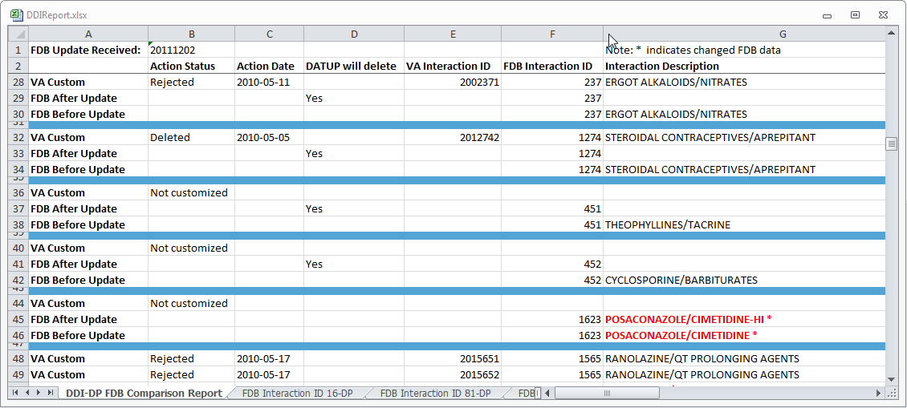

* VA Custom - Custom VA information about the Drug-Drug Interaction record(s). If the DDI has not been customized, the record will state "Not customized".
* Latest FDB - Indicates changes to the Drug-Drug Interaction record that appeared on the incremental FDB update you selected.
* Previous FDB - Displays the value for the Drug-Drug Interaction record in the incremental FDB update immediately prior to the incremental FDB update you selected.

The following fields are included in the report:

Table : FDB Comparison Drug-Drug Interaction/Drug Pair Report Fields

| Field | Description |
| --- | --- |
| Action Status | The current state of the record based on the most recent action performed on the associated record. |
| Action Date | The date the current action (Action Status) was performed. |
| DATUP will delete | YES in this column Indicates the associated record will be deleted by DATUP. |
| VA Interaction ID | A VA-assigned numerical identifier for the interaction. |
| FDB Interaction ID | An FDB-assigned numerical identifier for the interaction. |
| Interaction Description | A text description of the interaction. |
| Monograph ID | A numerical identifier for the Professional Monograph associated with the interaction. |
| Severity Level | A coded severity indicator. |
| Clinical Effect 1 | A three letter code describing the clinical effect. |
| Clinical Effect 2 | A three letter code describing the clinical effect. |

If the latest FDB update contains added or deleted drug pairs, these will be displayed on separate tabs titled "FDB Interaction ID <FDB Interaction ID number>-DP".

Figure : FDB Interaction ID-Drug Pairs Tab

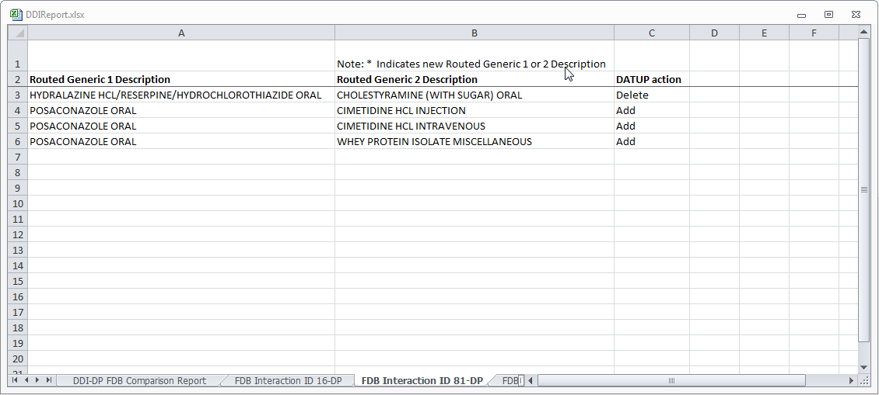

The following fields are included in the report:

Table : FDB Interaction ID-Drug Pairs Fields

| Field | Description |
| --- | --- |
| Routed Generic 1 Description | The Routed Generic Description of Drug 1 in the Drug Pair. |
| Routed Generic 2 Description | The Routed Generic Description of Drug 2 in the Drug Pair. |
| DATUP Action | The action that DATUP will perform. Either DATUP will add the drug pair to the PECS database or delete it from PECS. |

**Note:** A DDI record that is not listed on the DDI-DT FDB Comparison Report spreadsheet can still have added or deleted drug pairs listed in the latest incremental FDB update file. In that case, the drug pair information is just listed on an FDB Interaction ID-DP spreadsheet.

### FDB Comparison Duplicate Therapy Report

The Duplicate Therapy FDB Comparison Report displays the differences between the PECS FDB data and the data in the Incremental FDB Update file for the Duplicate Therapy (DT) concept. This report displays the following DT-specific data:

Figure : FDB Comparison Duplicate Therapy Report

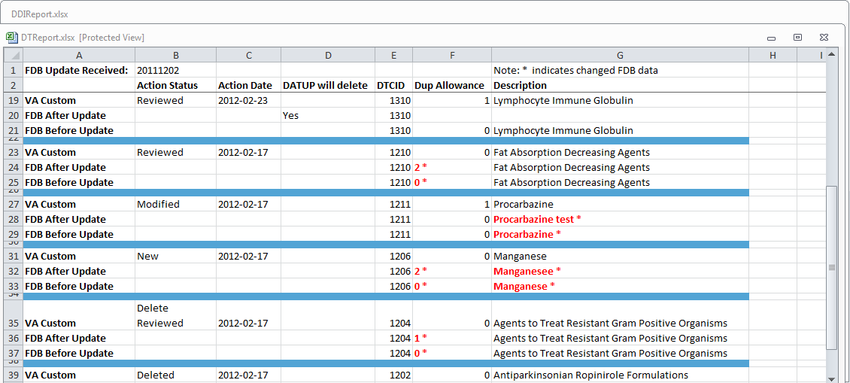

The three lines display the following fields:

Table : FDB Comparison Duplicate Therapy Report Fields

| Field Name | Field Description |
| --- | --- |
| DTCID | Duplicate Therapy Control ID. A numerical identifier for the DT FDB and VA records. |
| Dup Allowance | Duplicate Allowance. The number of drugs performing the same function before a warning is issued. |
| Description | A description (name) of the drug that is the basis of the DT record. |

To run the Duplicate Therapy FDB Comparison report, click the desired date of an FDB Incremental Update under the appropriate Duplicate Therapy heading.

Figure : FDB Incremental Update Dates



### FDB Comparison Dose Range Report

The Dose Range FDB Comparison Report displays the differences between the PECS FDB data and the data in the Incremental FDB Update file for the Dose Range (DR) concept.

Figure : FDB Comparison Dose Range Report

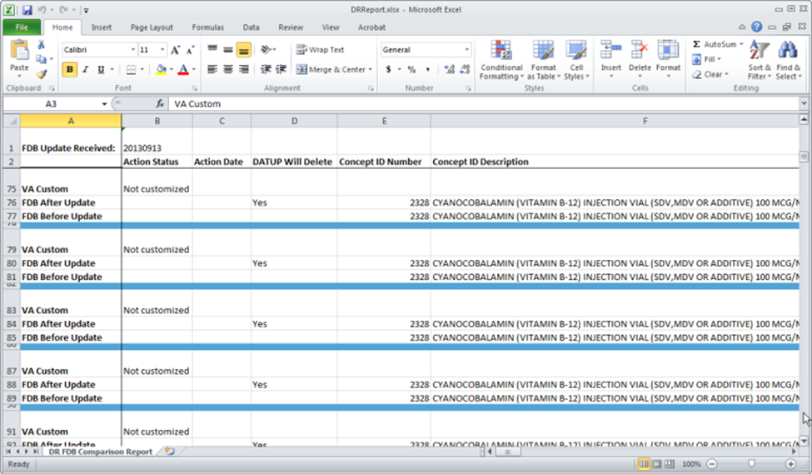

Only records where the Concept Type = 6 will display on the report. If the DR FDB record has not been customized, it will display on the report if the following conditions were met:

* Data in all of the first seven fields (Concept ID Number, Age Low in Days, Age High in Days, Dose Route ID, Dose Type ID, FDBDX, HITTYPE) is identical in the PECS FDB record and the latest incremental FDB update
* Data in at least one other field is different in the PECS FDB record and the latest incremental FDB update

If a DR FDB record has been customized, it will display on the report if all the conditions mentioned above have been met and the active VA custom record and the PECS FDB record are cross-referenced, thus indicating that the active VA custom record was created from the FDB record.

Fields

Table : FDB Comparison Dose Range Report

| Field Name | Field Description |
| --- | --- |
| Concept ID Number | Number identifying the drug. Identifies a specific drug within a given concept type. |
| Age Low in Days | Lowest patient age in days to which dosing information applies |
| Age High in Days | Highest patient age in days to which dosing information applies |
| Dose Route ID | Dose Route Identifier. Refers to the route of administration, which is the site or method by which a drug is administered |
| Dose Type ID | Dose type identifier |
| FDBDX | FDBDX type code to identify a Medical Condition |
| HITTYPE | Signifies whether the dose record came from the Dosage Range Check module or the Minimum/Maximum dosing module. There are 3 possible values: 1 – Dose Range Check; 2 – Dosing Not Established For This Age Range; 3 – Minimum/maximum dosing. HITTYPE is used to determine how to structure the dose alerts. |
| Concept ID Description | Text description of the Concept ID. Also defined as the drug name. For example, the Concept ID Description is GUAIFENESIN/PHENYLPROPANOLAMINE HCL/ACETAMINOPHEN/CAFFEINE ORAL TABLET and the Concept ID is 713. |
| DXID | First Databank Medical Lexicon (FML) Disease Identifier |
| Dose Low | Minimum amount to be administered per day |
| Dose Low Units | Unit of measure for low dose per day |
| Dose High | Highest amount to be administered per day |
| Dose High Units | Unit of measure for high dose per day |
| Dose Form Low | Low dose for a given dose form |
| Dose Form Low Units | Unit of measure for the dose form (EA/KG/DAY) |
| Dose Form High | High dose for a given dose form |
| Dose Form High Units | Unit of measure for the dose form (EA/KG/DAY) |
| Frequency Low | Low end of a drug’s frequency of administration per day |
| Frequency High | High end of a drug’s frequency of administration per day |
| Duration Low | Lowest recommended duration of therapy (in days) |
| Duration High | Highest recommended duration of therapy (in days) |
| Maximum Duration | Maximum recommended duration of therapy (in days) |
| Maximum Single Dose | Maximum amount to be administered in a single dose |
| Maximum Single Dose Units | Unit of measure for the maximum single dose |
| Maximum Single Dose Form | Maximum single dose for a given form |
| Maximum Single Dose Form Units | Unit of measure for the dose form (EA/KG/DAY) |
| Maximum Daily Dose | Maximum amount to be administered per day |
| Maximum Daily Dose Units | Unit of measure for the maximum daily dose |
| Maximum Daily Dose Form | Maximum daily dose for a dose form |
| Maximum Daily Dose Form Units | Unit of measure for the dose form (EA/KG/DAY) |
| Maximum Lifetime Dose | Maximum amount to be administered over a patient’s lifetime, if available |
| Maximum Lifetime Dose Units | Unit of measure for maximum lifetime dose |
| Maximum Lifetime Dose Form | Maximum lifetime dose for a given dose form |
| Maximum Lifetime Dose Form Units | Unit of measure for the dose form (EA/KG/DAY) |
| Dose Rate Low | Minimum amount to be administered per dose rate (hours or minutes) |
| Dose Rate Low Units | Unit of measure for low dose rate (hours or minutes) |
| Dose Rate High | Highest amount to be administered per dose rate (hours or minutes) |
| Dose Rate High Units | Unit of measure for high dose rate (hours or minutes) |
| Dose Form Rate Low | Low dose for a given dose form rate (hours or minutes) |
| Dose Form Rate Low Units | Unit of measure for the dose form rate (hours or minutes) |
| Dose Form Rate High | High dose for a given dose form rate (hours or minutes) |
| Dose Form Rate High Units | Unit of measure for the dose form rate (hours or minutes) |
| Maximum Single Dose Rate | Maximum amount to be administered in a single dose rate (hours or minutes) |
| Maximum Single Dose Rate Units | Unit of measure for the maximum single dose rate (hours or minutes) |
| Maximum Single Dose Form Rate | Maximum single dose for a given dose form rate (hours or minutes) |
| Maximum Single Dose Form Rate Units | Unit of measure for the dose form rate (hours or minutes) |
| Maximum Daily Dose Form Rate | Maximum daily dose for a dose form rate (hours or minutes) |
| Maximum Daily Dose Rate | Maximum amount to be administered per dose rate (hours or minutes) |
| Maximum Daily Dose Form Rate Units | Unit of measure for the dose form rate (hours or minutes) |
| Maximum Daily Dose Rate Units | Unit of measure for the maximum daily dose rate (hours or minutes) |
| Max Single NTE Dose | Maximum Not-to-Exceed (NTE) amount to be administered in a single dose |
| Max Single NTE Dose Unit | Unit of measure for the maximum single NTE dose |
| Max Single NTE Dose Form | Maximum Unit of measure for the NTE dose form (EA/KG/DAY) |
| Max Single NTE Dose Form Unit | Maximum Not-to-Exceed amount to be administered in a single dose for a given dose form |
| Hepatic Impairment Indicator | Indicates that the drug’s dosing information needs to be adjusted for a patient with hepatic impairment. This flag does not differentiate between mild, moderate, and severe hepatic failure. |
| Renal Impairment Indicator | Indicates whether the dosing information needs to be modified for any degree of renal impairment in the patient. |
| CRCL Threshold | Lowest Creatinine Clearance (CRCL) to which dosing applies. |
| CRCL Threshold Units | Unit of measure for the Creatinine Clearance (CRCL) threshold. |
| Low Elimination Half Life | Low end of the drug’s half-life range |
| High Elimination Half Life | High end of the drug’s half-life range. |
| Half Life Units | Unit of time for the half-life range of a drug. |
| Weight Required Indicator | Indicates whether weight is required for dosing. |
| BSA | Required Indicator Indicates whether Body Surface Area (BSA) is required for dosing |

*(This page included for two-sided copying.)*

# Online Help

PECS provides an online help system that provides information on using the application.

Figure : PECS Online Help Window

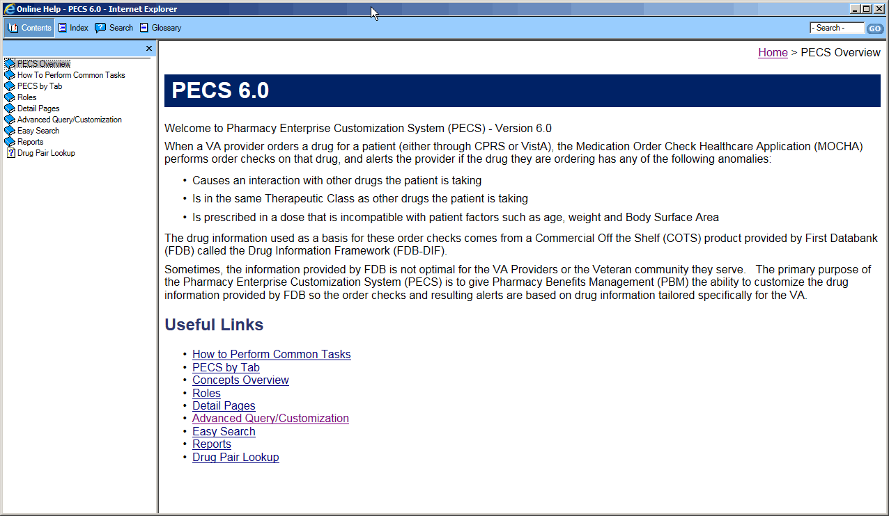

## Accessing Online Help

There are two ways to access online help: the Help tab and Page Help link.

1. Click the Help tab to open the main Online Help page

Figure : The Help Tab

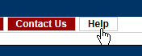

1. Click the Page Help link to access help specific to the page you are on.

Figure : The Page Help Link

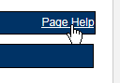

Using the Page Help link will display help page relevant to the current page. Click the Show link to display the Table of Contents.

Figure : The Show Link

